Cloudera Configuration on Centos 7

Cloudera Setup and Installation from Internet

1/4/2017

Shalaj Shukla

Contents

Install Cloudera Manager 2

Cloudera Manager 2

Setup Pre-requisites 3

Check configuration of all nodes 3

Host Machines Configuration 4

Disable Firewall (IPTables) 5

Enabling NTP 5

Set umask to 022 7

SSH Password less sudo Access 8

Set swappiness to 10 11

Disabling SELinux 12

Download and install 13

Add hosts to cluster 43

Add Role Instance 56

HDFS Service 56

Zookeeper Service 64

Yarn Service 69

Hive Service 74

Impala Service 79

Oozie Service 83

Hue Service 89

Install Custom-database (MySQL) 97

Uninstall Cloudera Manager and Managed Software 97

# Install Cloudera Manager

## Cloudera Manager

**What is it?**

* Cloudera Manager is a management tool for Hadoop eco system
* Easy for set up Hadoop cluster and also facilitates monitoring of Hadoop Cluster

**Components**

* Cloudera Manager on one machine
* Relational database on same machine as Cloudera manager or different machine
* Cloudera Agent on all machine

**How it works**

* Cloudera manager will be running on one machine in the cluster
* Cloudera agent will be running on all machines in the cluster
* Cloudera agent sends data collected from all machines such as resources utilization (memory, storage, CPU etc.)
* Data will be stored in a relational database which will act as a repository
* Cloudera manager consolidates this information and provide capabilities such as alerts, dashboards etc.

**Steps to set it up**

* Install Cloudera manager on one of the masters
* Set up database if you want it to be in different host than where Cloudera manager is running
* Set up Cloudera manager
* Start Cloudera manager
* Validate by going to url (http://hostname:7180)

## Setup Pre-requisites

### Check configuration of all nodes

Check Configuration of all four machines by issuing ***lscpu*** command

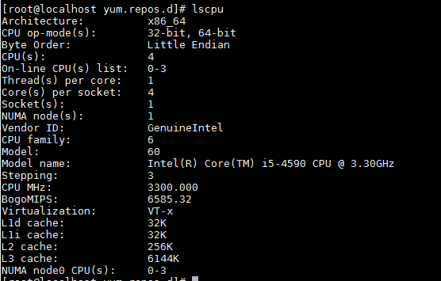

Check OS version of all four machines by checking content of /etc/*-release file

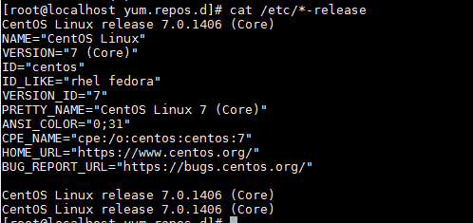

Check the java version on all four machines

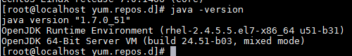

The entire configuration more or less should be same across cluster

### Host Machines Configuration

Here we are planning to setup four node clusters on following centos 7 machines

|  |  |
| --- | --- |
| **Machine** | **Roles** |
| 172.27.155.122 | All Cloudera Management services  Data Node  Cloudera-agent  Failover controller  Secondary Name Node |
| 172.27.155.53 | Data Node  Cloudera-agent |
| 172.27.155.55 | Data Node  Cloudera-agent  Name Node |
| 172.27.155.78 | Data Node  Cloudera-agent |

You can find all other roles as we install different role instances on machines

We need to have Yum install on machine by default yum comes with centos

Update hostname of all four machine using hostname <name_of_host> command

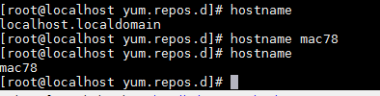

Update /etc/hosts file of all four nodes, file should be same across cluster

|  |
| --- |
| 127.0.0.1 localhost localhost.localdomain localhost4 localhost4.localdomain4  ::1 localhost localhost.localdomain localhost6 localhost6.localdomain6  172.27.155.78 mac78  172.27.155.55 mac55  172.27.155.53 mac53  172.27.155.122 mac122 |

***Note: please do not put any special character in hostname only alphabets, digits and hyphen allowed***

Also please set hostname permanently by issuing following command in all nodes

|  |
| --- |
| ***#*** hostnamectl set-hostname <Your-New-Host-Name-Here> |

### Disable Firewall (IPTables)

Disable firewall by issuing command below

|  |
| --- |
| [root@mac122 cloudera-scm-server]# systemctl disable firewalld  Removed symlink /etc/systemd/system/dbus-org.fedoraproject.FirewallD1.service.  Removed symlink /etc/systemd/system/basic.target.wants/firewalld.service.  [root@mac122 cloudera-scm-server]# systemctl stop firewalld  [root@mac122 cloudera-scm-server]# |

For Redhat 6 version please use below commands

|  |
| --- |
| # service iptables stop # chkconfig iptables off  # service ip6tables stop # chkconfig ip6tables off |

### Enabling NTP

CDH requires that you configure the Network Time Protocol (NTP) service on each machine in your cluster. To start NTP and configure it to run automatically on reboot, perform the following steps on each node in your cluster.

1. Install NTP if it is not installed already

|  |
| --- |
| # yum -y install ntp |

2. Open the /etc/ntp.conf file and copy one of the server name that we use later

|  |
| --- |
| # For more information about this file, see the man pages  # ntp.conf(5), ntp_acc(5), ntp_auth(5), ntp_clock(5), ntp_misc(5), ntp_mon(5).  driftfile /var/lib/ntp/drift  # Permit time synchronization with our time source, but do not  # permit the source to query or modify the service on this system.  restrict default nomodify notrap nopeer noquery  # Permit all access over the loopback interface. This could  # be tightened as well, but to do so would effect some of  # the administrative functions.  restrict 127.0.0.1  restrict ::1  # Hosts on local network are less restricted.  #restrict 192.168.1.0 mask 255.255.255.0 nomodify notrap  # Use public servers from the pool.ntp.org project.  # Please consider joining the pool (http://www.pool.ntp.org/join.html).  server 0.centos.pool.ntp.org iburst  server 1.centos.pool.ntp.org iburst  server 2.centos.pool.ntp.org iburst  server 3.centos.pool.ntp.org iburst  #broadcast 192.168.1.255 autokey # broadcast server  #broadcastclient # broadcast client  #broadcast 224.0.1.1 autokey # multicast server  #multicastclient 224.0.1.1 # multicast client  #manycastserver 239.255.254.254 # manycast server  #manycastclient 239.255.254.254 autokey # manycast client  # Enable public key cryptography.  #crypto  includefile /etc/ntp/crypto/pw  # Key file containing the keys and key identifiers used when operating  # with symmetric key cryptography.  keys /etc/ntp/keys  # Specify the key identifiers which are trusted.  #trustedkey 4 8 42  # Specify the key identifier to use with the ntpdc utility.  #requestkey 8  # Specify the key identifier to use with the ntpq utility.  #controlkey 8  # Enable writing of statistics records.  #statistics clockstats cryptostats loopstats peerstats  # Disable the monitoring facility to prevent amplification attacks using ntpdc  # monlist command when default restrict does not include the noquery flag. See  # CVE-2013-5211 for more details.  # Note: Monitoring will not be disabled with the limited restriction flag. |

3. Configure the NTP service to run at reboot.

|  |
| --- |
| chkconfig ntpd on |

4. Start and enable the NTP service

|  |
| --- |
| #systemctl start ntpd  #systemctl enable ntpd |

5. Synchronize the node

|  |
| --- |
| #ntpdate -u <your_ntp_server> |

In our case

ntpdate -u 0.centos.pool.ntp.org

6. Synchronize the system clock (to prevent synchronization problems).

|  |
| --- |
| #hwclock --systohc |

7. Check ntpstat

|  |
| --- |
| [root@mac122 ~]# ntpstat  synchronised to NTP server (123.108.200.124) at stratum 4  time correct to within 8130 ms  polling server every 64 s |

8. Check list of server

|  |
| --- |
| [root@mac122 ~]# ntpq -pn  remote refid st t when poll reach delay offset jitter  ==============================================================================  139.59.45.40 .INIT. 16 u - 64 0 0.000 0.000 0.000  *123.108.200.124 195.219.205.9 3 u 38 64 17 33.051 24.723 41.028  139.59.19.184 .INIT. 16 u - 64 0 0.000 0.000 0.000  139.59.61.225 .INIT. 16 u - 64 0 0.000 0.000 0.000 |

Here server with * is configured server

### Set umask to 022

By default umask value is 022 so that every file will be created with 755 permission

If it is not configured to 022 please update it accordingly

|  |
| --- |
| [root@mac92 ~]# umask  0022  [root@mac92 ~]# umask 022  [root@mac92 ~]# umask  0022 |

### SSH Password less sudo Access

In case if you do not want to setup with root user, we need to create ssh password less sudo access.

Please skip this step if you are planning to install with root user

Please follow below steps to configure ssh password less sudo access

1. First we need to create a new user on each node (username should be same)

|  |
| --- |
| [root@mac248 ~]# useradd cloudera-user  [root@mac248 ~]# passwd cloudera-user  Changing password for user cloudera-user.  New password:  BAD PASSWORD: The password fails the dictionary check - it is based on a dictionary word  Retype new password:  passwd: all authentication tokens updated successfully. |

Repeat this step to all nodes

2. Run visudo command to add new user to sudoers list

|  |
| --- |
| Defaults requiretty  Defaults:cloudera-user !requiretty  #  # Refuse to run if unable to disable echo on the tty. This setting should also be  # changed in order to be able to use sudo without a tty. See requiretty above.  #  ..  ..  ..  ..  ## Next comes the main part: which users can run what software on  ## which machines (the sudoers file can be shared between multiple  ## systems).  ## Syntax:  ##  ## user MACHINE=COMMANDS  ##  ## The COMMANDS section may have other options added to it.  ##  ## Allow root to run any commands anywhere  root ALL=(ALL) ALL  cloudera-user ALL=(ALL) NOPASSWD: ALL |

Add highlighted text at proper place in file and save it

Repeat this step to all nodes

3. Now create public and private key on one of the node , first we need to switch to Cloudera-user

|  |
| --- |
| [root@mac248 ~]# su - cloudera-user  [cloudera-user@mac248 ~]$ ssh-keygen -t rsa  Generating public/private rsa key pair.  Enter file in which to save the key (/home/cloudera-user/.ssh/id_rsa):  Created directory '/home/cloudera-user/.ssh'.  Enter passphrase (empty for no passphrase):  Enter same passphrase again:  Your identification has been saved in /home/cloudera-user/.ssh/id_rsa.  Your public key has been saved in /home/cloudera-user/.ssh/id_rsa.pub.  The key fingerprint is:  66:9a:b5:ab:a9:b6:06:50:cc:9d:6f:48:fe:0b:66:f1 cloudera-user@mac248  The key's randomart image is:  +--[ RSA 2048]----+  | o . . |  | + + |  | . o o |  |. + o |  | . = S |  | . + E* . |  | + .o.. |  | o .. . |  | oooo.. |  +-----------------+ |

4. Check if files are created successfully under .ssh folder

|  |
| --- |
| [cloudera-user@mac248 ~]$ ls -la  total 24  drwx------ 3 cloudera-user cloudera-user 4096 Apr 21 20:52 .  drwxr-xr-x. 6 root root 4096 Apr 21 20:44 ..  -rw-r--r-- 1 cloudera-user cloudera-user 18 Dec 7 04:49 .bash_logout  -rw-r--r-- 1 cloudera-user cloudera-user 193 Dec 7 04:49 .bash_profile  -rw-r--r-- 1 cloudera-user cloudera-user 231 Dec 7 04:49 .bashrc  drwx------ 2 cloudera-user cloudera-user 4096 Apr 21 20:52 .ssh  [cloudera-user@mac248 ~]$ cd .ssh  [cloudera-user@mac248 .ssh]$ ls -l  total 8  -rw------- 1 cloudera-user cloudera-user 1675 Apr 21 20:52 id_rsa  -rw-r--r-- 1 cloudera-user cloudera-user 402 Apr 21 20:52 id_rsa.pub |

5. Now create authorized_keys file on each of the node by issuing command below

|  |
| --- |
| [cloudera-user@mac248 .ssh]$ ssh-copy-id -i /home/cloudera-user/.ssh/id_rsa.pub cloudera-user@172.27.155.71  The authenticity of host '172.27.155.71 (172.27.155.71)' can't be established.  ECDSA key fingerprint is e8:61:2c:01:63:4e:0e:08:06:de:fb:be:be:57:82:7f.  Are you sure you want to continue connecting (yes/no)? yes  /bin/ssh-copy-id: INFO: attempting to log in with the new key(s), to filter out any that are already installed  /bin/ssh-copy-id: INFO: 1 key(s) remain to be installed -- if you are prompted now it is to install the new keys  cloudera-user@172.27.155.71's password:  Number of key(s) added: 1  Now try logging into the machine, with: "ssh 'cloudera-user@172.27.155.71'"  and check to make sure that only the key(s) you wanted were added. |

Same step we need to perform on each node including the node on which you created public and private key

|  |
| --- |
| [cloudera-user@mac248 .ssh]$ ssh-copy-id -i /home/cloudera-user/.ssh/id_rsa.pub cloudera-user@172.27.155.248  The authenticity of host '172.27.155.248 (172.27.155.248)' can't be established.  ECDSA key fingerprint is fd:c8:7e:95:da:8f:37:57:de:47:d8:d0:75:4b:80:e3.  Are you sure you want to continue connecting (yes/no)? yes  /bin/ssh-copy-id: INFO: attempting to log in with the new key(s), to filter out any that are already installed  /bin/ssh-copy-id: INFO: 1 key(s) remain to be installed -- if you are prompted now it is to install the new keys  cloudera-user@172.27.155.248's password:  Number of key(s) added: 1  Now try logging into the machine, with: "ssh 'cloudera-user@172.27.155.248'"  and check to make sure that only the key(s) you wanted were added. |

Here we are creating authorized_keys file on same node

6. Now run below command to ensure if SSH password less sudo access has been established

|  |
| --- |
| [cloudera-user@mac248 .ssh]$ ssh cloudera-user@172.27.155.71 sudo ls -l  total 0  [cloudera-user@mac248 .ssh]$ |

If command runs without asking password it means it is working fine ( run this command for all nodes)

7. Just to verify, check on each node if authorized_keys file is created under .ssh folder

|  |
| --- |
| [root@mohammadkhan-w8 .ssh]# su -cloudera-user  bash: loudera-user: command not found  [root@mohammadkhan-w8 .ssh]# su - cloudera-user  [cloudera-user@mac71 ~]$ cd .ssh  [cloudera-user@mac71 .ssh]$ ls -l  total 4  -rw------- 1 cloudera-user cloudera-user 402 Apr 21 15:29 authorized_keys |

### Set swappiness to 10

Check swappiness value

|  |
| --- |
| [root@mac122 log]# sysctl vm.swappiness  vm.swappiness = 60 |

OR

|  |
| --- |
| [root@mac53 etc]# cat /proc/sys/vm/swappiness  60 |

It means it’s going to start swapping out when 40% of physical memory is used

You can change swappiness value by editing /etc/sysctl.conf file

Add line add the end of file vm.swappiness = <value> like vm.swappiness = 10

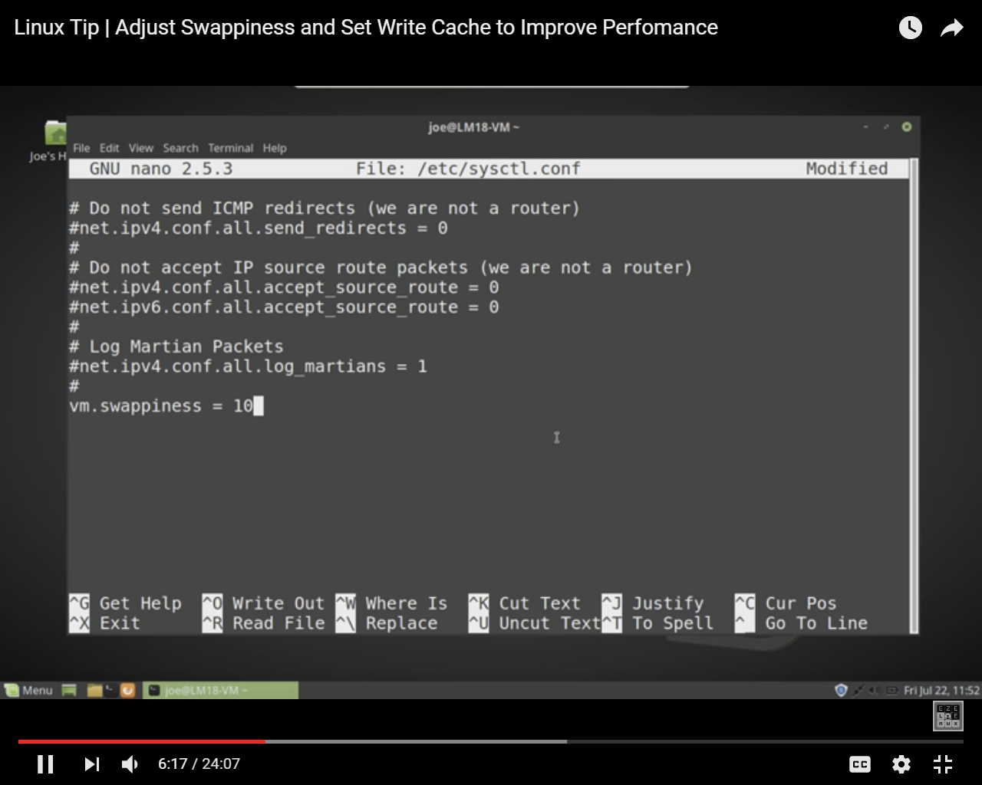

Cloudera recommended assigning 10 to swappiness

Reboot system

### Disabling SELinux

First you need to disable SELinux before installing Cloudera manager

Security-Enhanced Linux (SELinux) allows you to set access control through policies. You must disable SELinux on each host before you deploy CDH on your cluster.

To disable SELinux, perform the following steps on each host.

1. Check the SELinux state.

getenforce

If the output is disabled, you can skip this task, if the output is enforcing, continue to the next step.

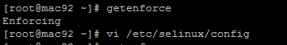

Or you can check sestatus command

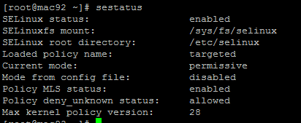

1. Open the /etc/selinux/config file (in some systems, the /etc/sysconfig/selinux file).

Change the line SELINUX=enforcing to SELINUX=disabled.

1. Save and close the file.
2. Reboot machine by reboot command

After reboot, you can verify the status of SELinux. Issue “sestatus” command to verify that SELinux permanently disabled:

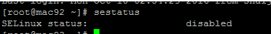

Or you can check by getenforce command

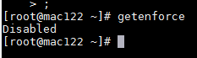

## Download and install

Now download Cloudera manager installer

|  |
| --- |
| wget http://archive.cloudera.com/cm5/installer/latest/cloudera-manager-installer.bin |

Give execute permission

|  |
| --- |
| chmod +x cloudera-manager-installer.bin |

Install Cloudera Manager Packages from internet

|  |
| --- |
| sudo ./cloudera-manager-installer.bin |

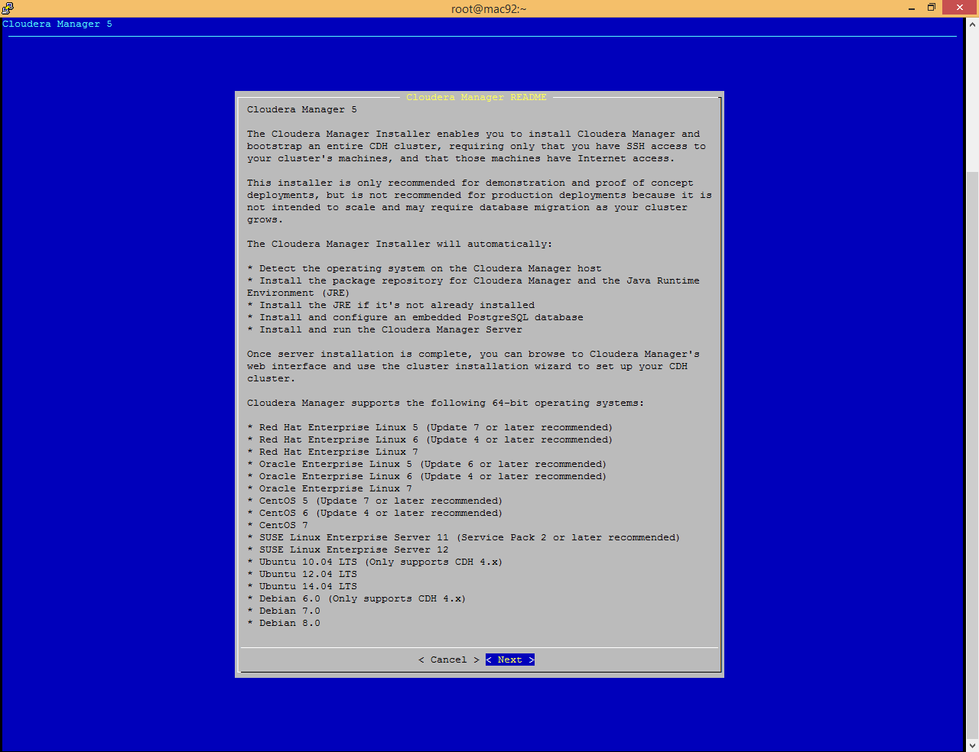

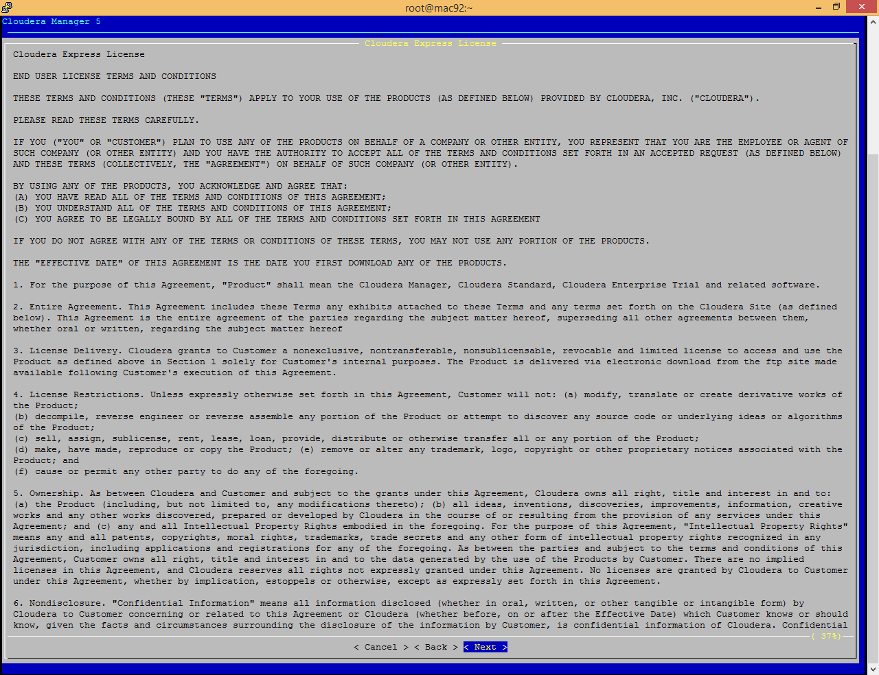

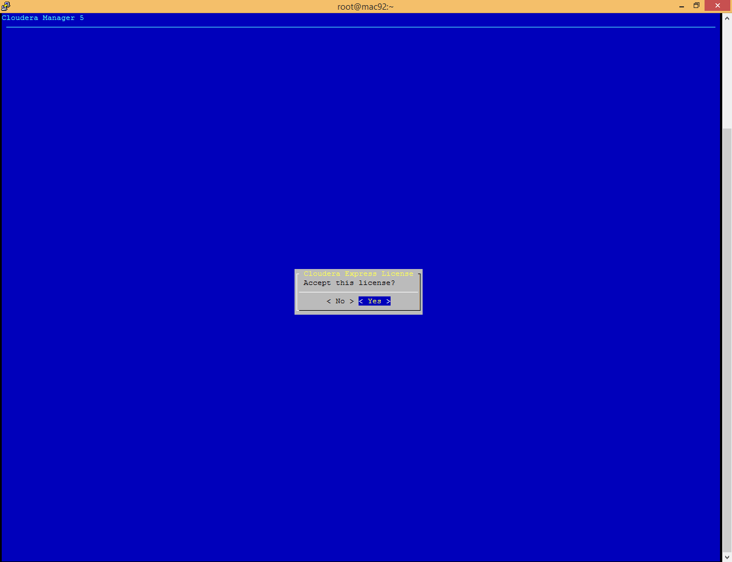

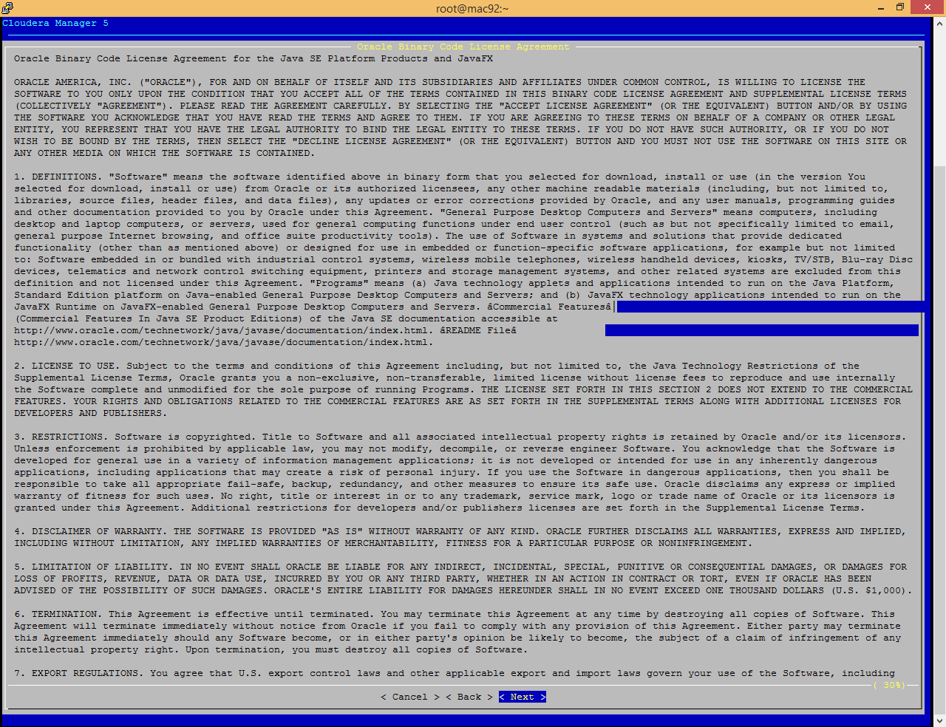

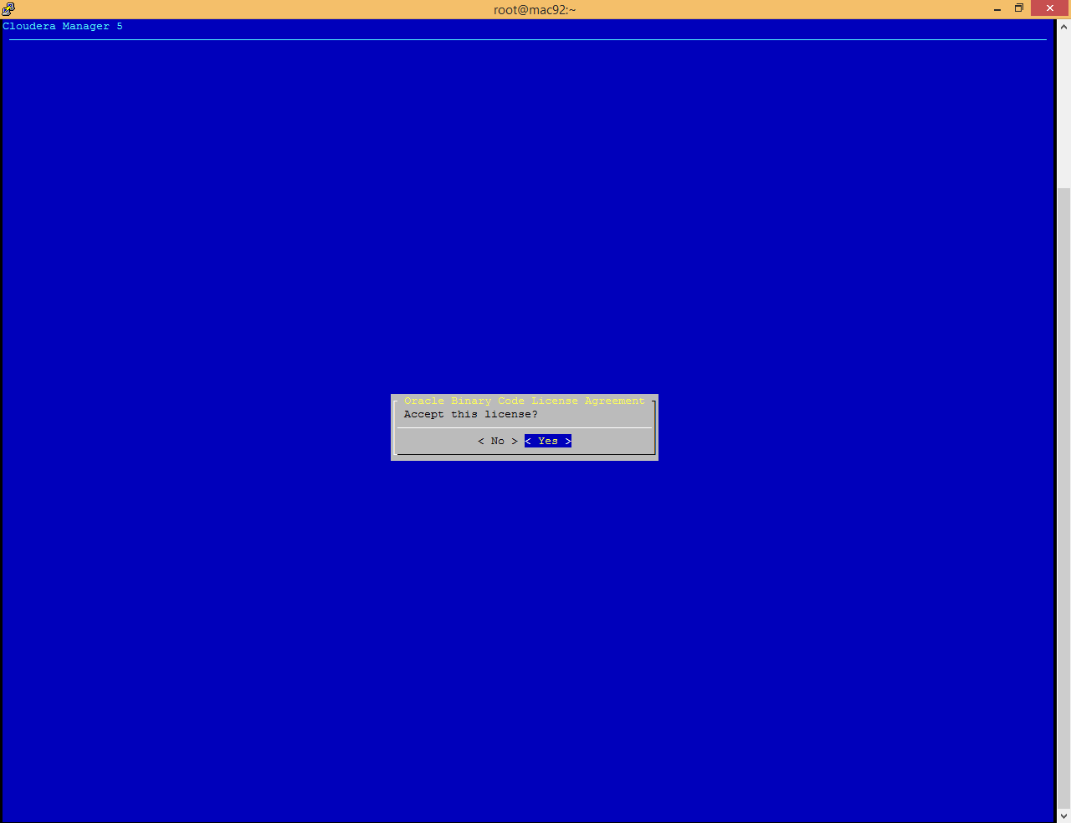

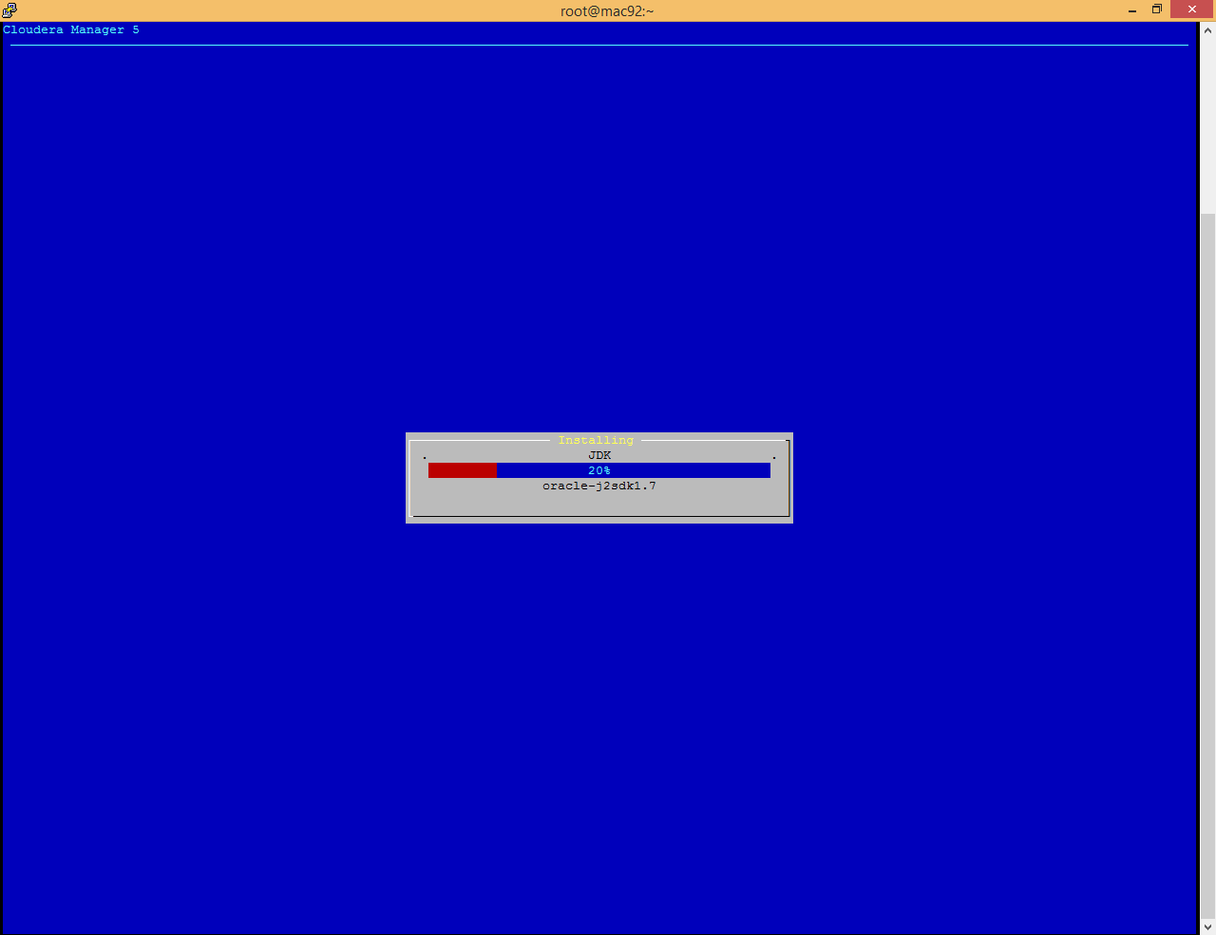

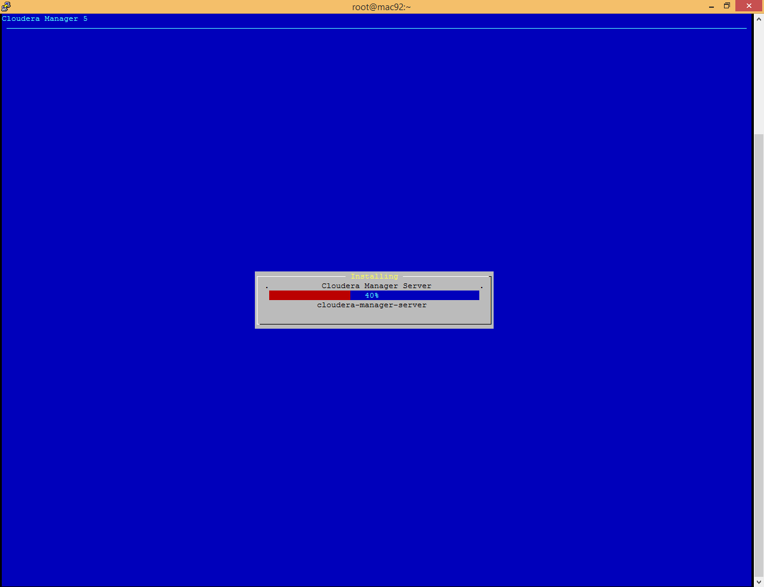

You can see the log information under **/var/log/cloudera-manager-installer**

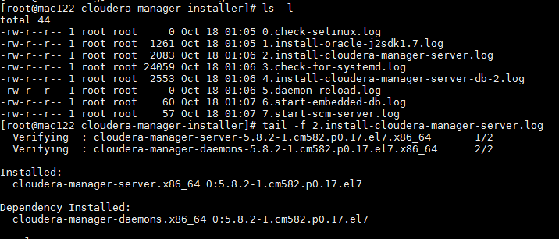

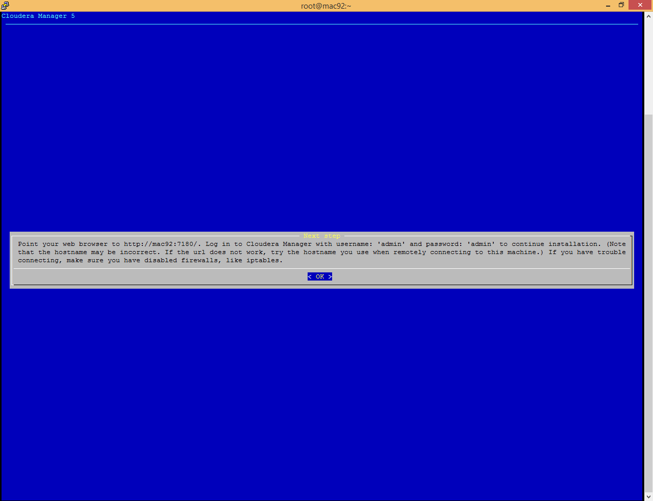

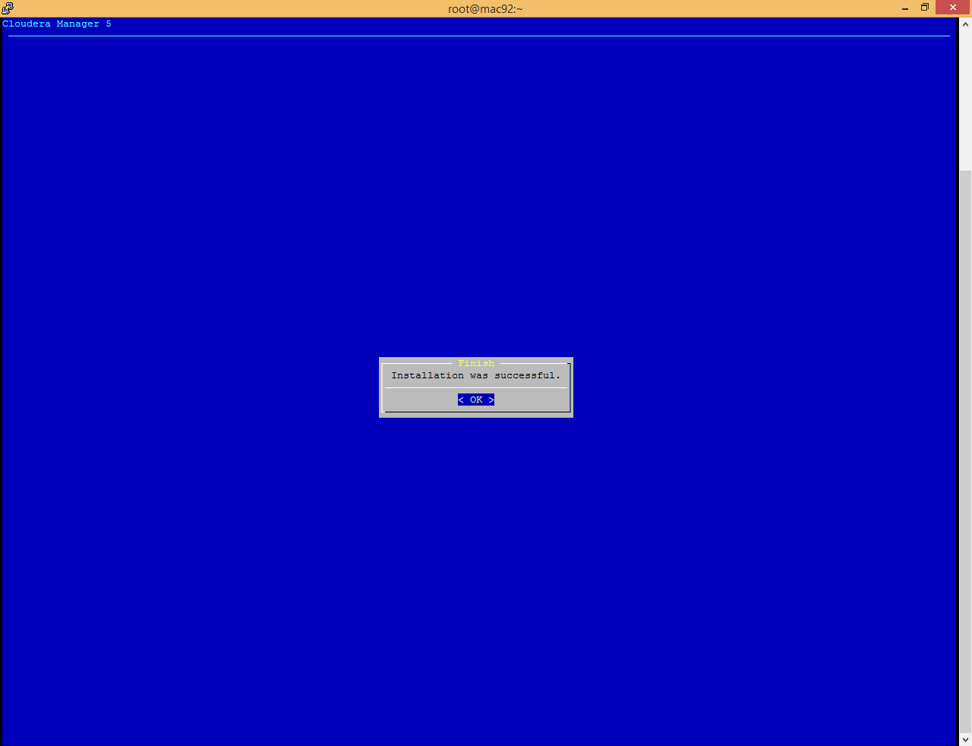

Now open <http://172.27.155.122:7180/> (http://<IP>:7180)

If facing issue while opening this page please make sure that [firewall is disabled](#_Disable_Firewall_(IPTables))

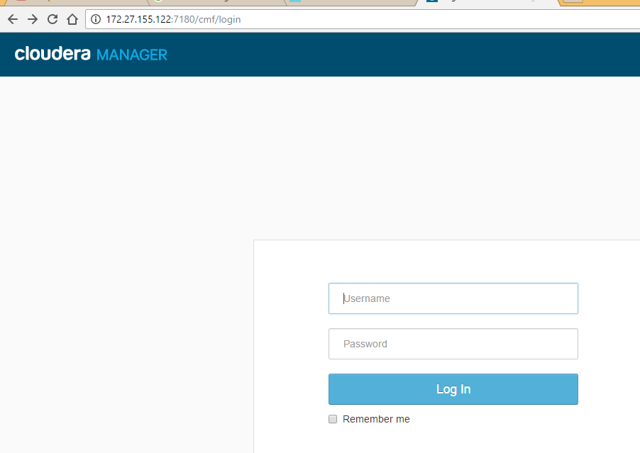

Login with admin/admin

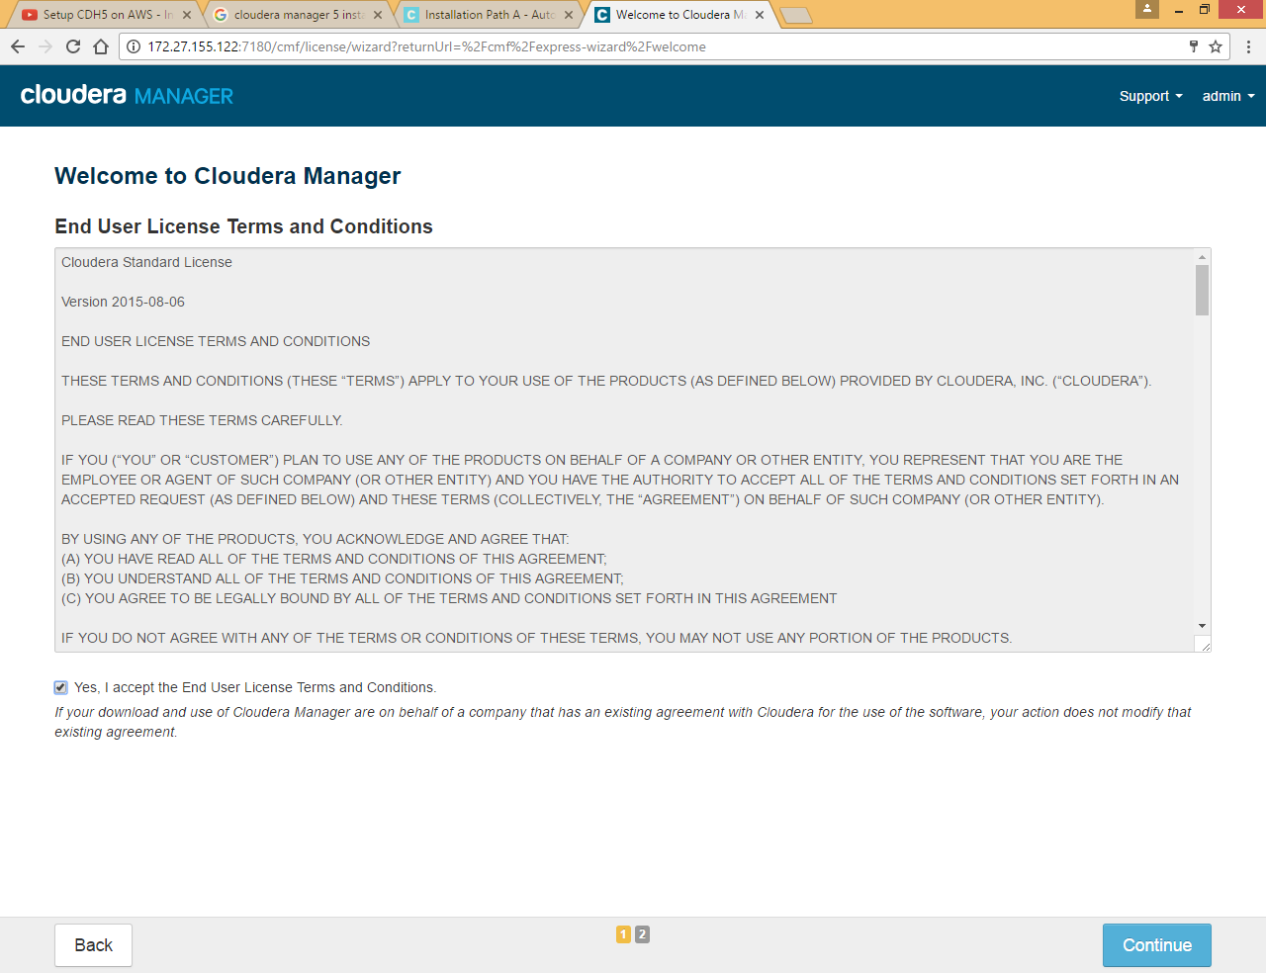

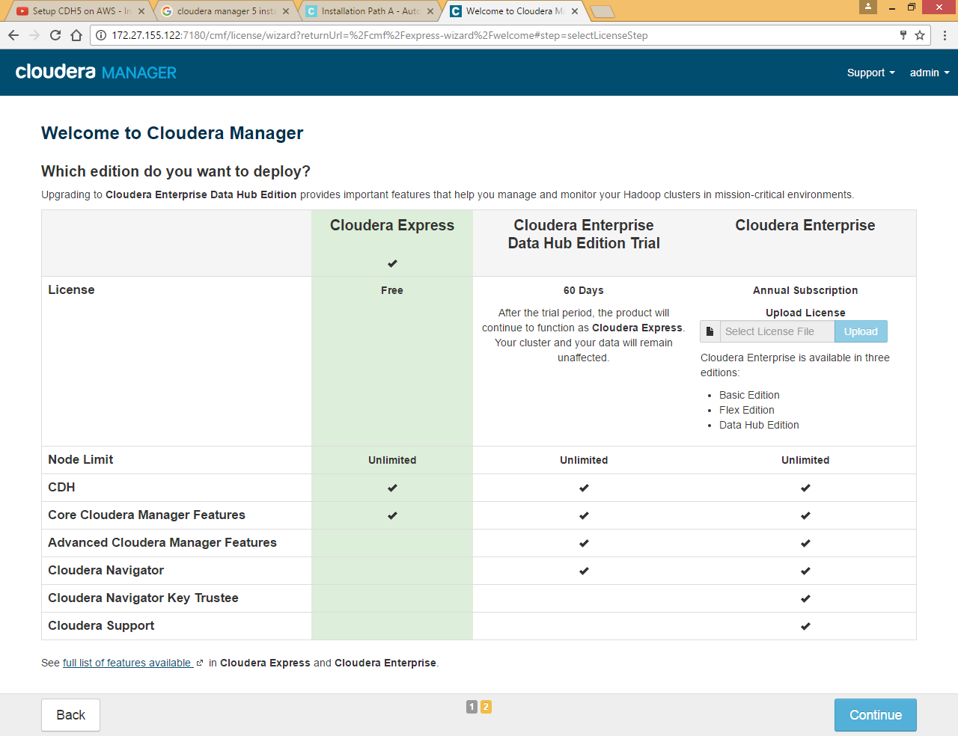

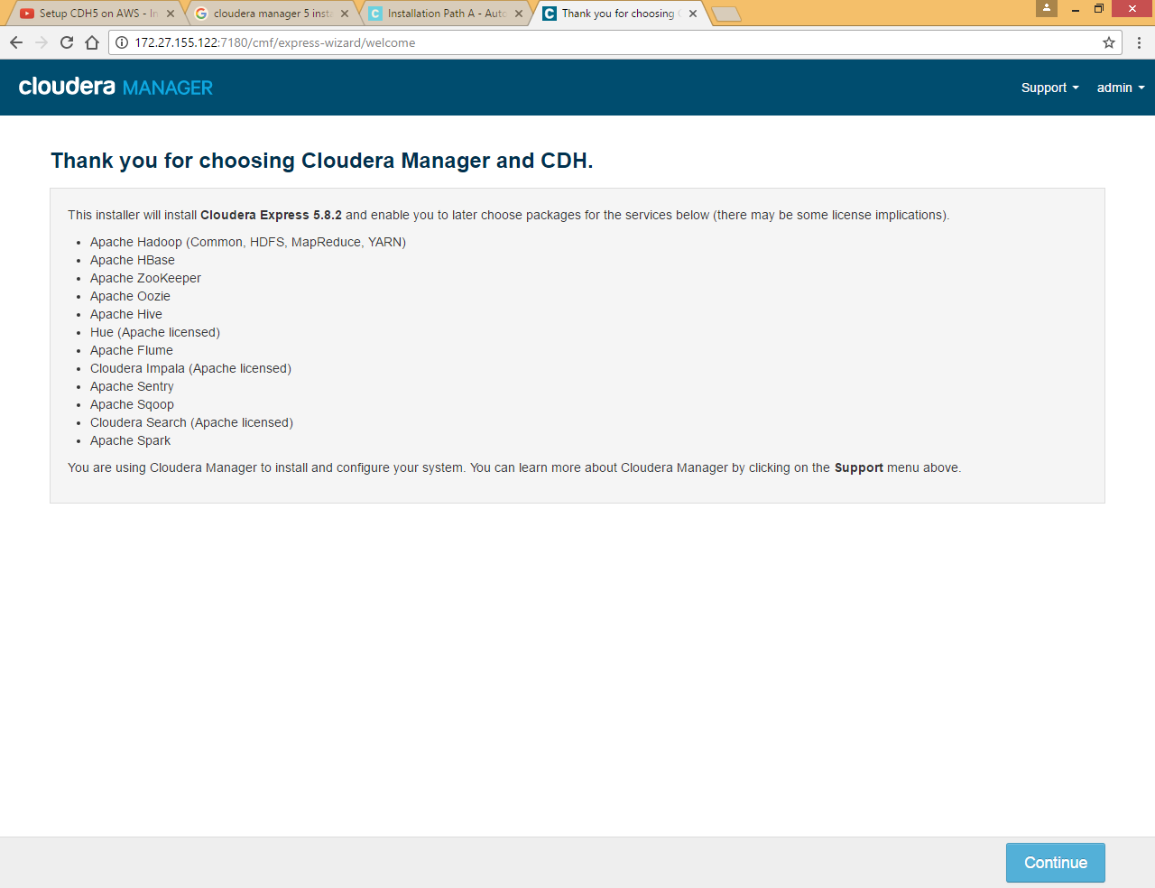

Here we are not providing all the nodes in one step we will go one node at a time, you can give all node IP separated by comma

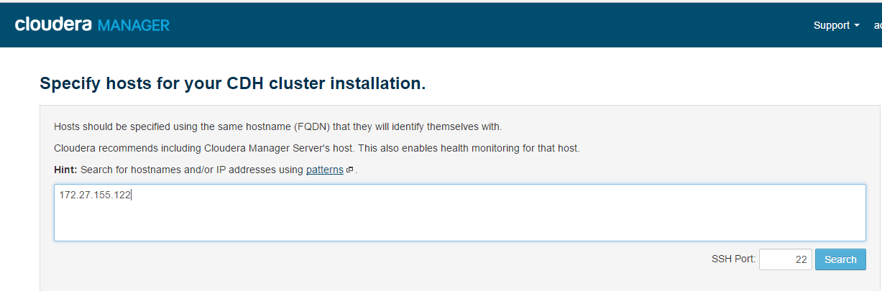

Click on Search

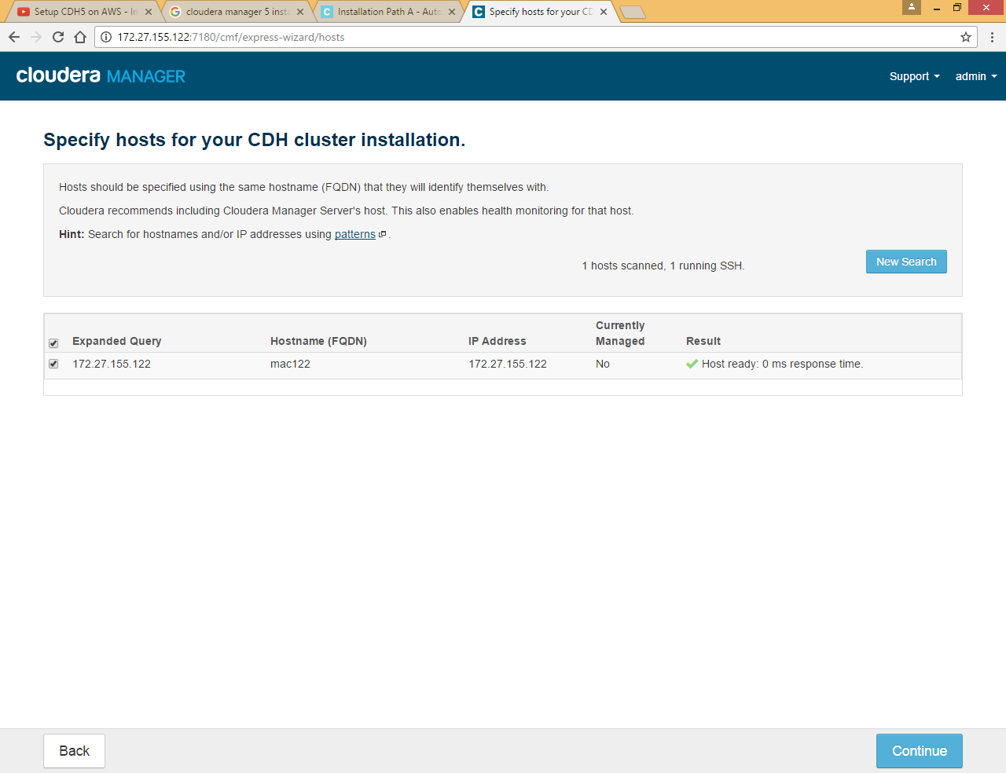

Choose Use Parcel option

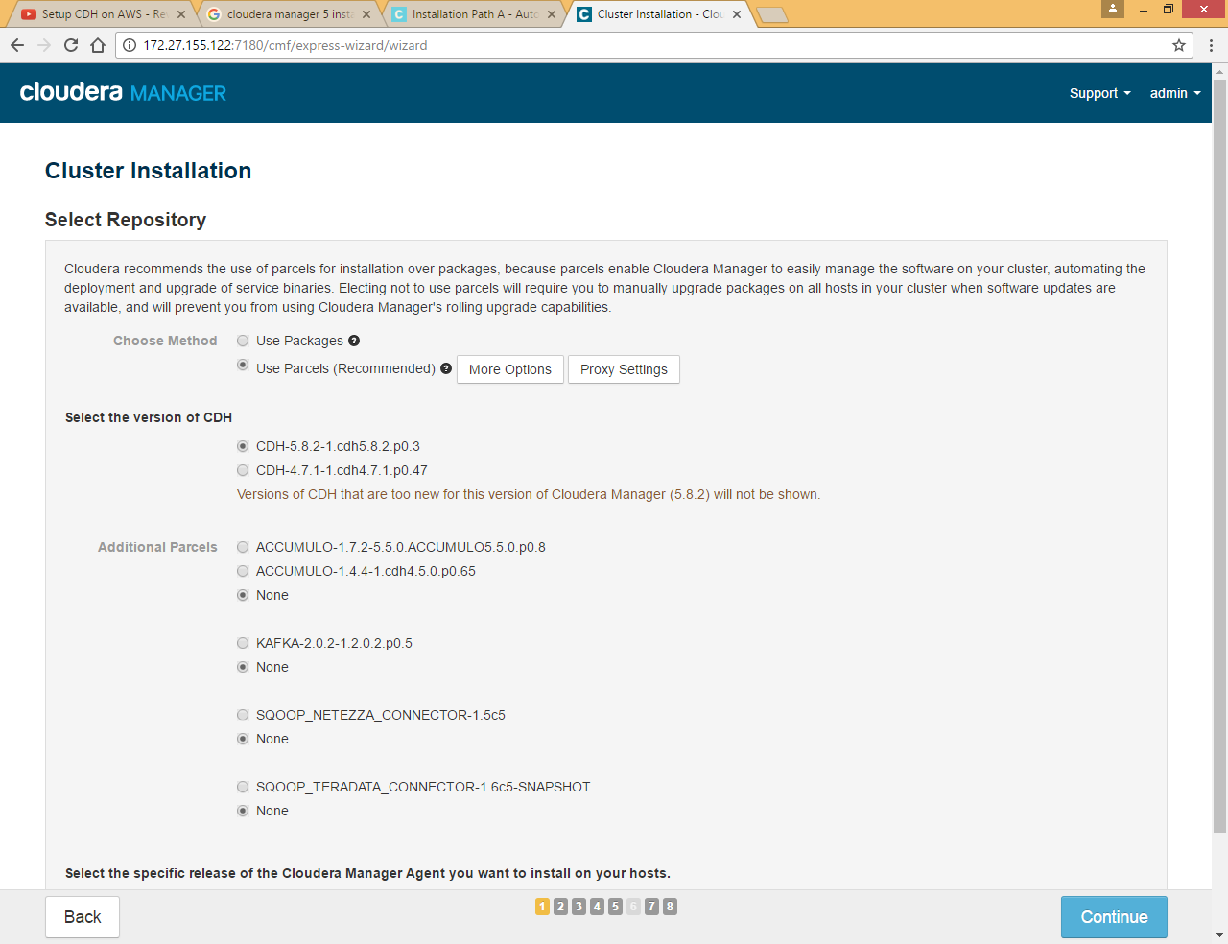

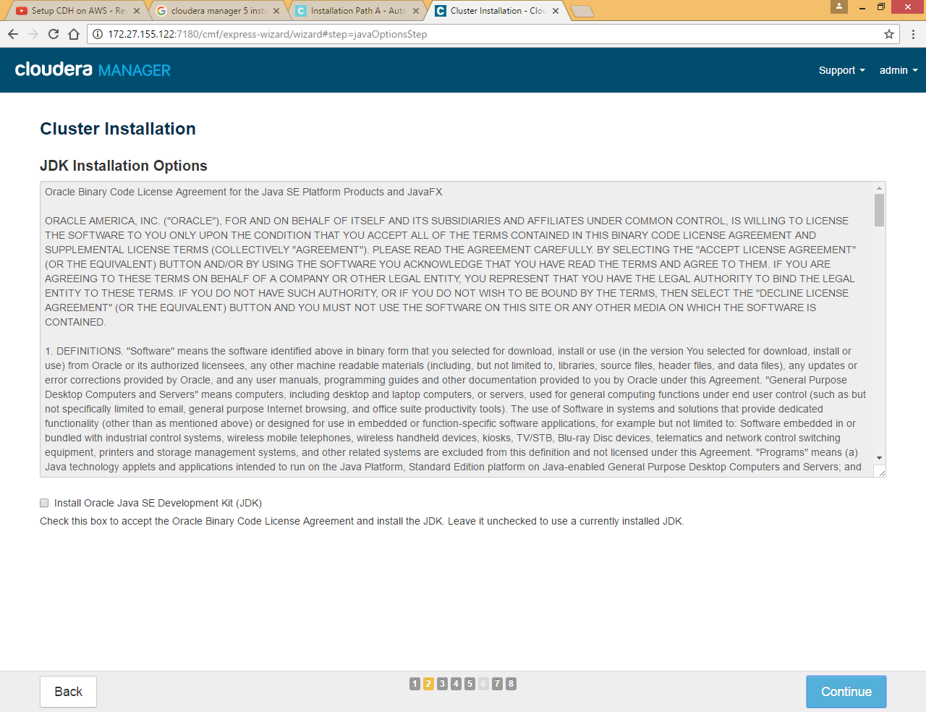

Leave JDK installation as we already have java installed

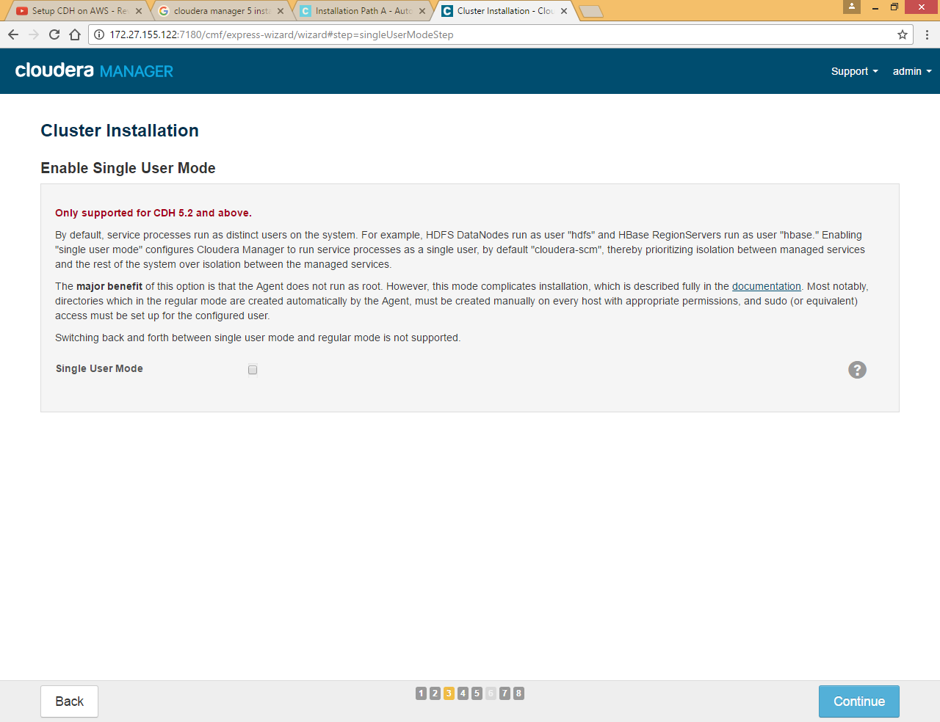

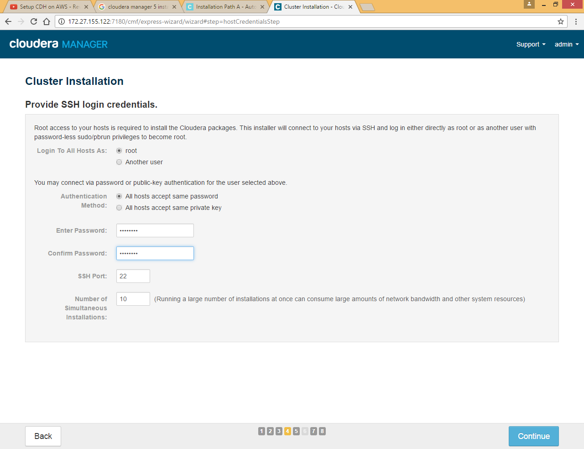

Enter password for centos machine

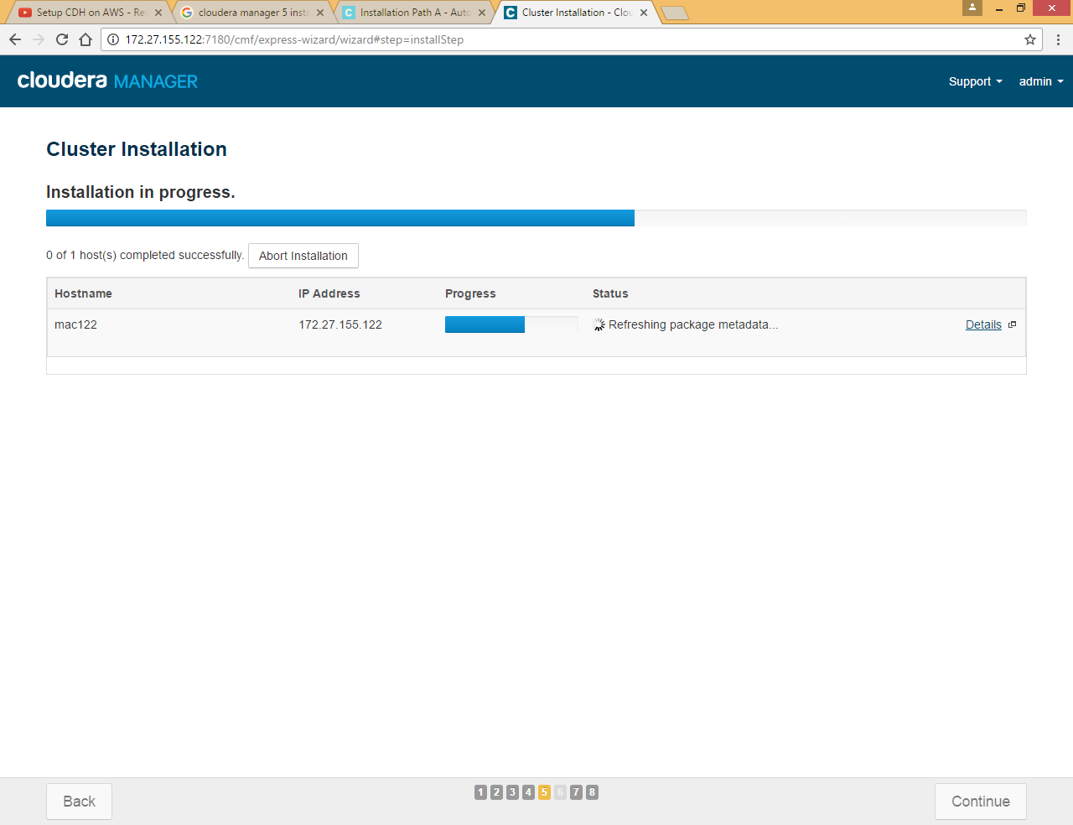

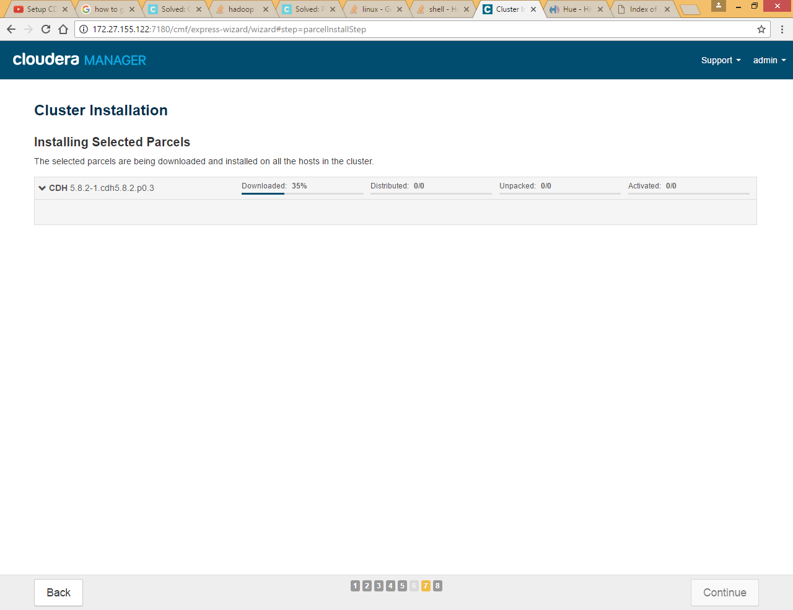

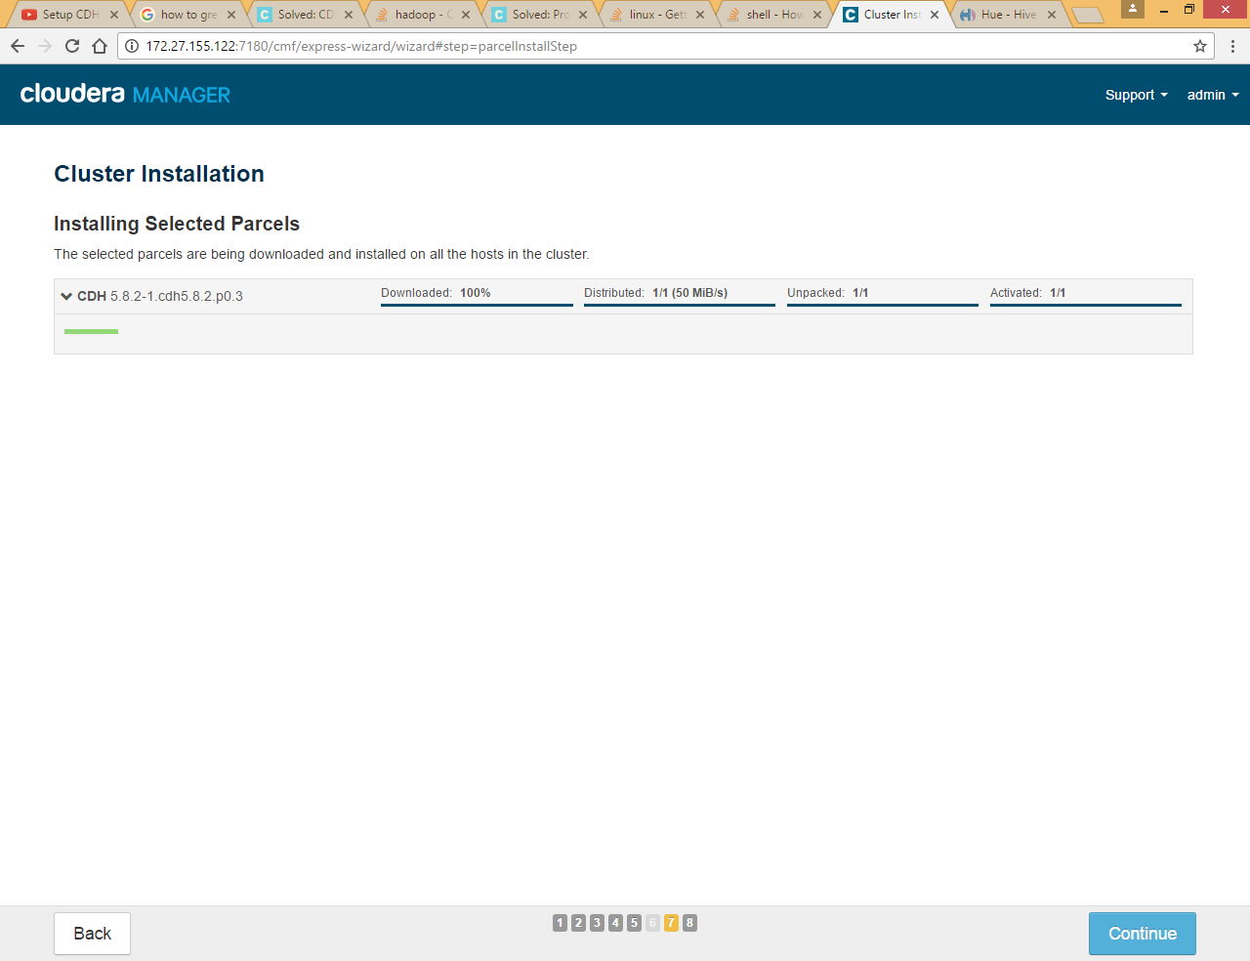

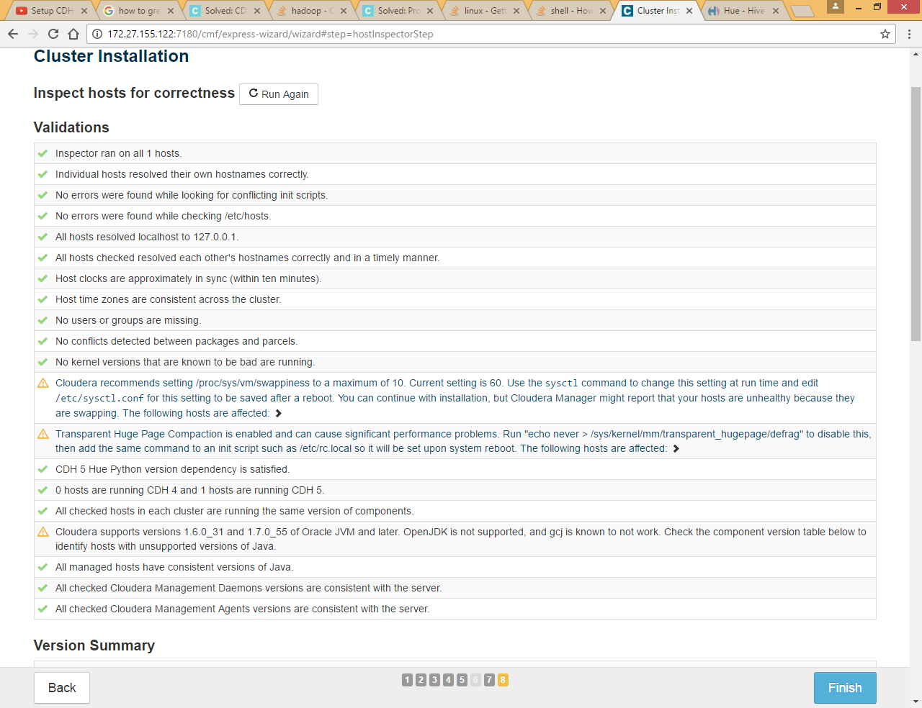

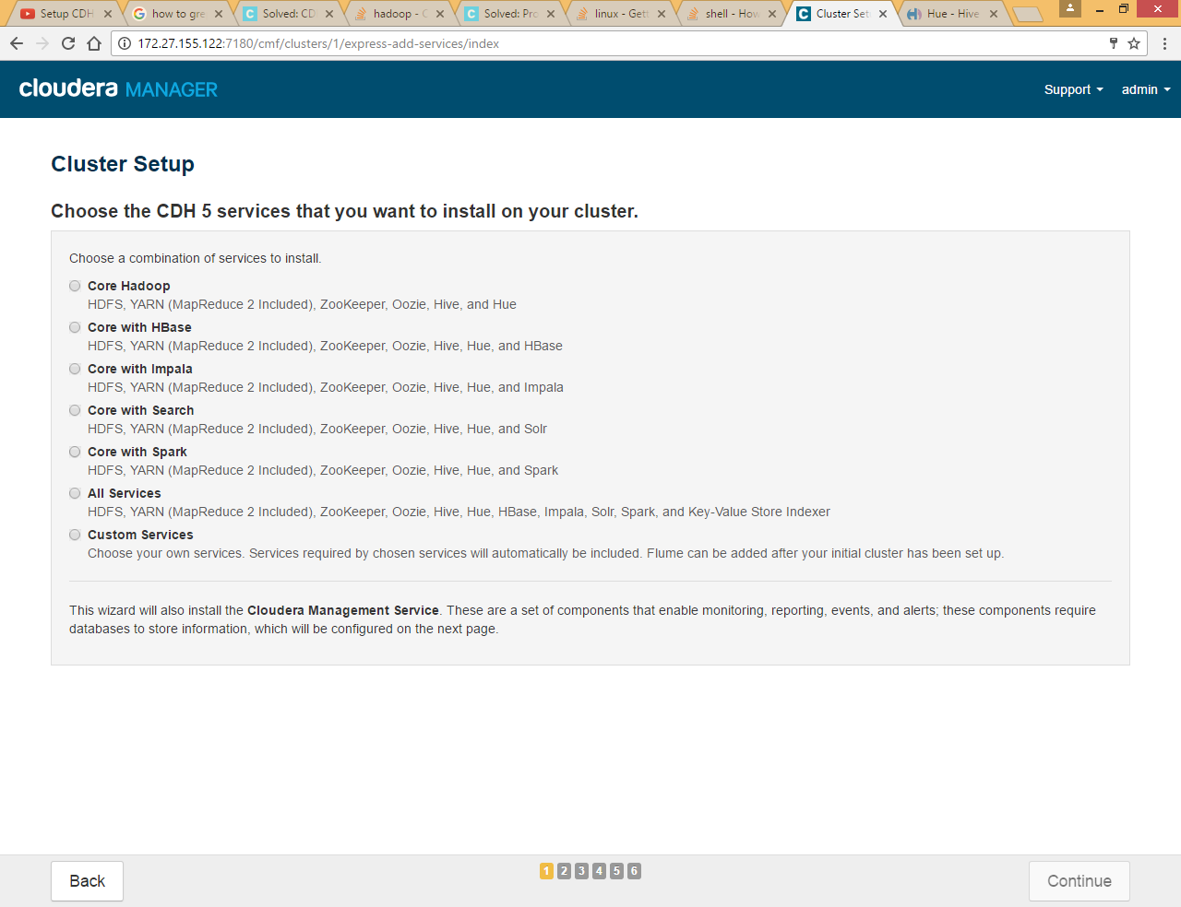

Select custom services and HDFS, we will add other services later

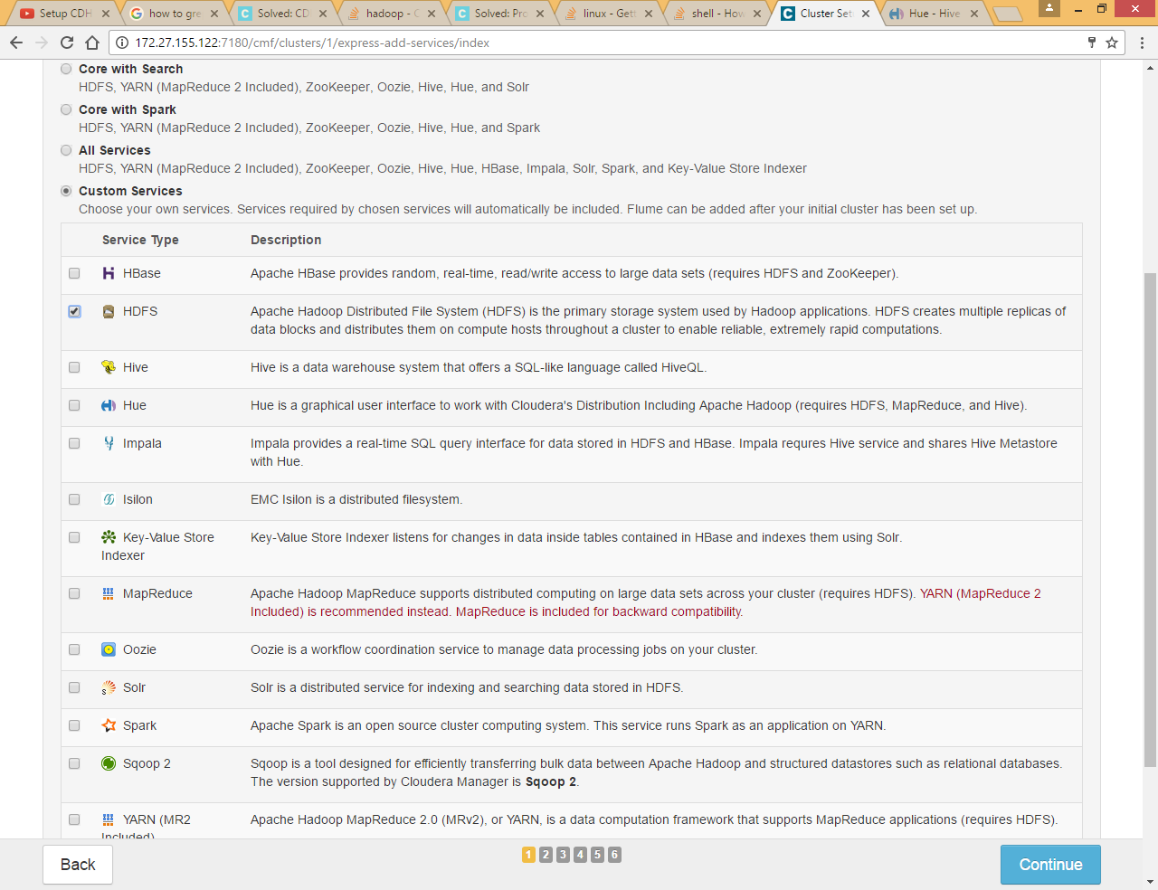

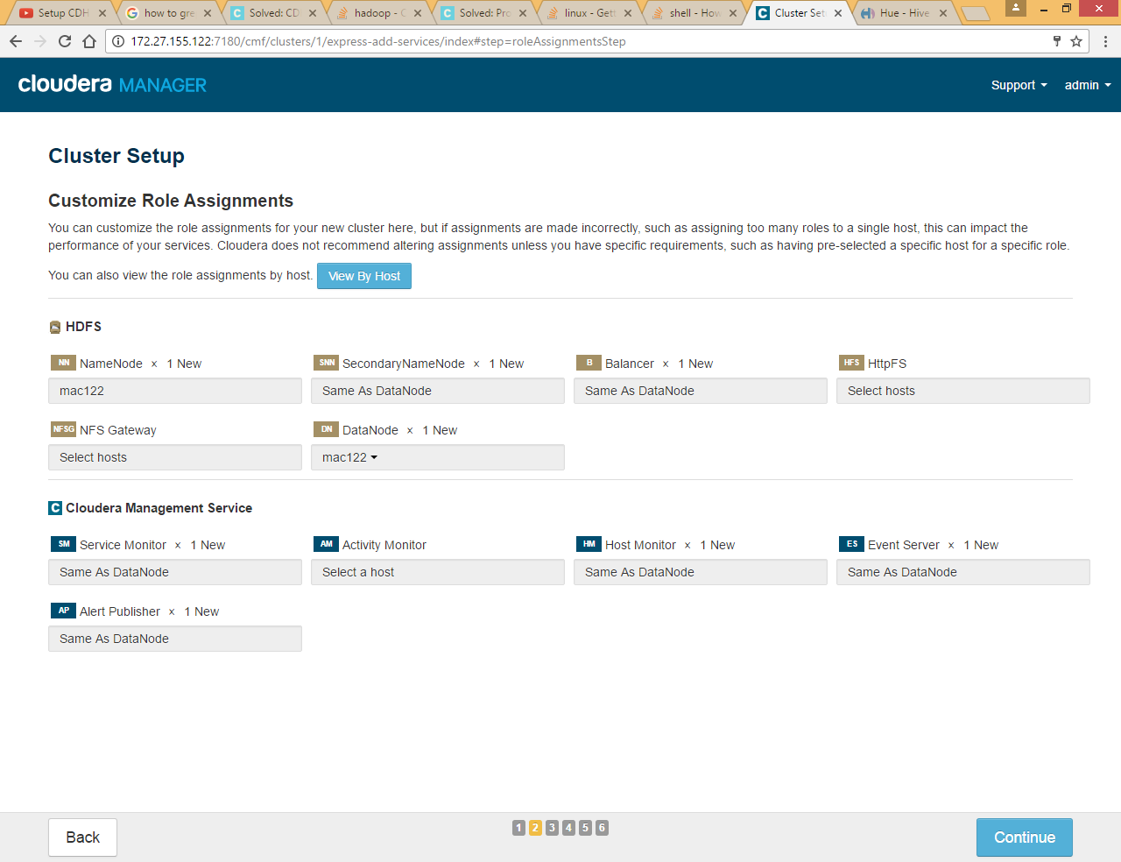

*Note: Instead of HDFS service we should install zookeeper first and later we should install HDFS so that we can choose different hosts for NameNode and Secondary Name Node so please choose zookeeper in place of HDFS service*

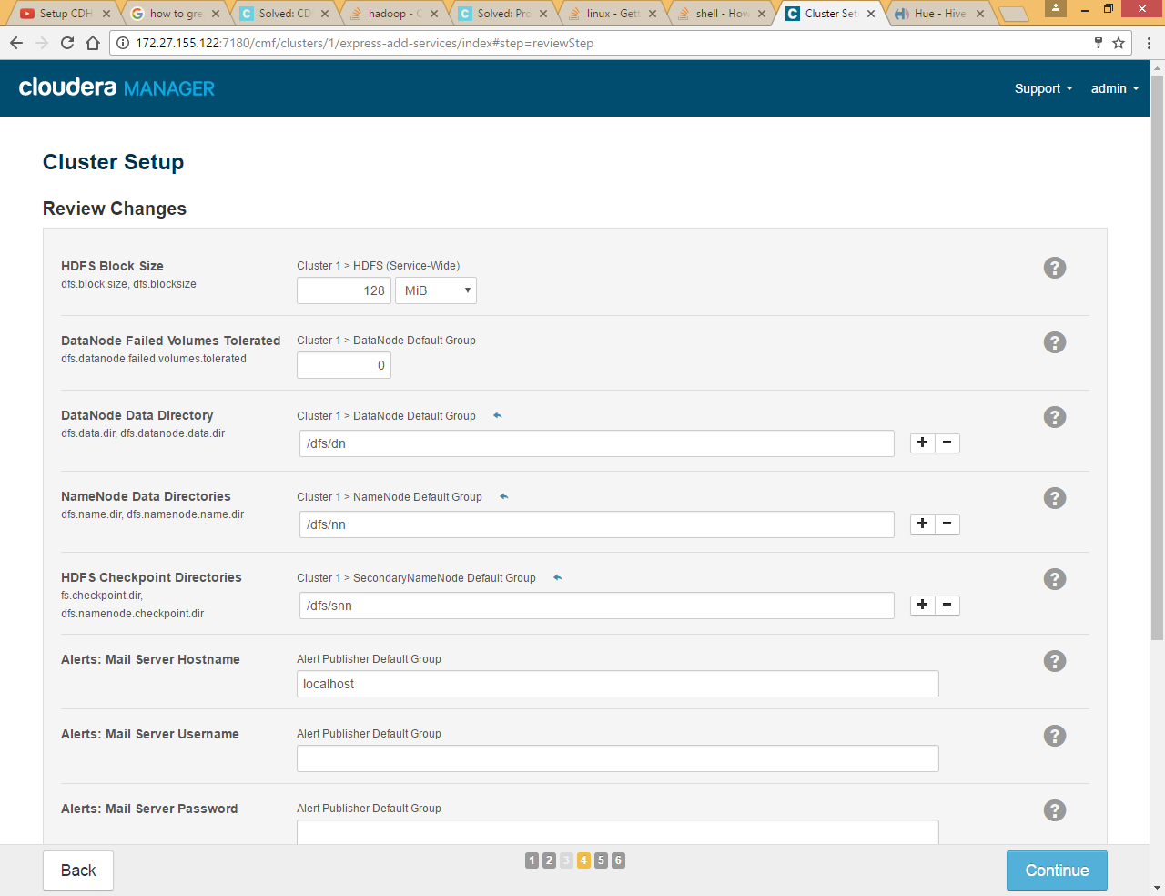

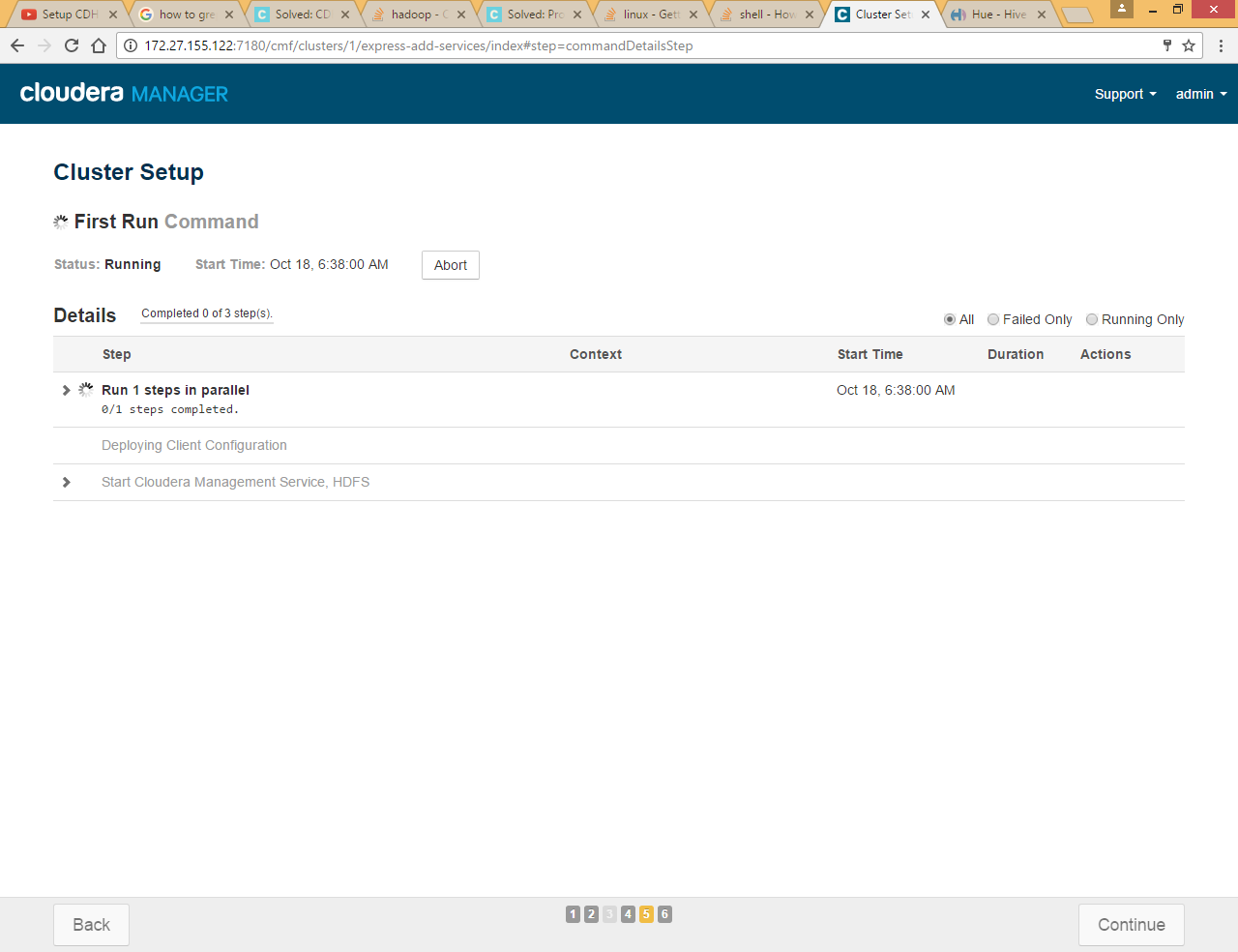

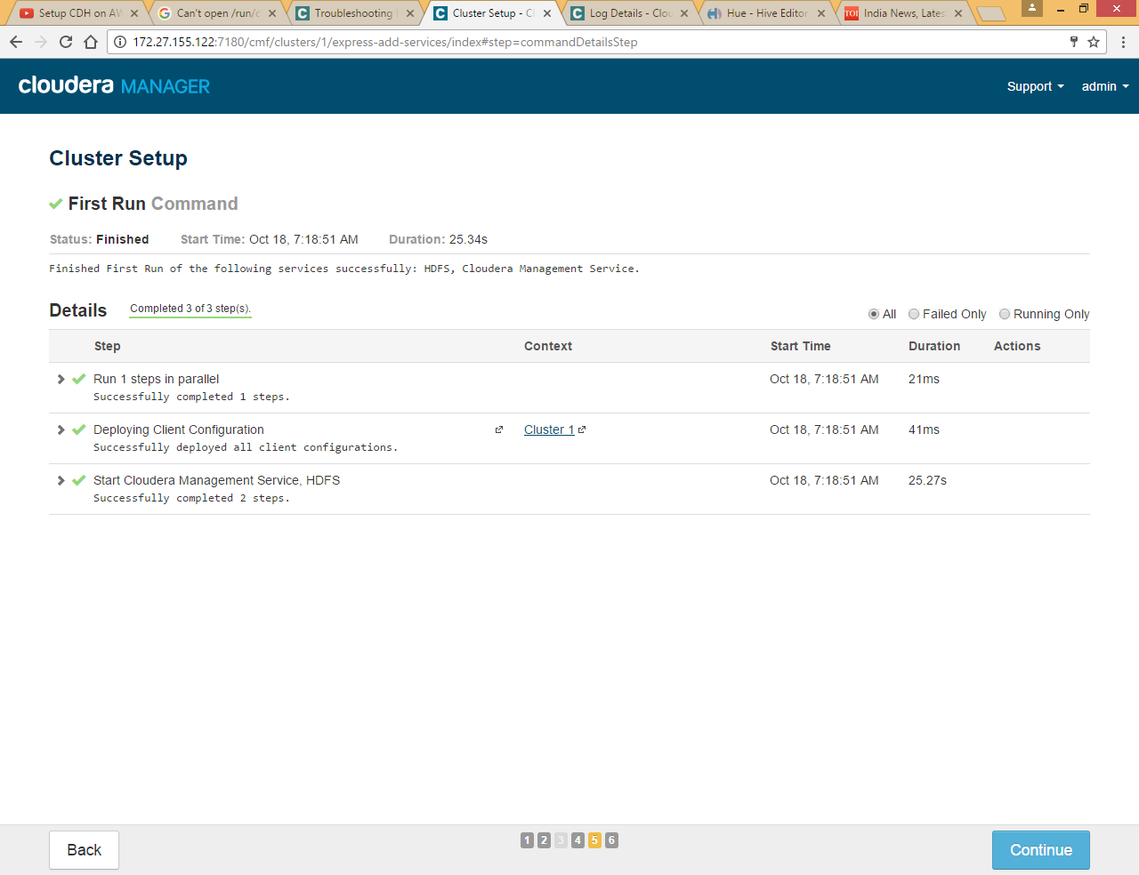

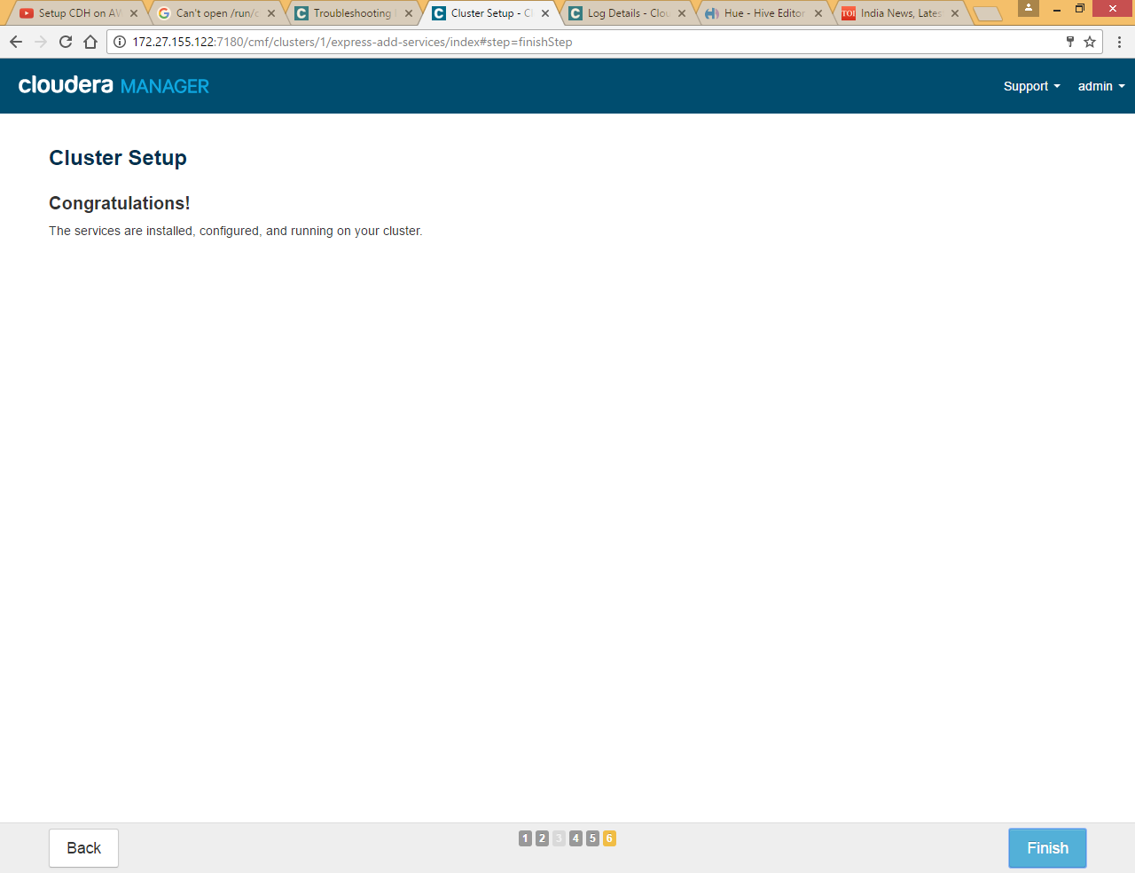

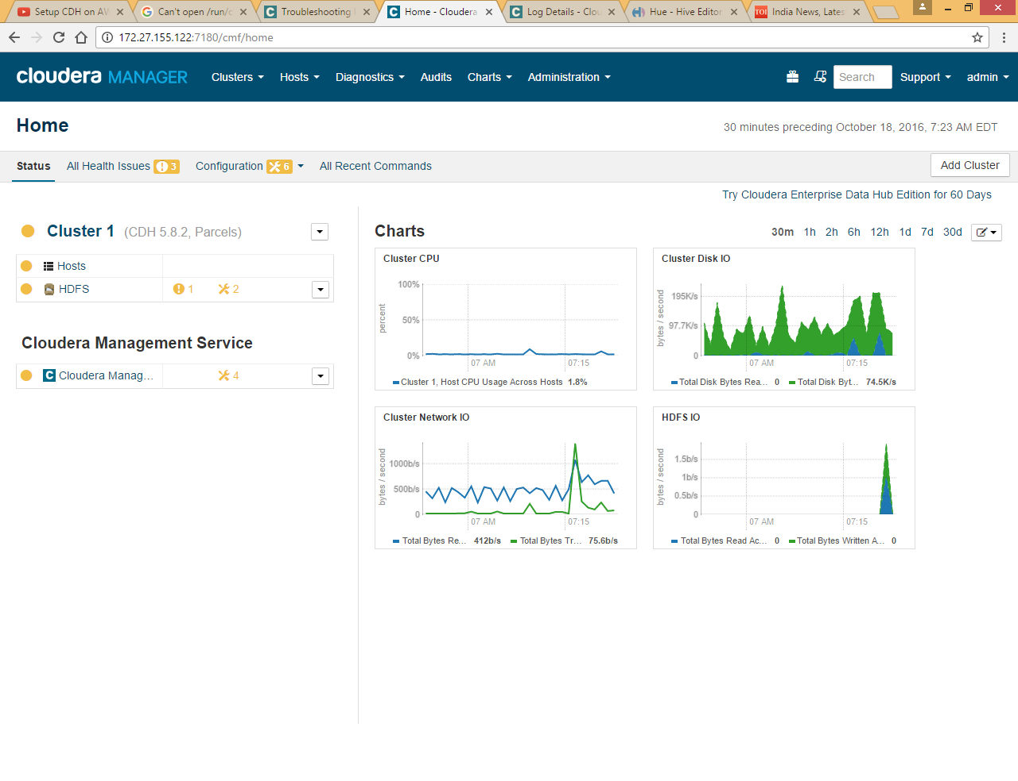

## Add hosts to cluster

Click on Hosts>> All Hosts

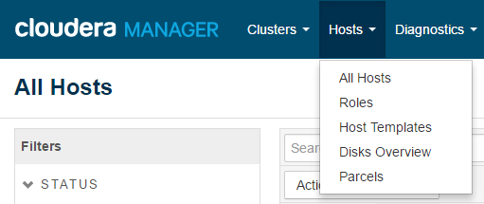

Click on Add New Hosts to Cluster



Again all steps will be almost same like we did for 172.27.155.122 machine installation

Again we are adding host one by one, you can do it at once by using comma separated machine IPs

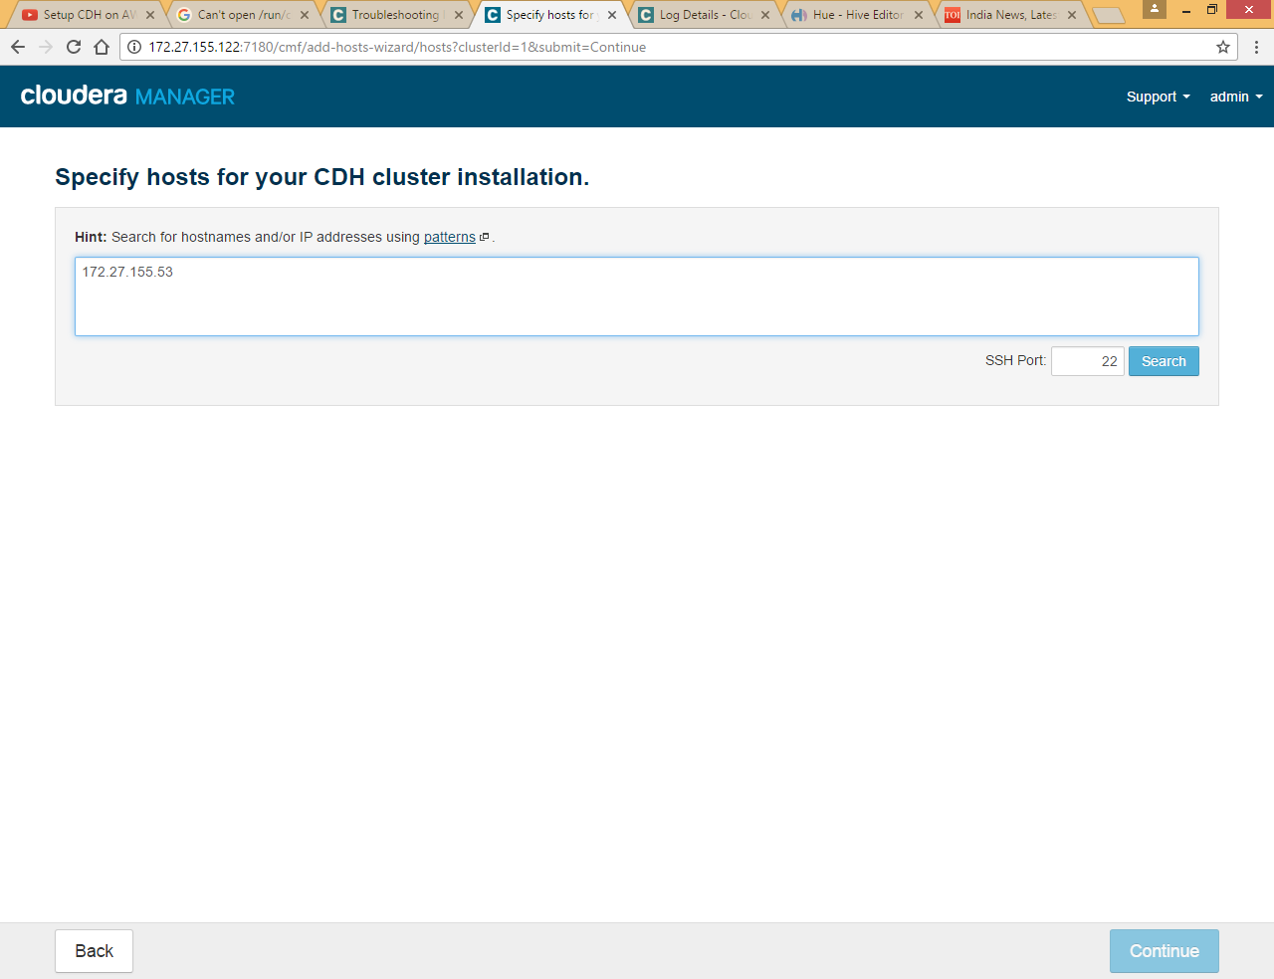

Enter IP and Click search

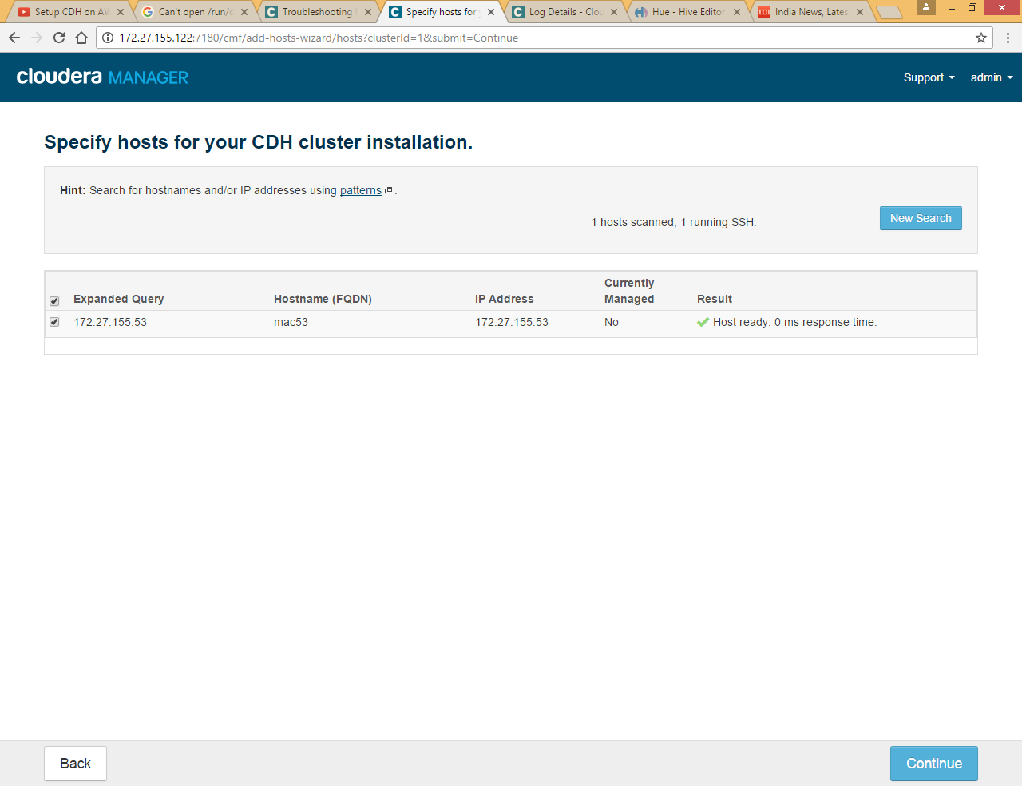

Click Continue

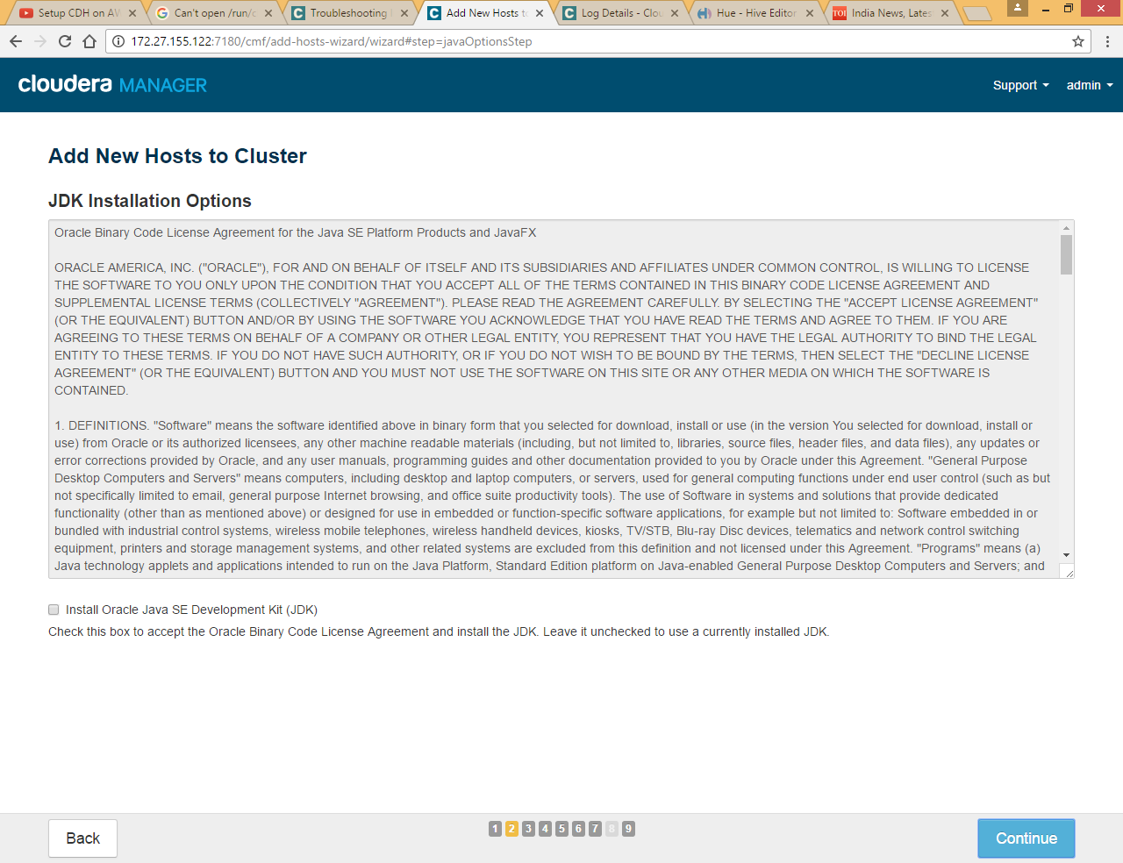

Leave Java installation since we already have java installed on machine

Click Continue

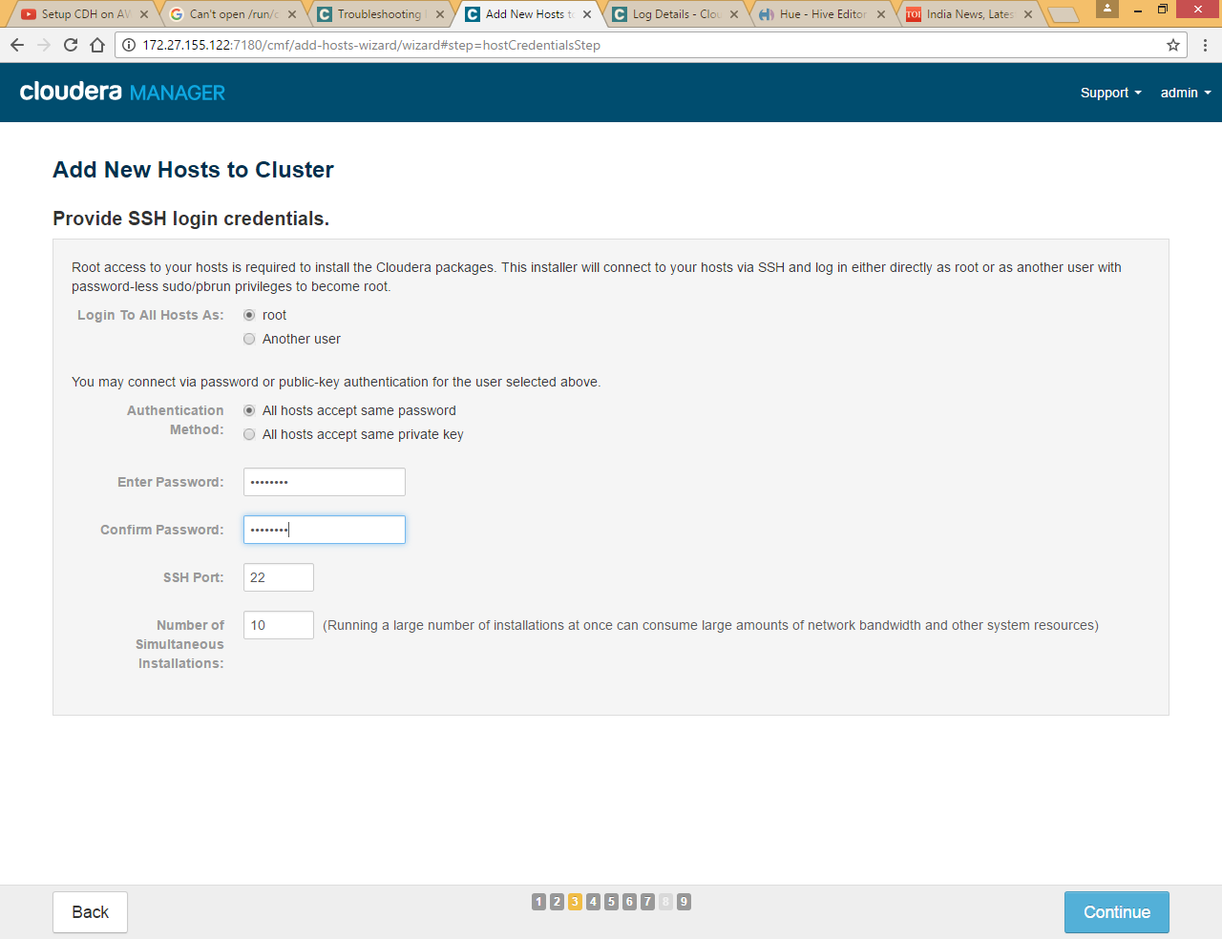

Provide machine password for root

Else If you established SSH password less sudo Access , choose id_rsa file as private key

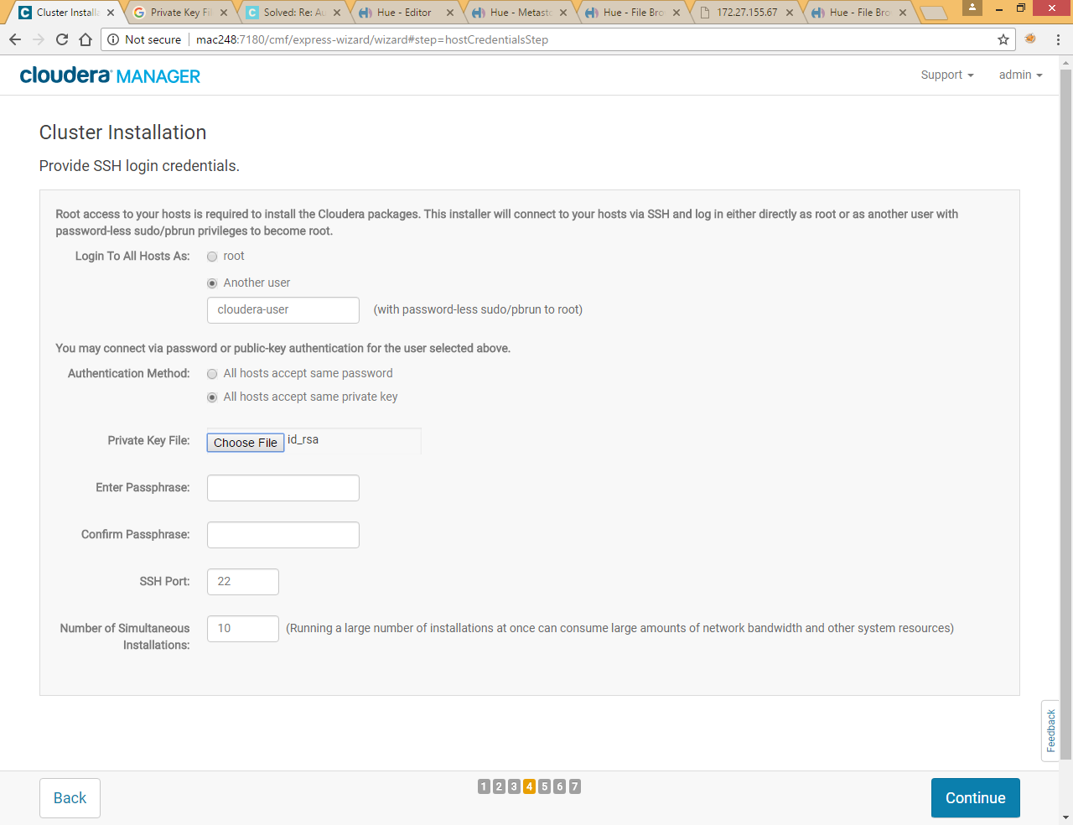

Click Continue

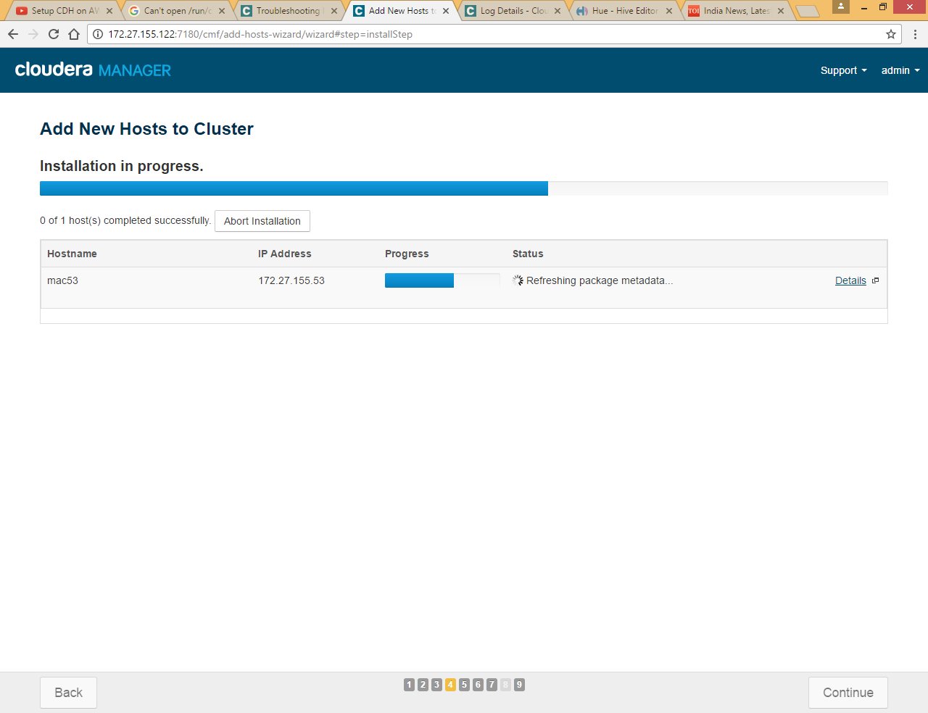

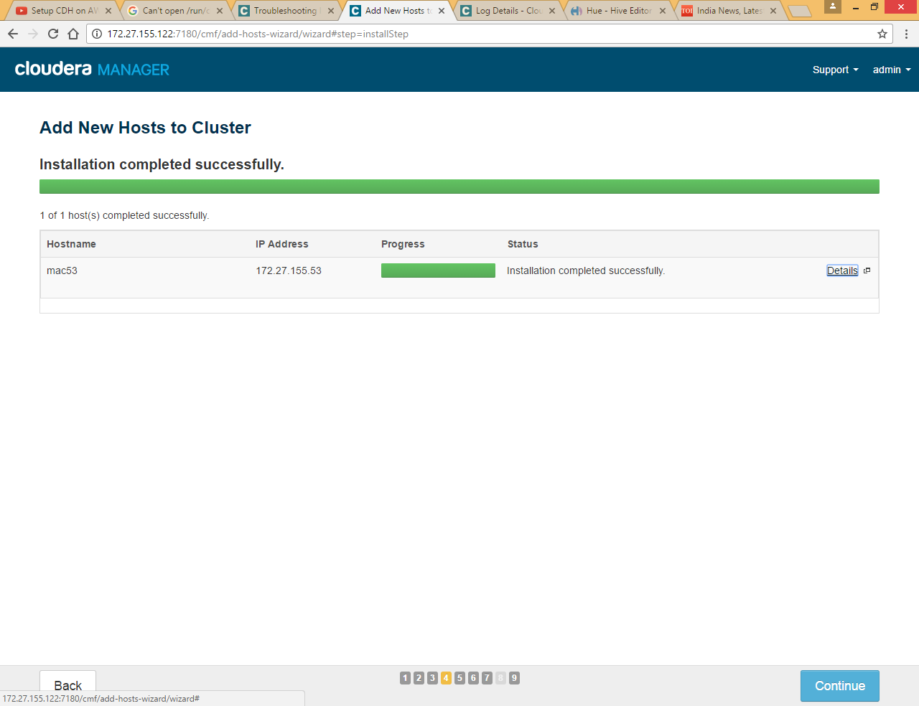

Click Continue

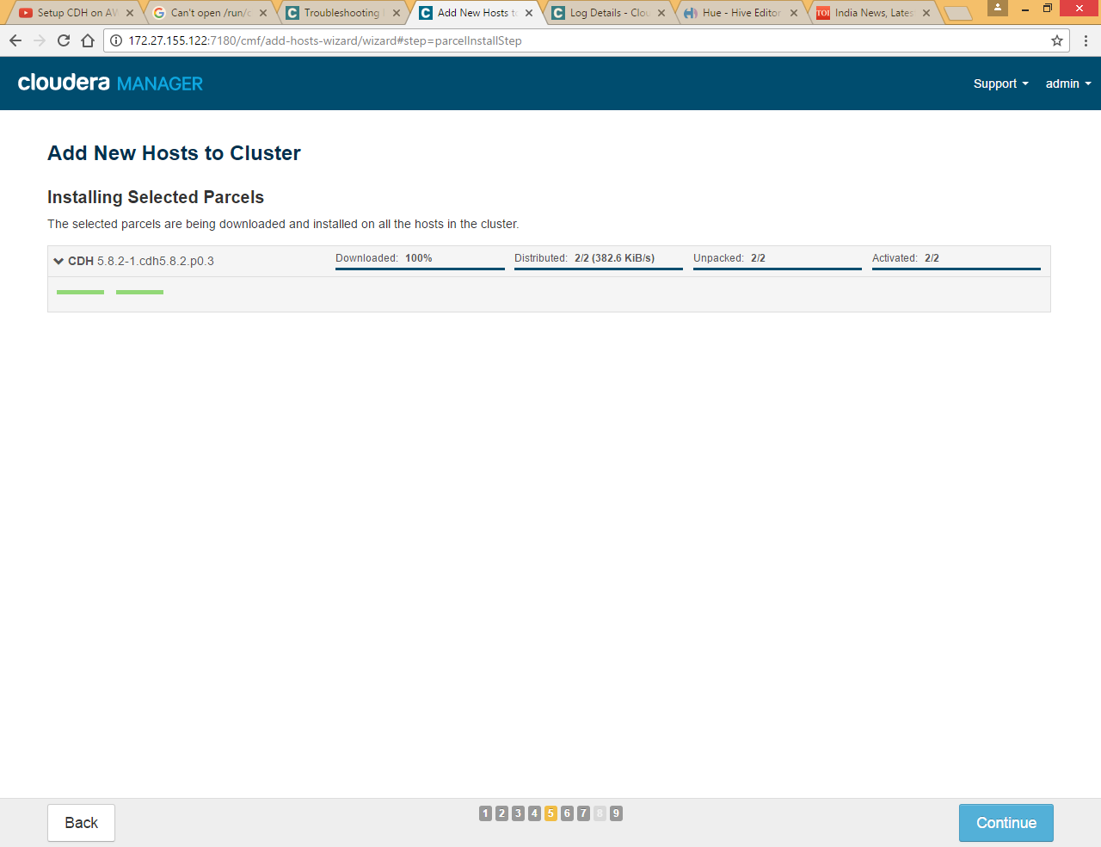

Click Continue

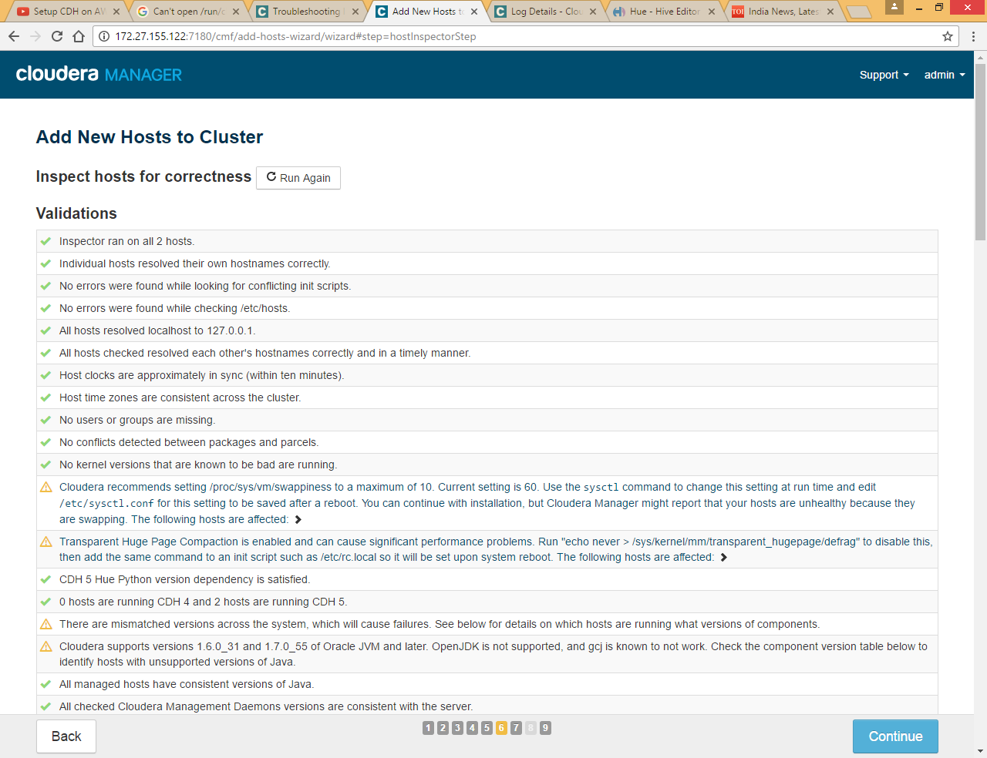

Click Continue

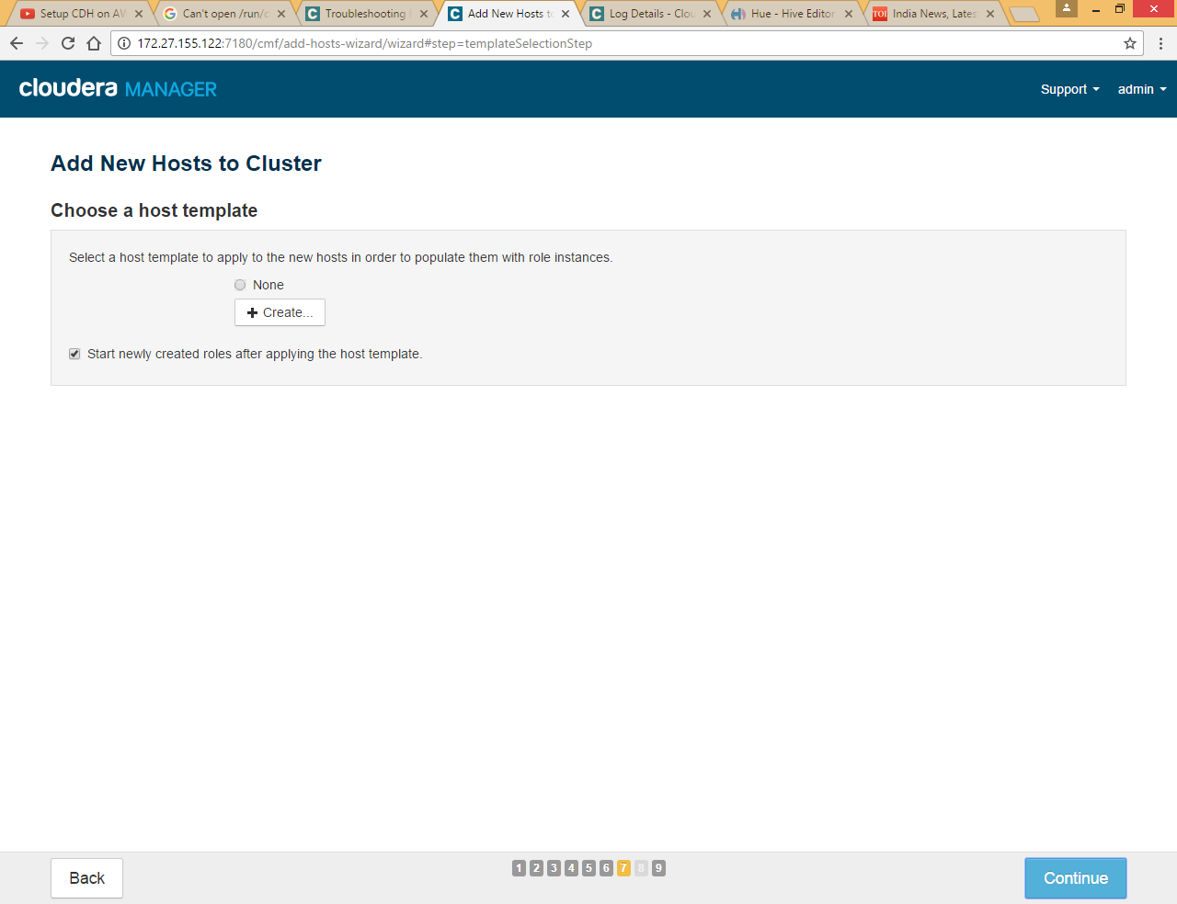

Click Continue

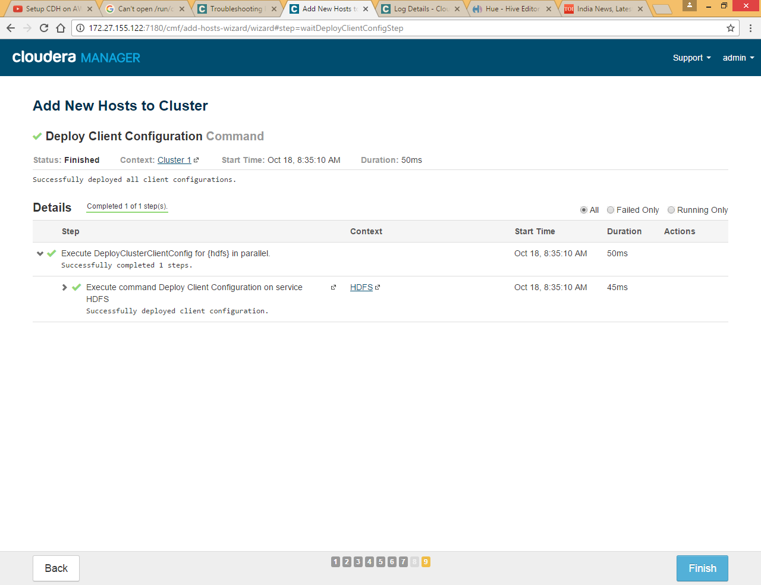

Click finish

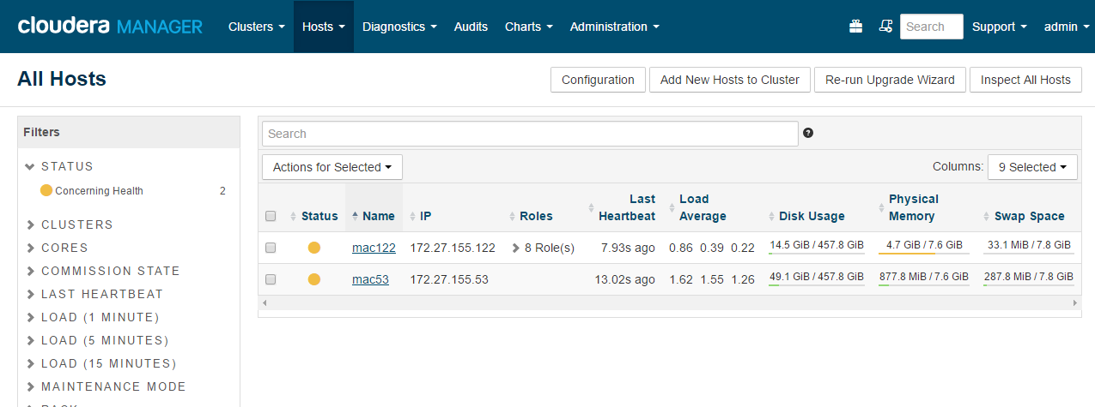

Same way we can add all nodes to cluster

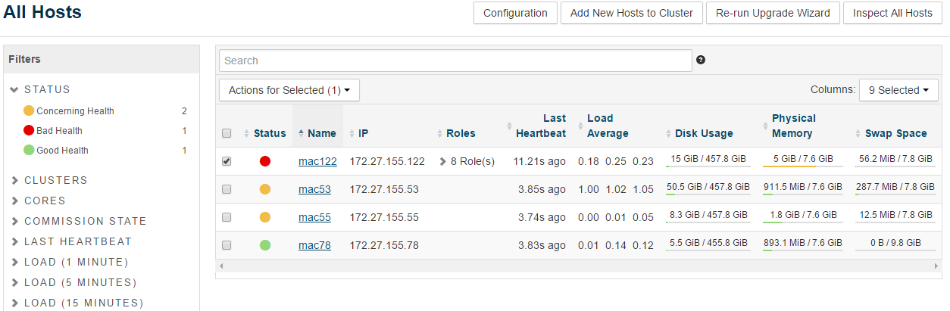

## Add Role Instance

### HDFS Service

As we already installed HDFS service we are going to delete this service here and will add it again for all 4 nodes so that we can allocate different hosts for Name Node and Secondary Name Node

First stop HDFS service and then delete it

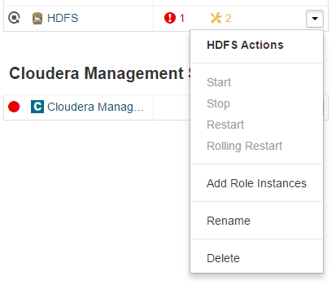

Now again add HDFS service

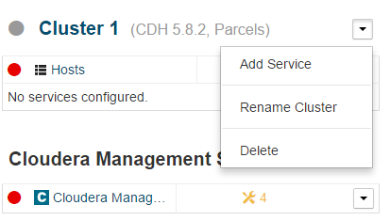

Click Add Service

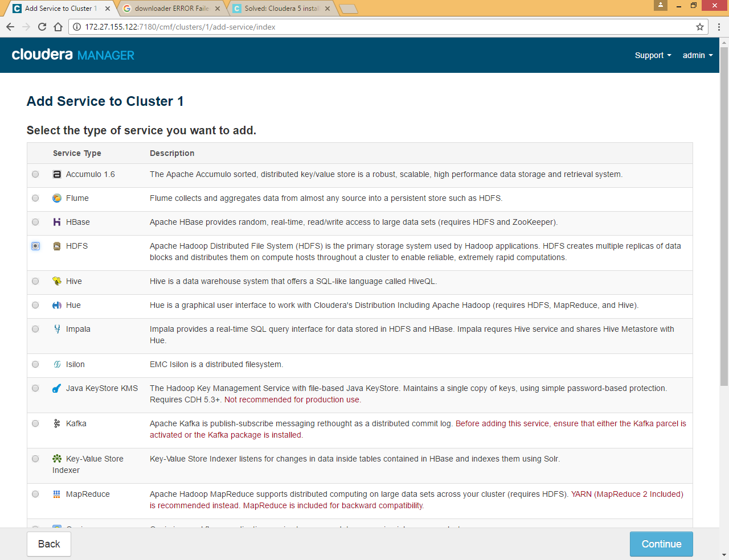

Select HDFS

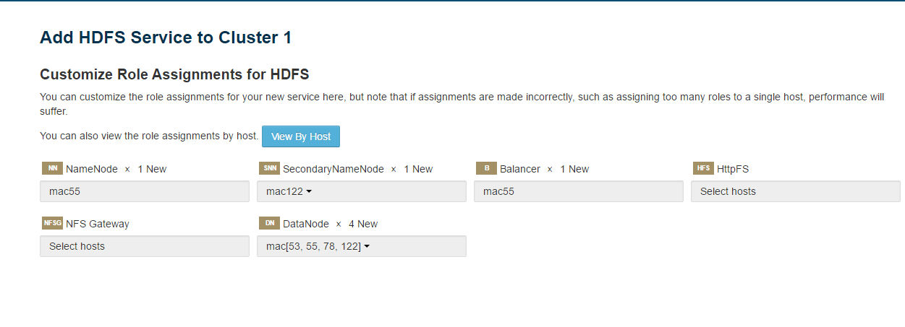

Here we are selecting as per below table

|  |  |
| --- | --- |
| **Service** | **Host** |
| Name Node | Mac55 |
| Secondary name node | Mac122 |
| Balancer | Mac55 |
| Data Node | All four hosts (mac53,mac55,mac78 and mac 122) |

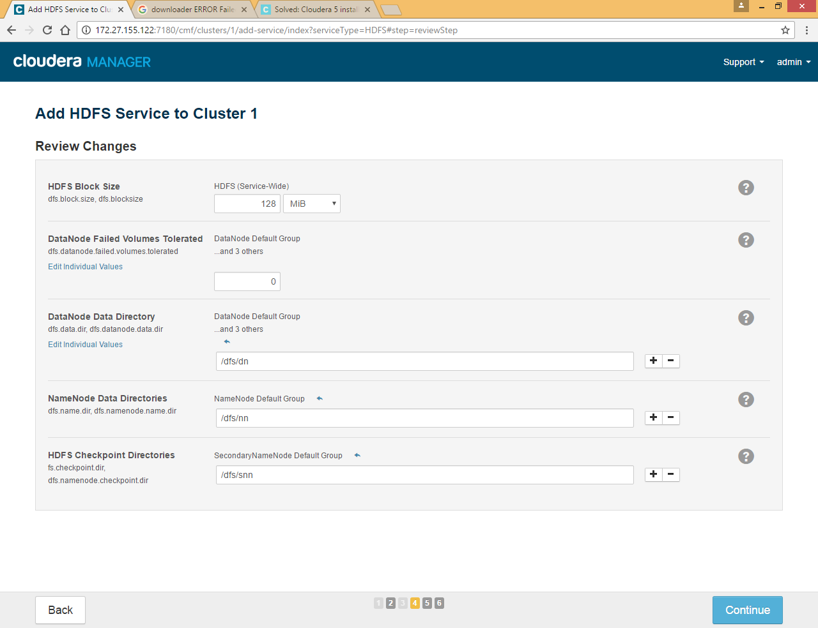

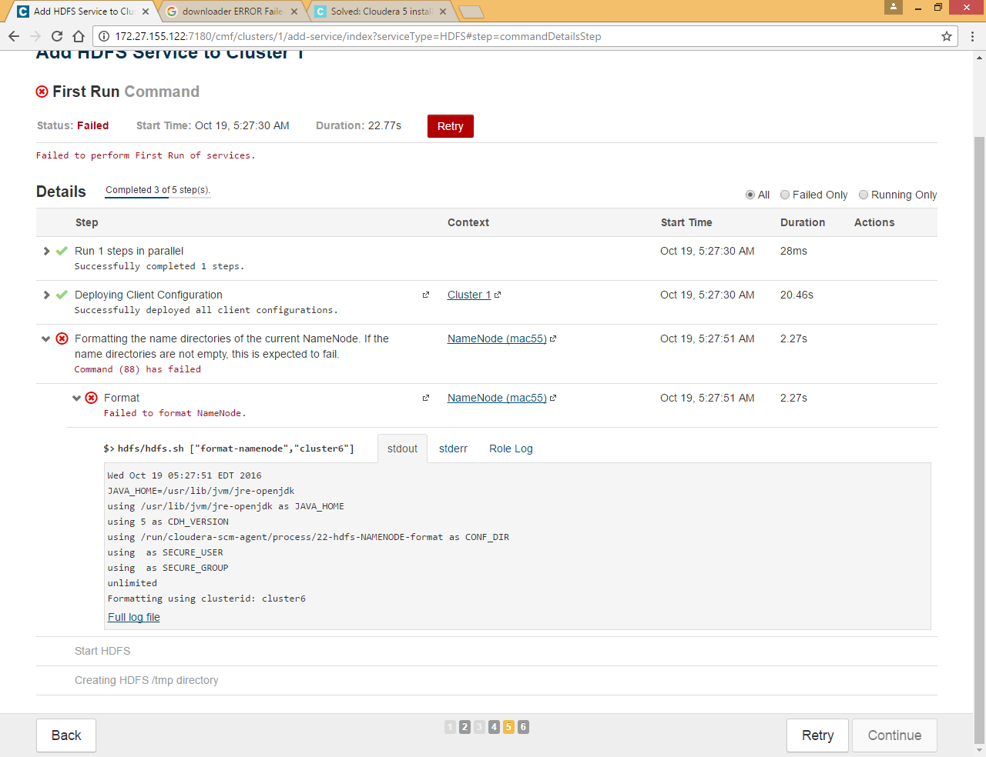

Make sure you delete all the files under **/dfs/dn** , **/dfs/nn** and **/dfs/snn** directory from all nodes

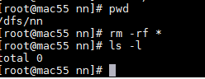

Retry again

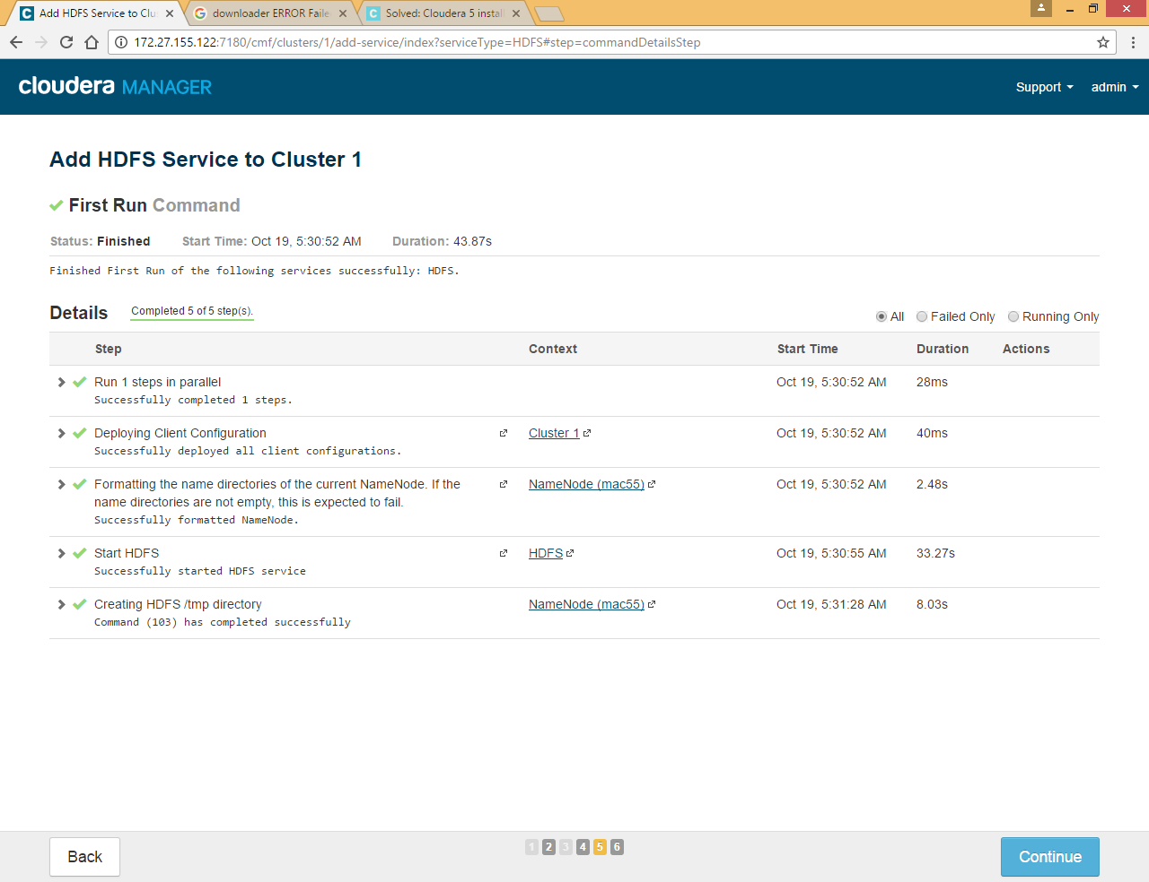

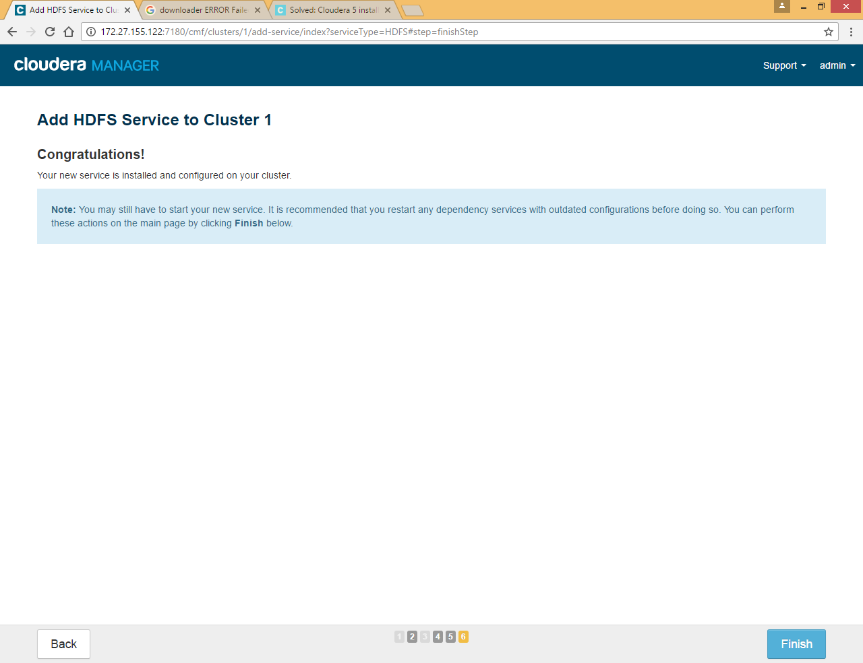

Click on HDFS >> Instances to check all Roles for HDFS

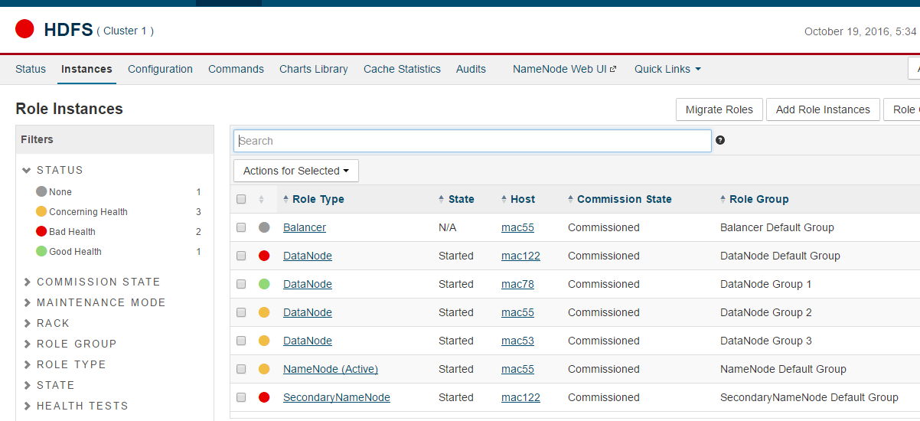

### Zookeeper Service

Click on Add Service



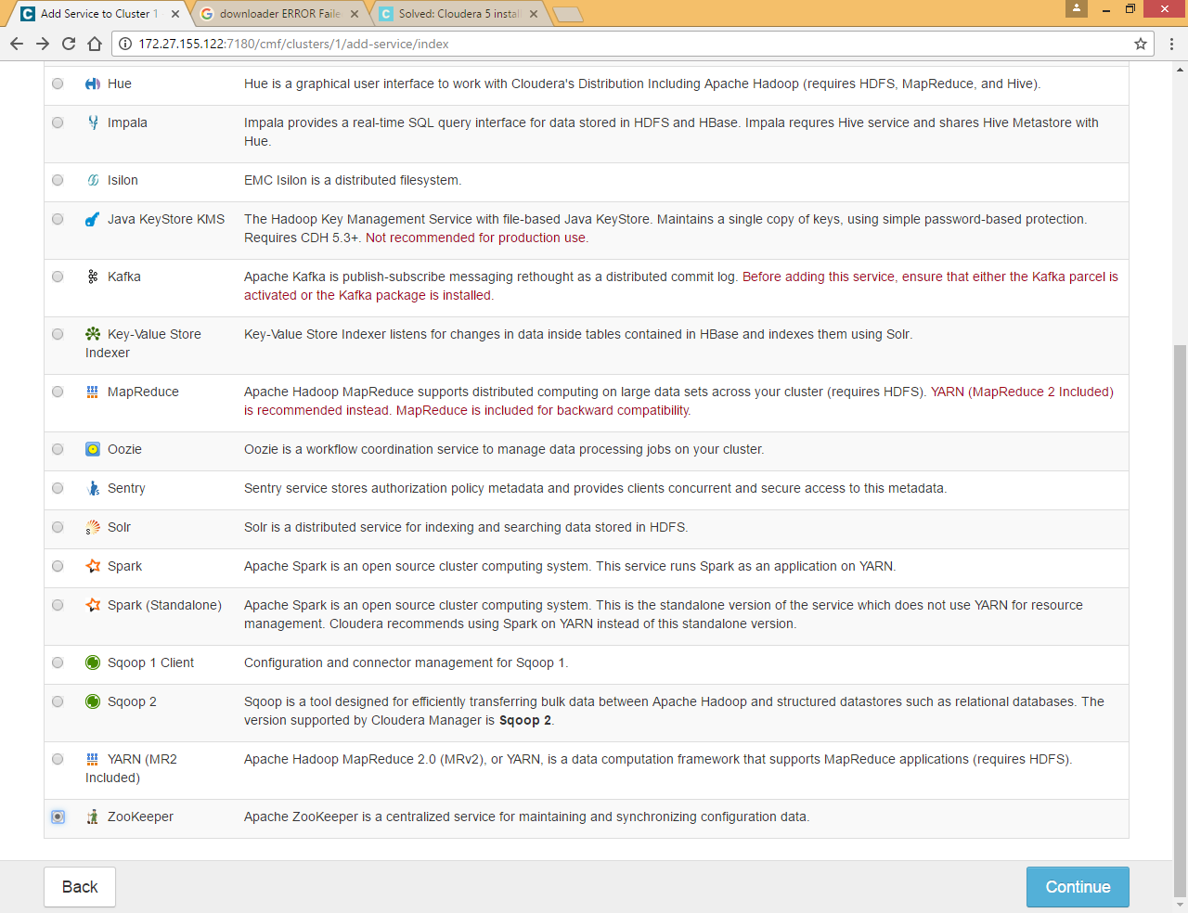

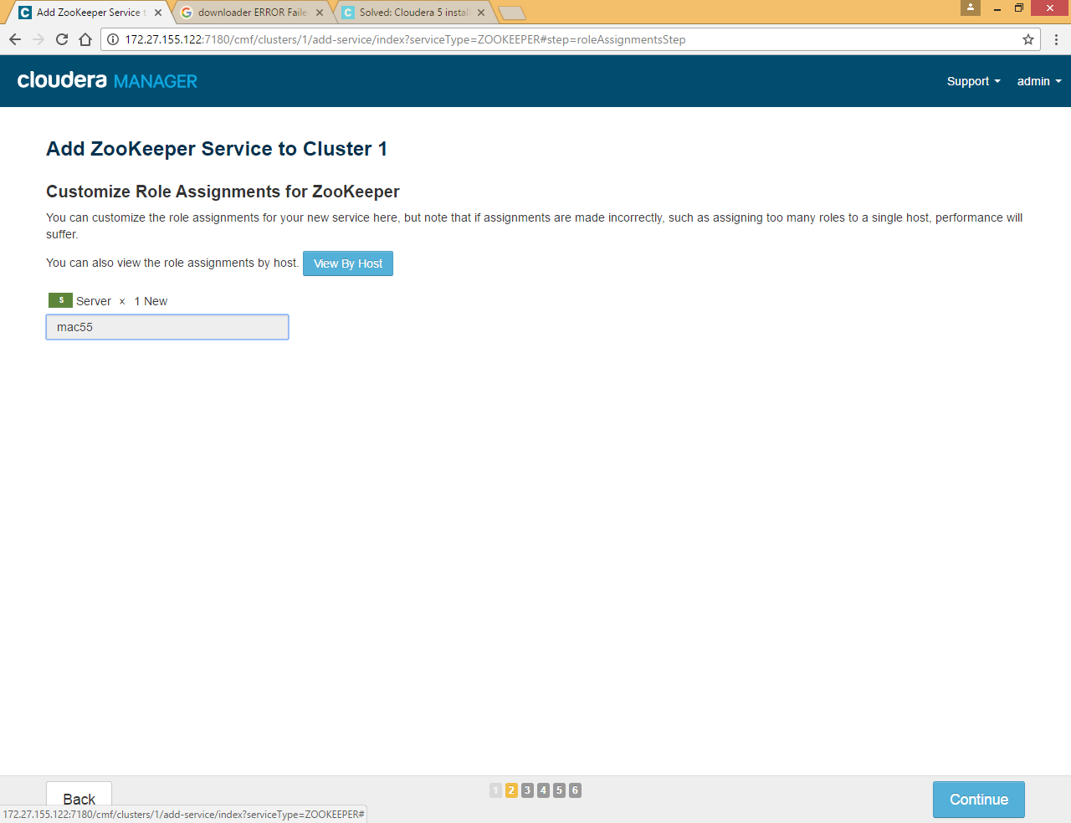

Click on mac55 and select any 3 hosts

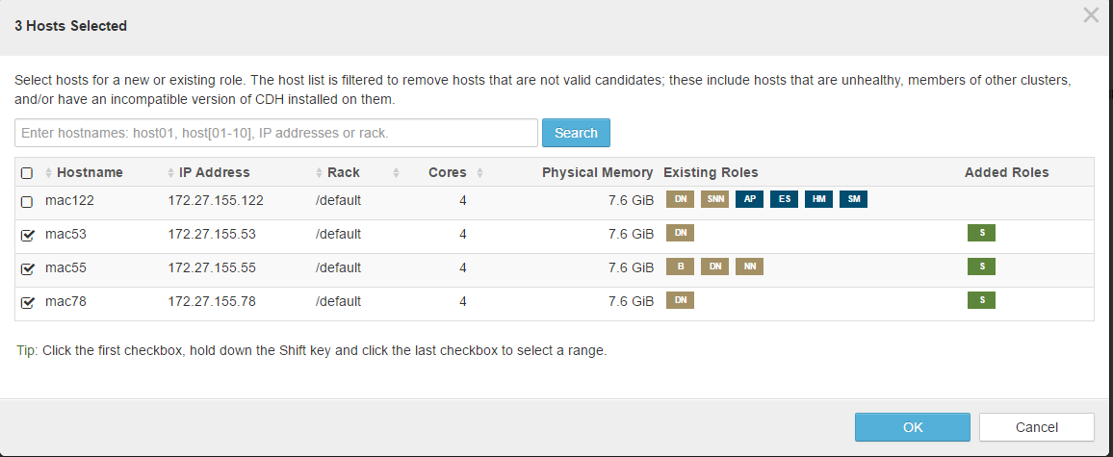

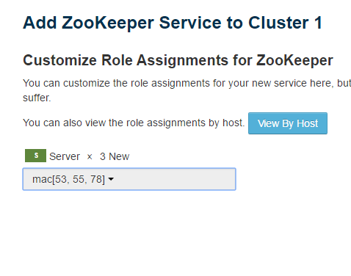

As per standard zookeeper should be installed on odd number of nodes

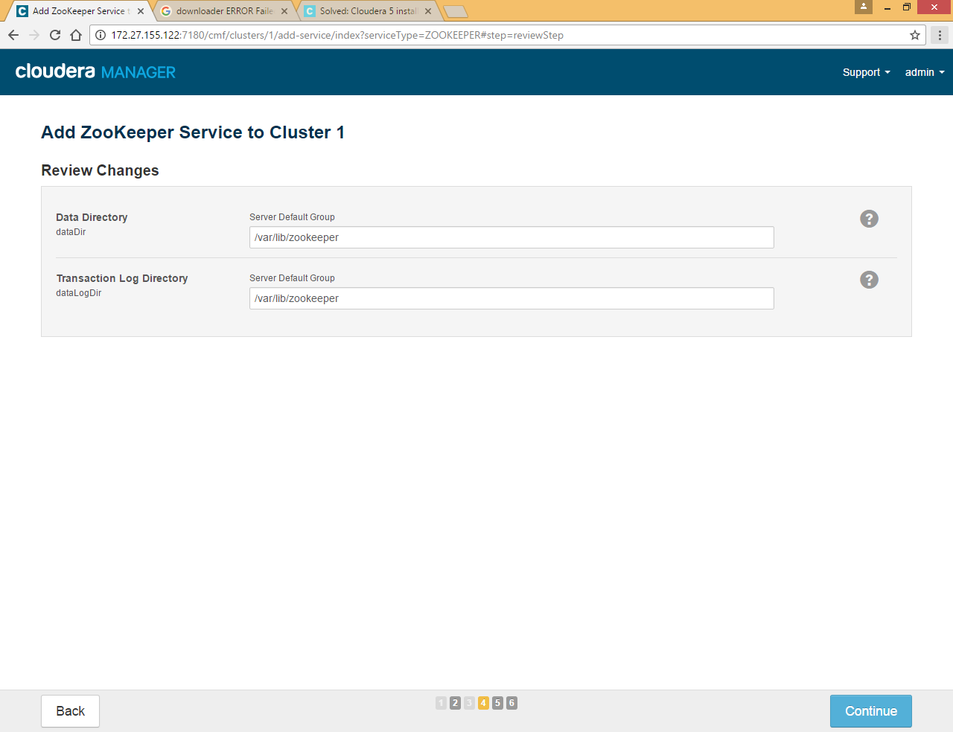

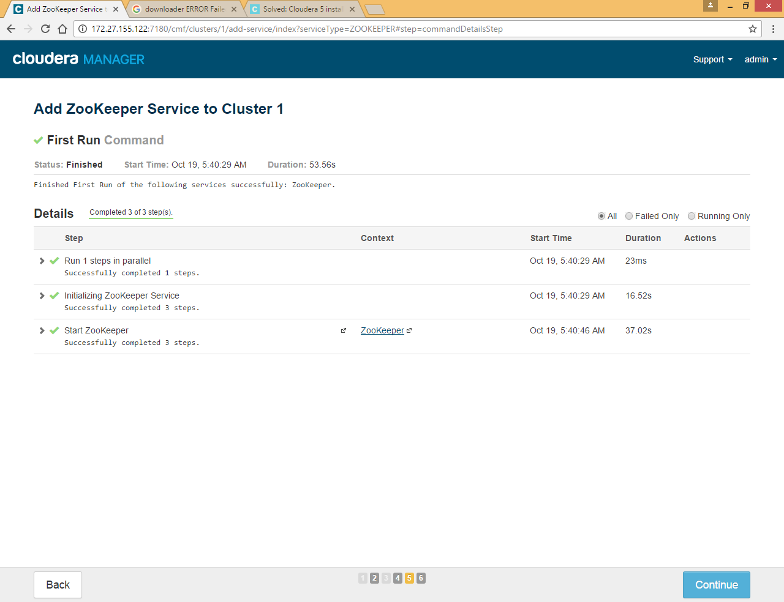

### Yarn Service

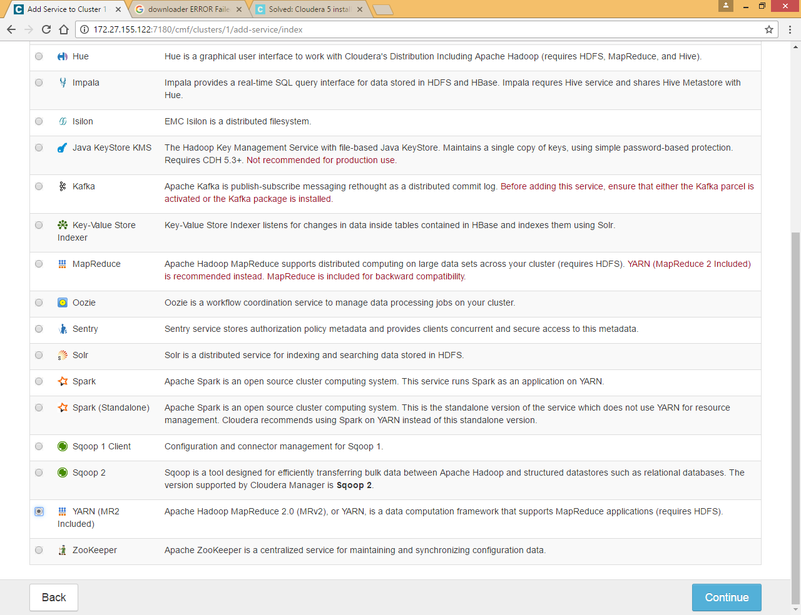

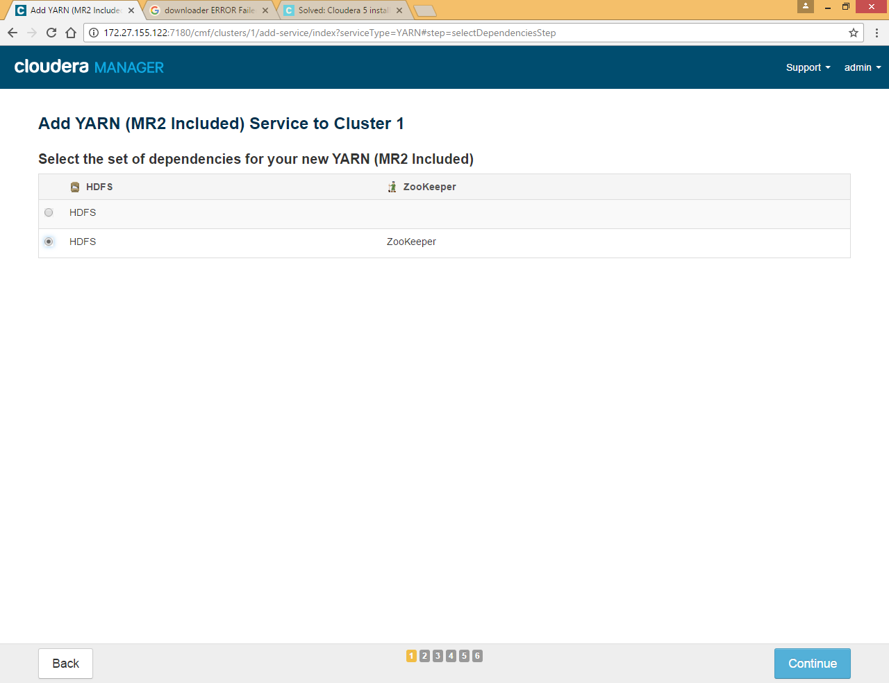

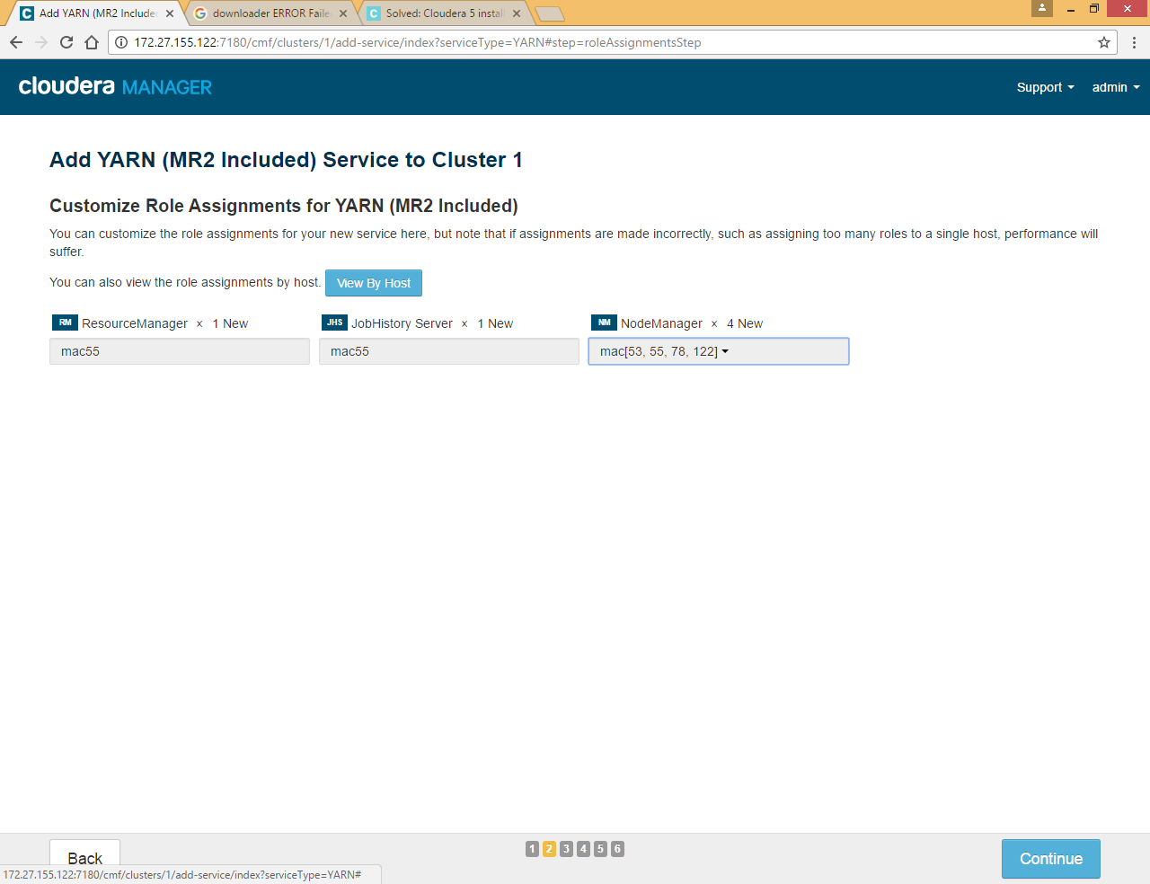

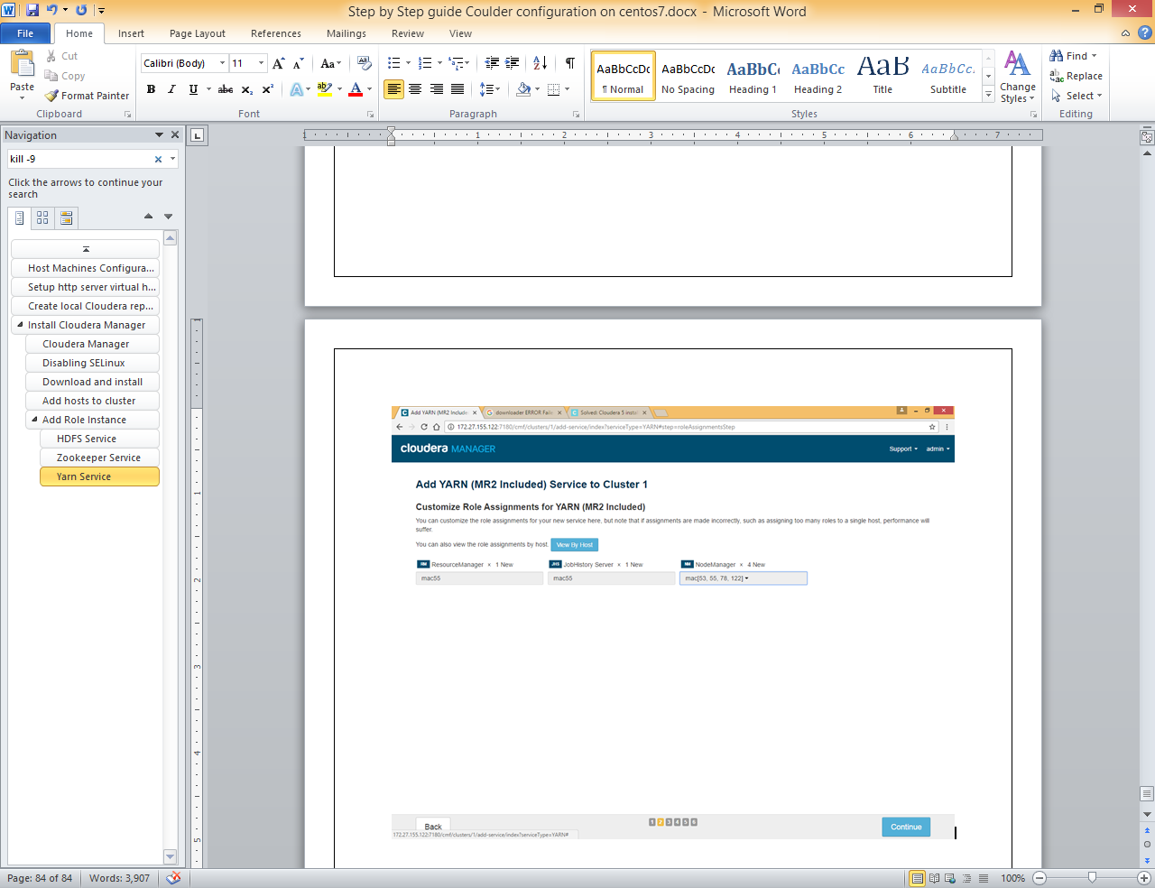

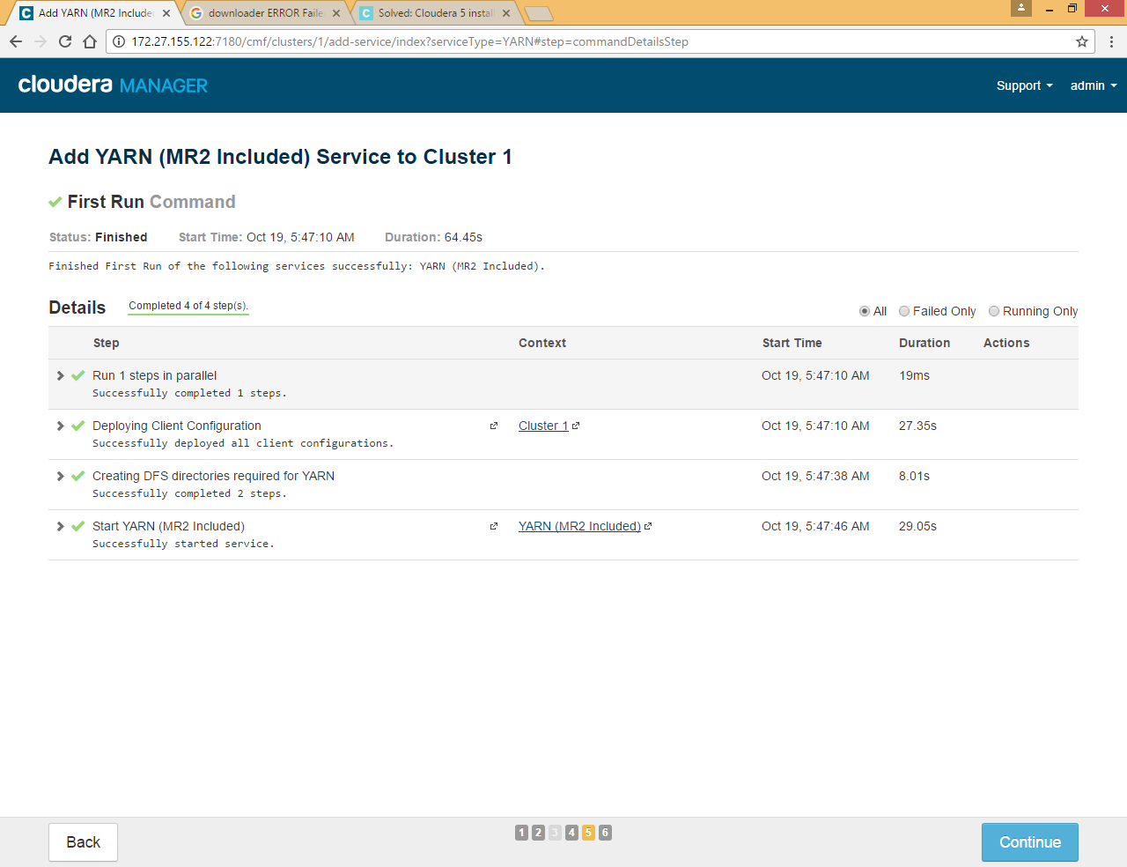

### Hive Service

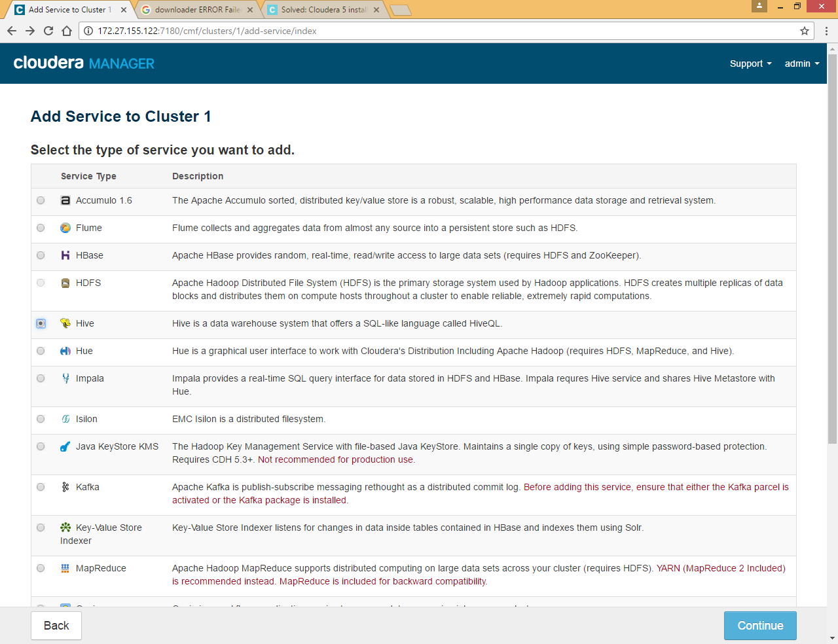

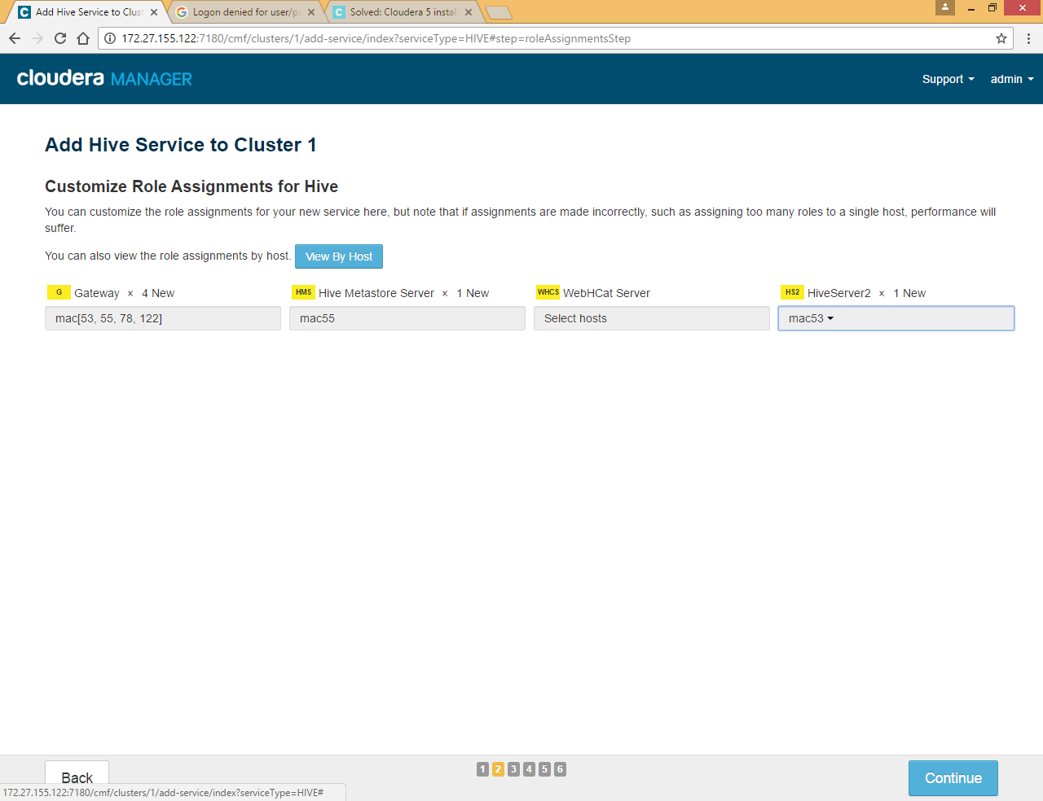

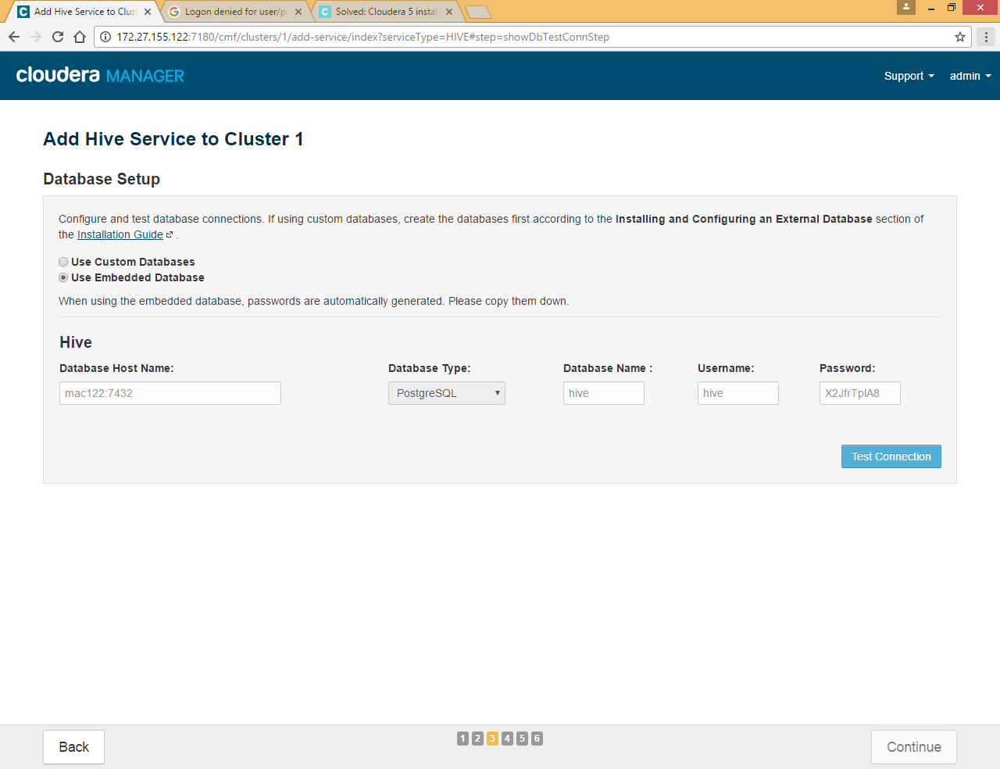

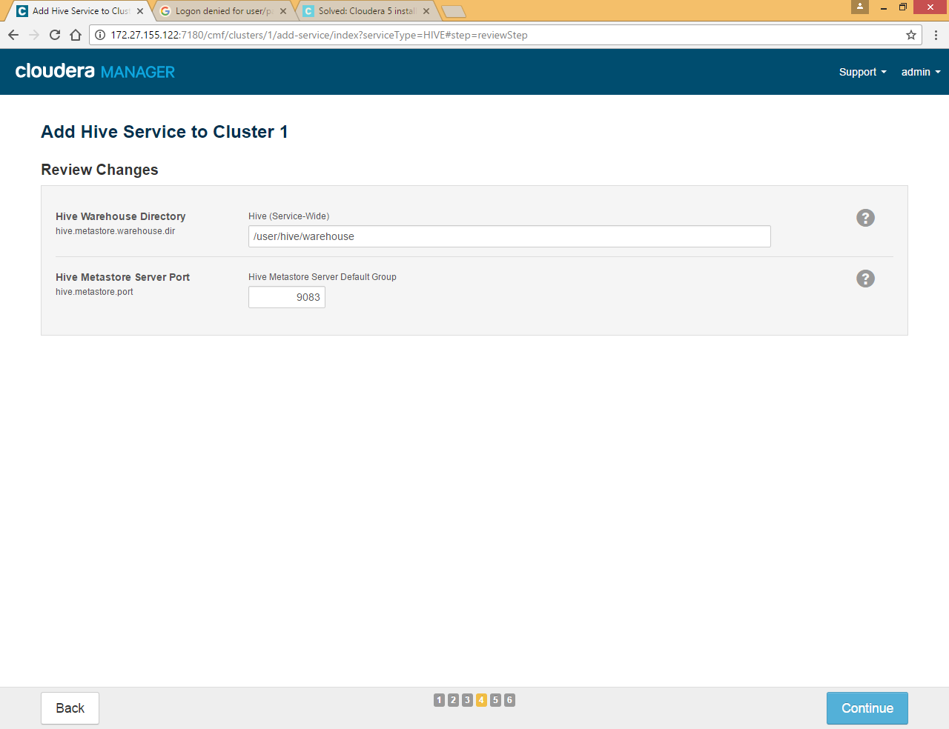

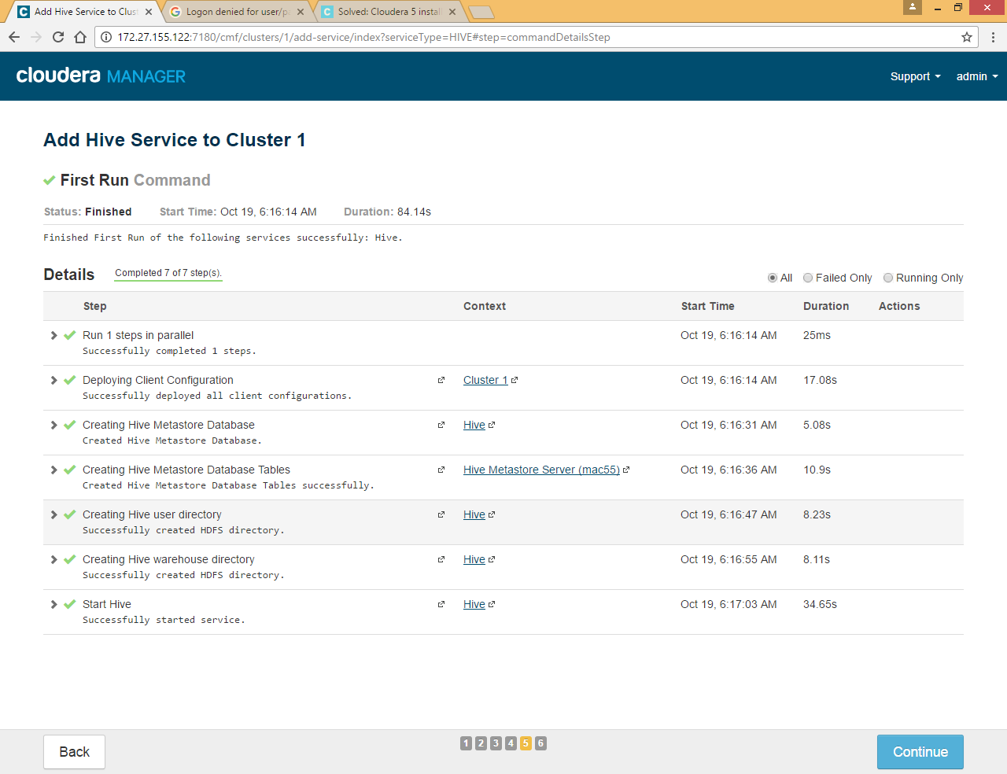

### Impala Service

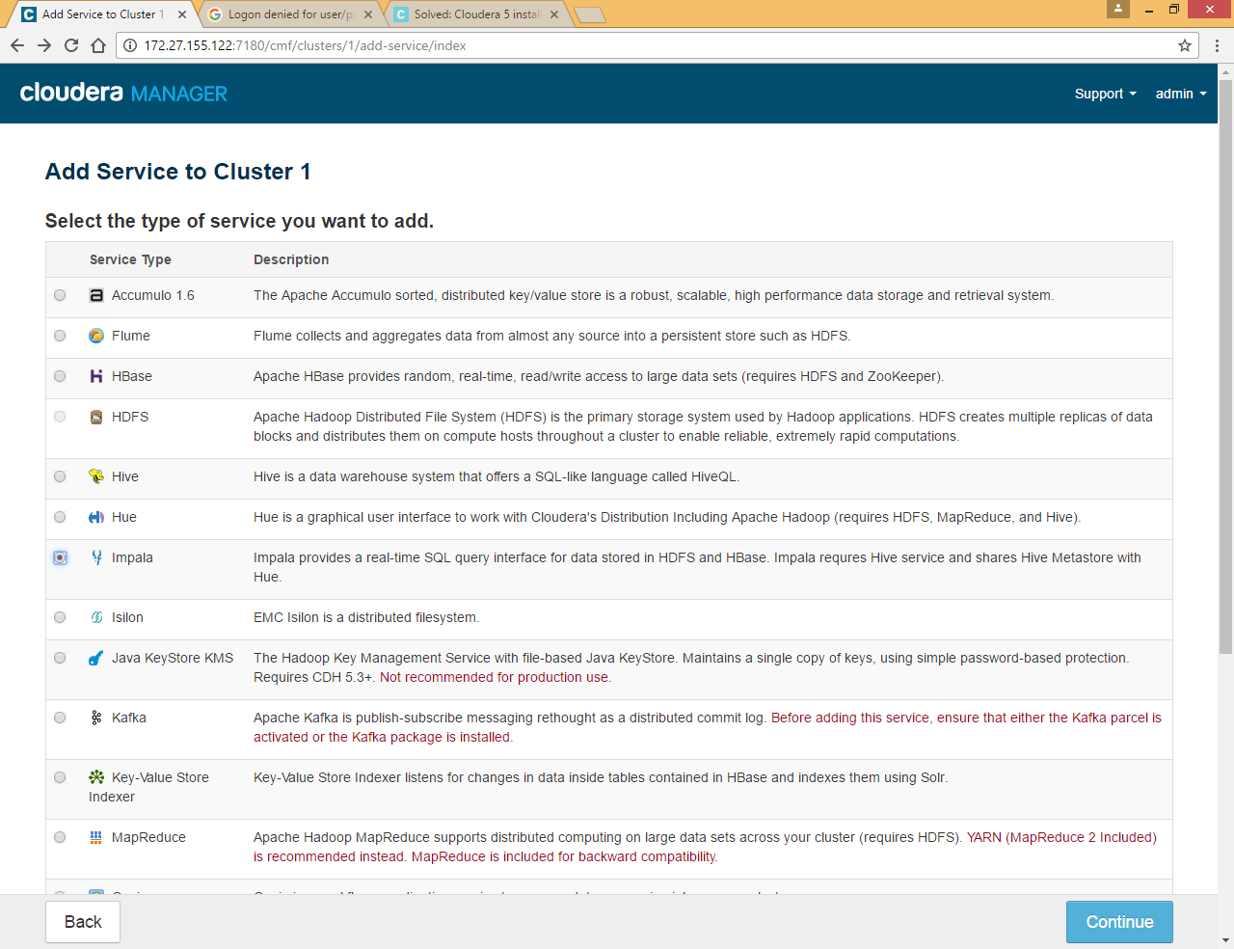

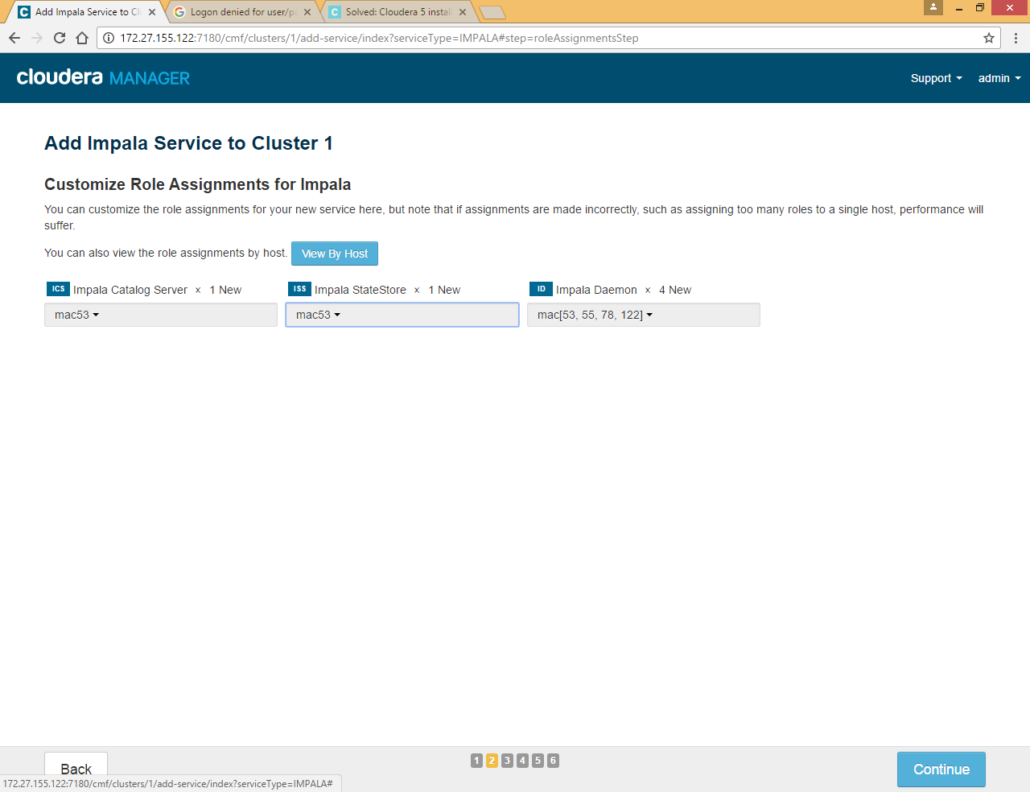

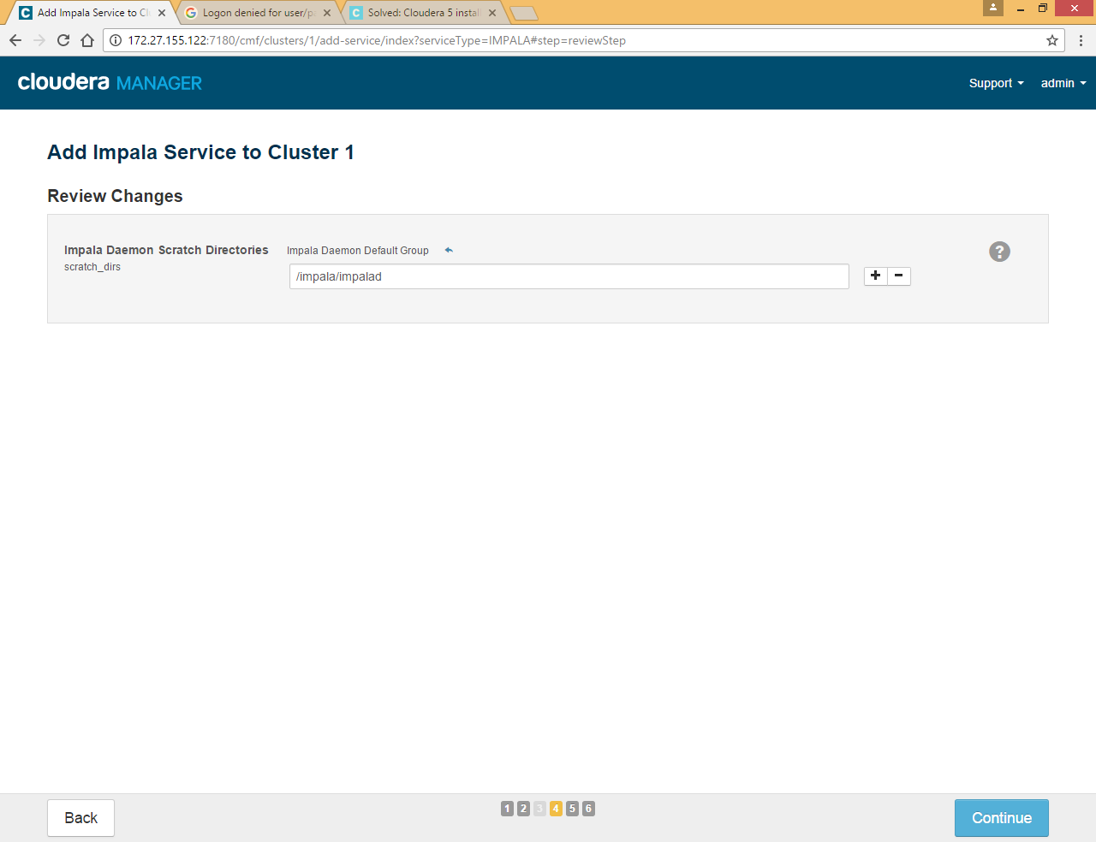

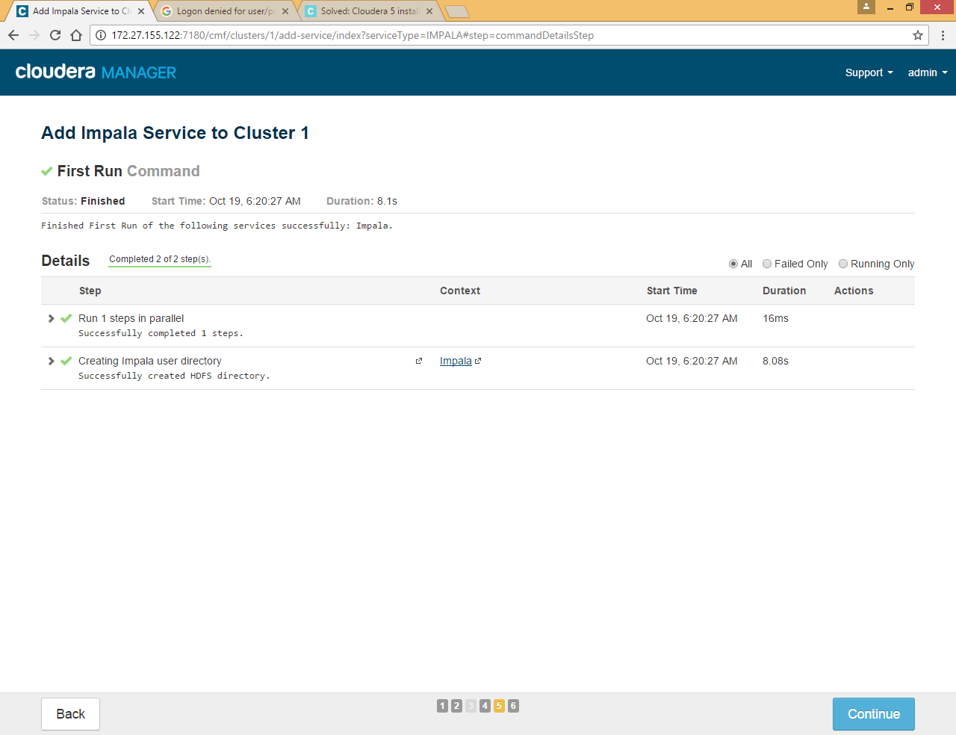

### Oozie Service

This service is required for hue

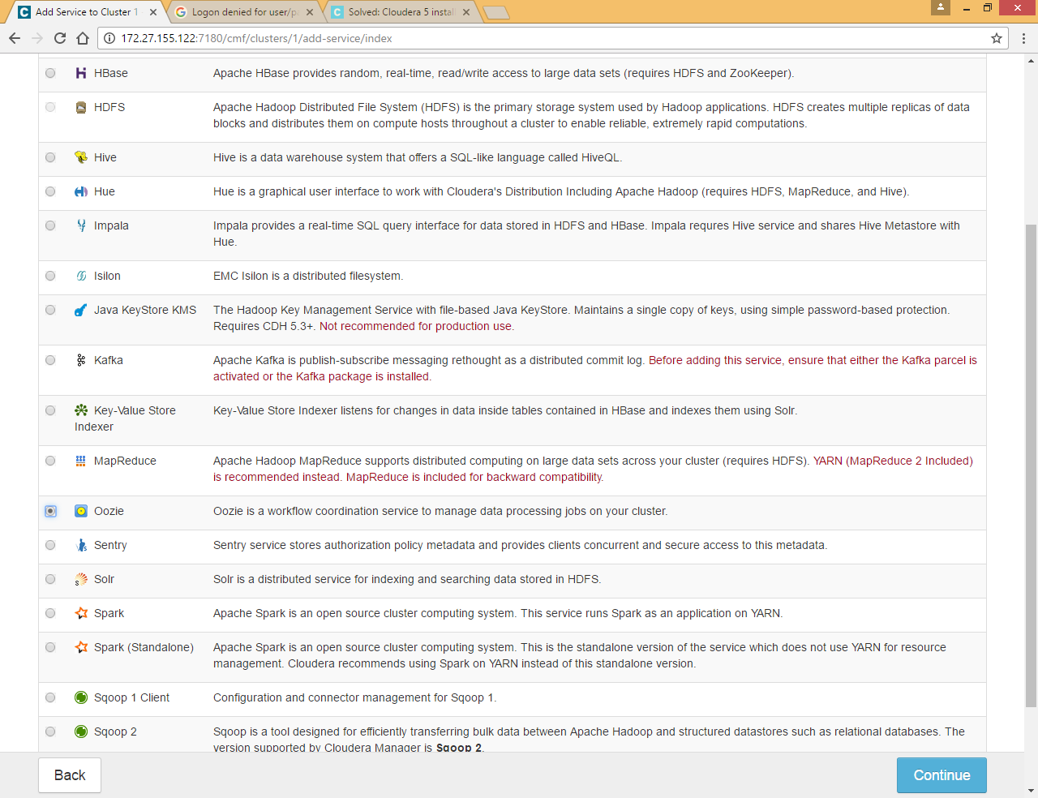

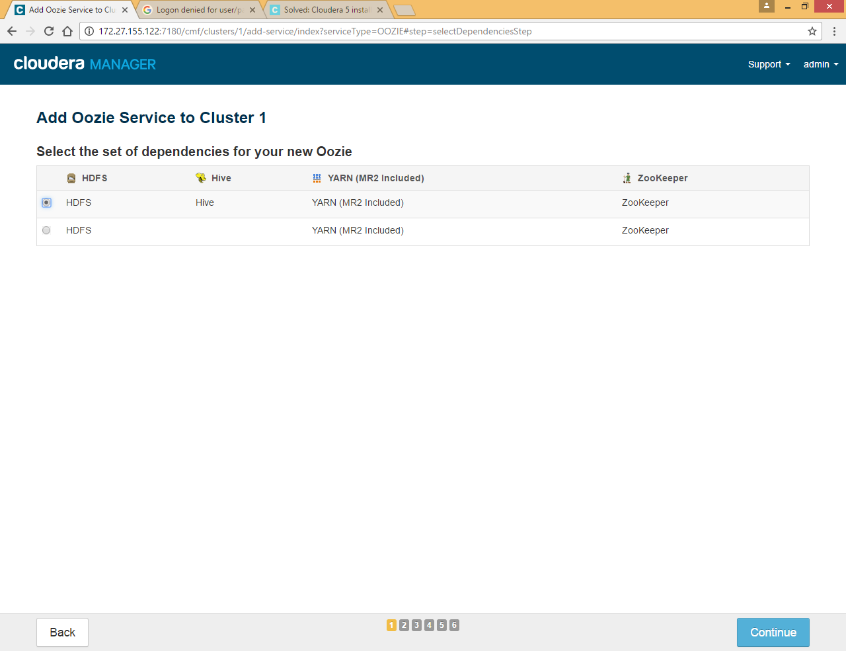

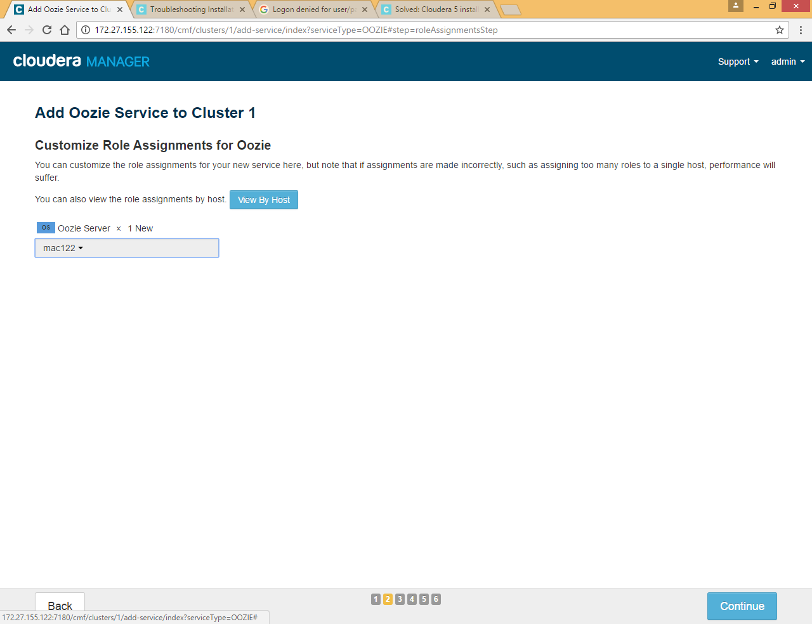

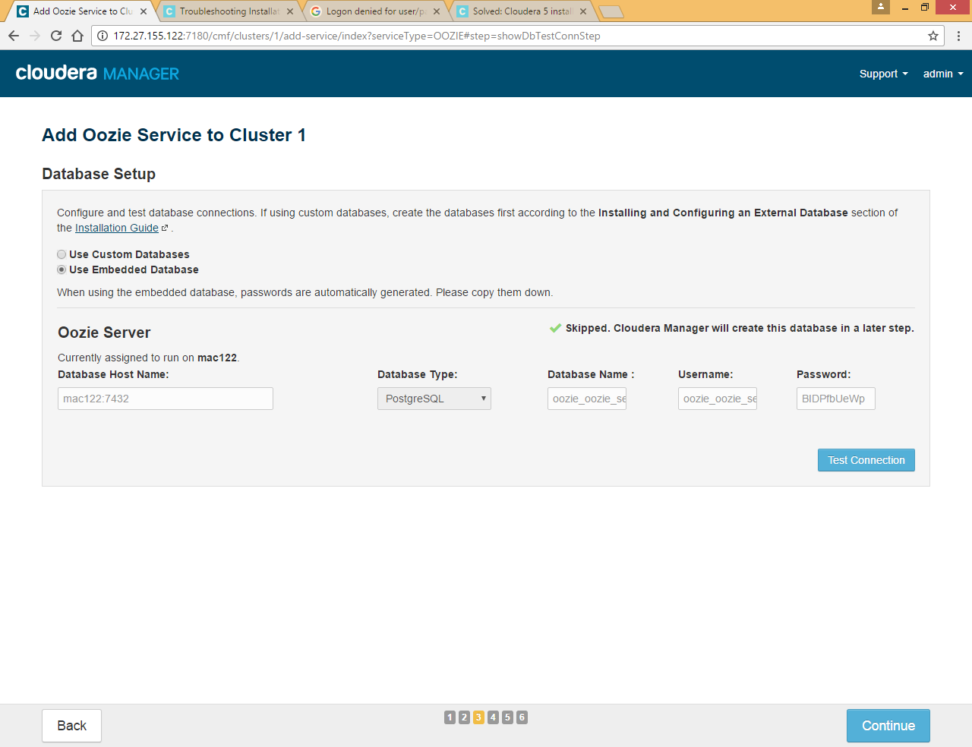

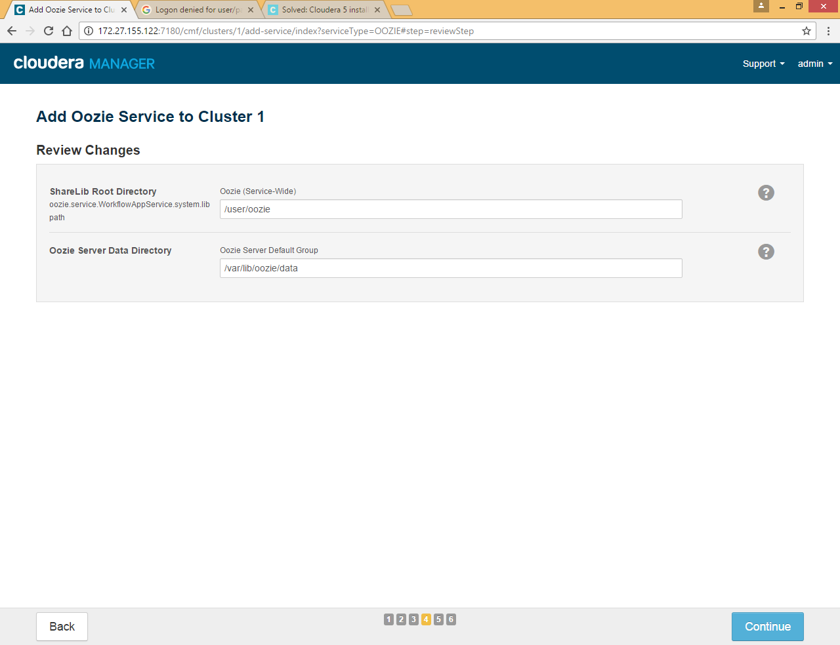

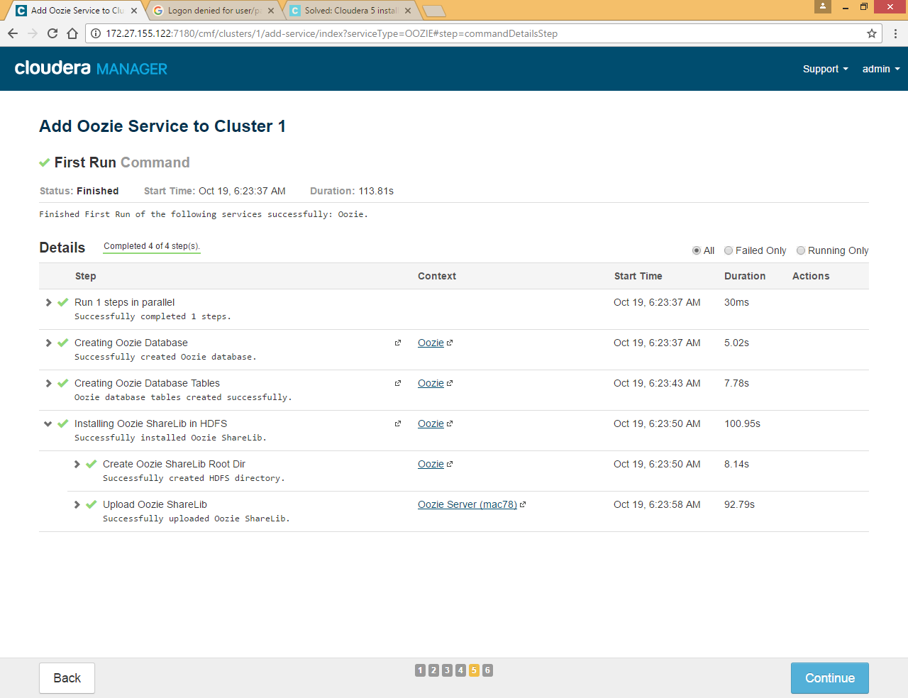

### Hue Service

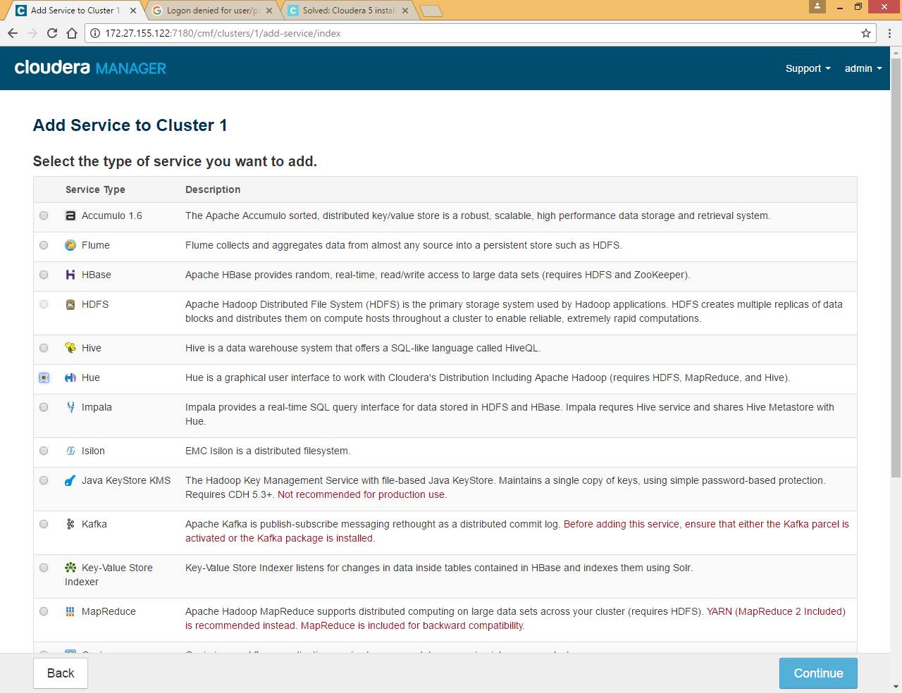

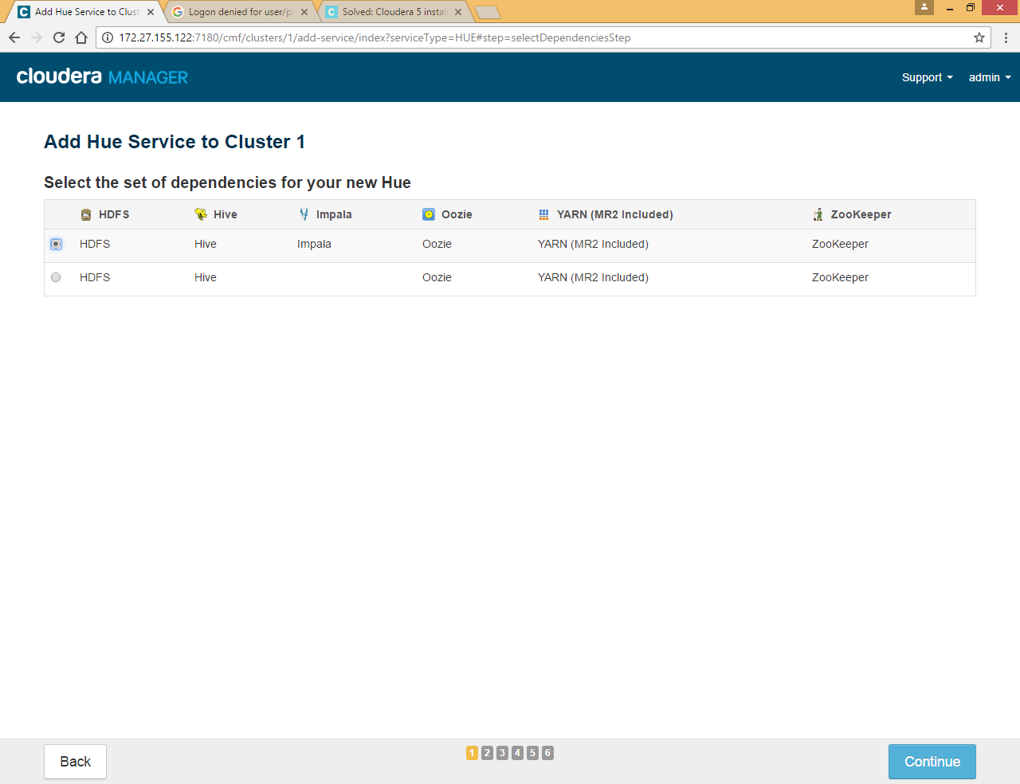

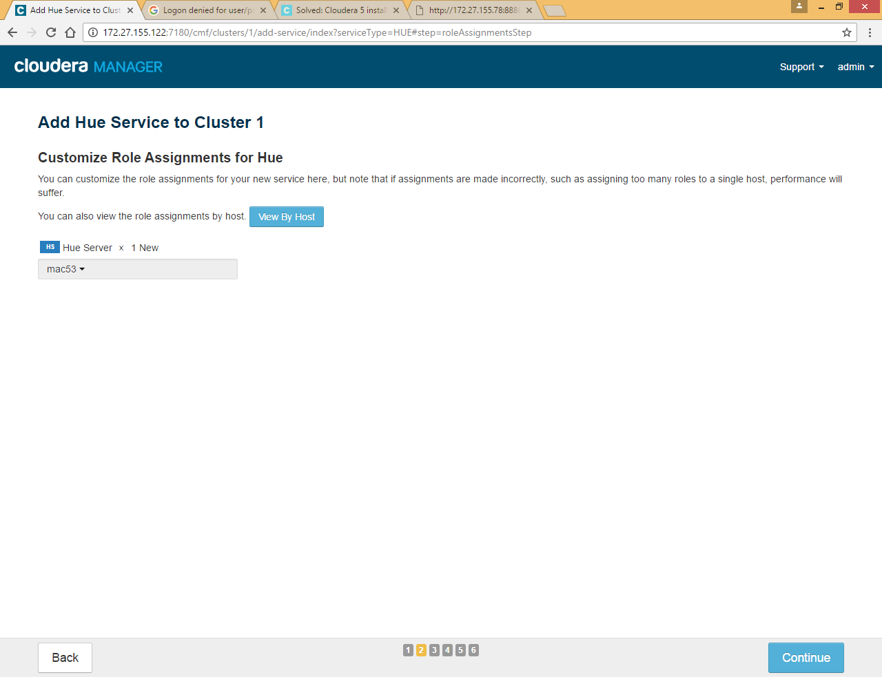

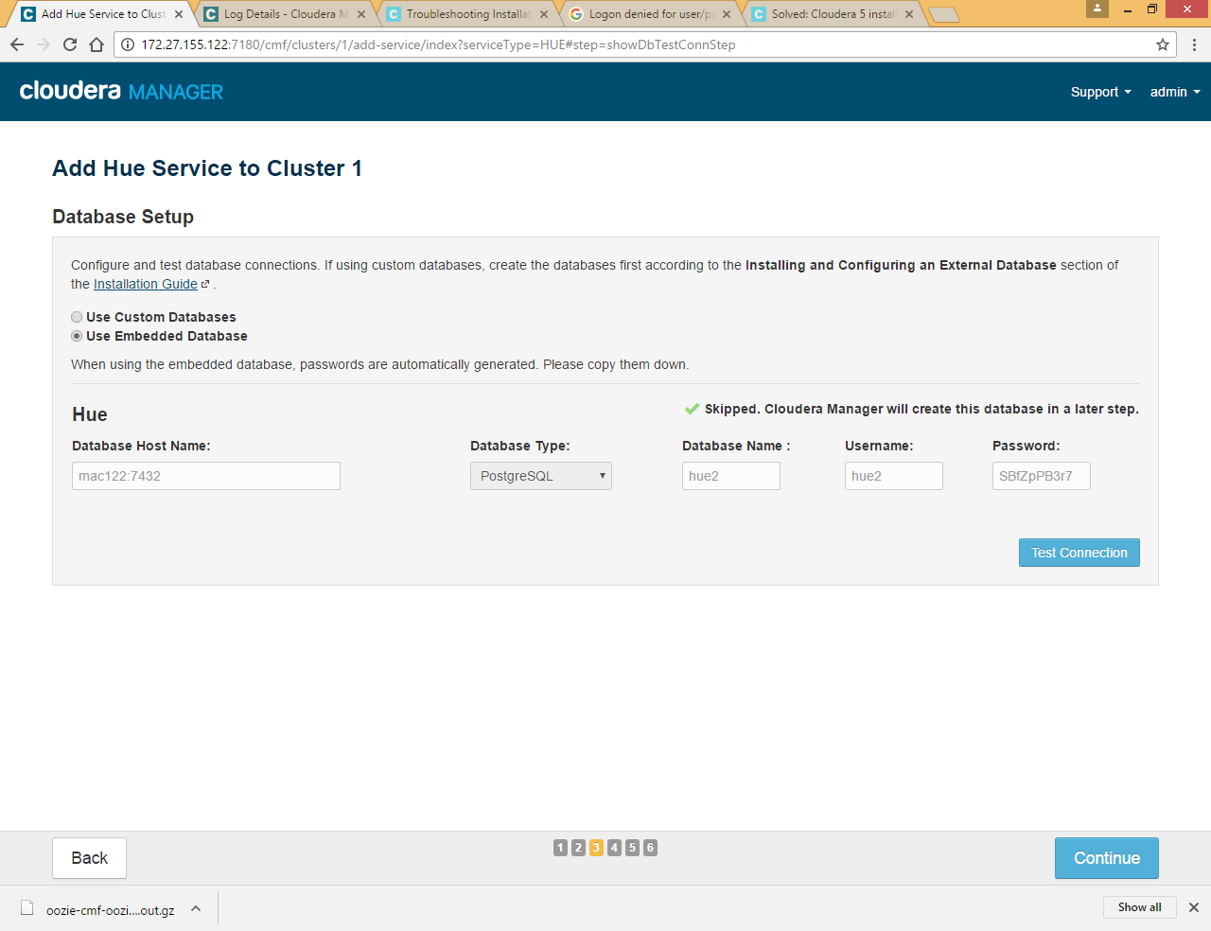

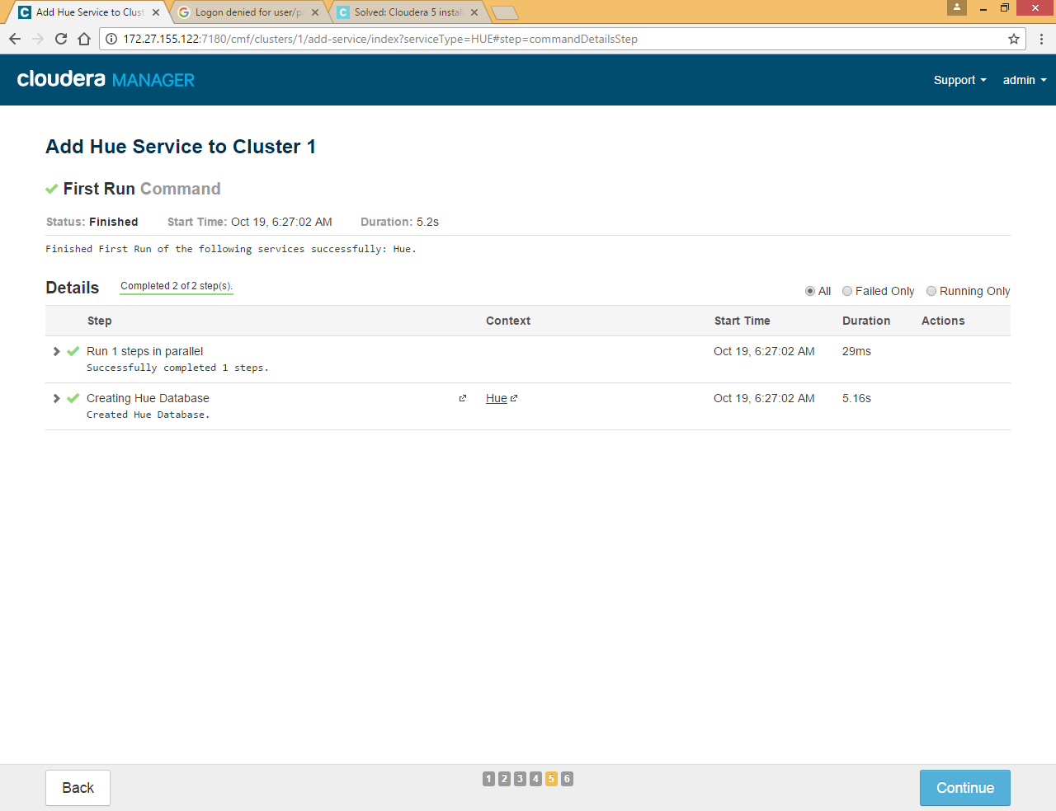

Start hue service

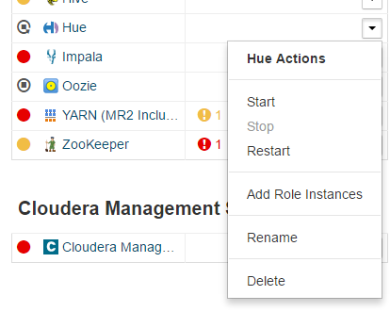

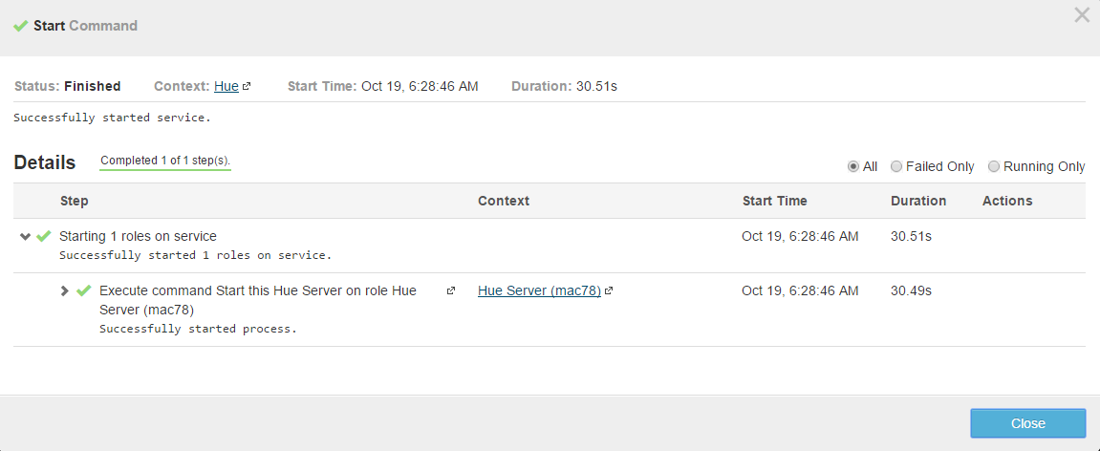

Go to <http://172.27.155.53:8888/> to access hue web UI

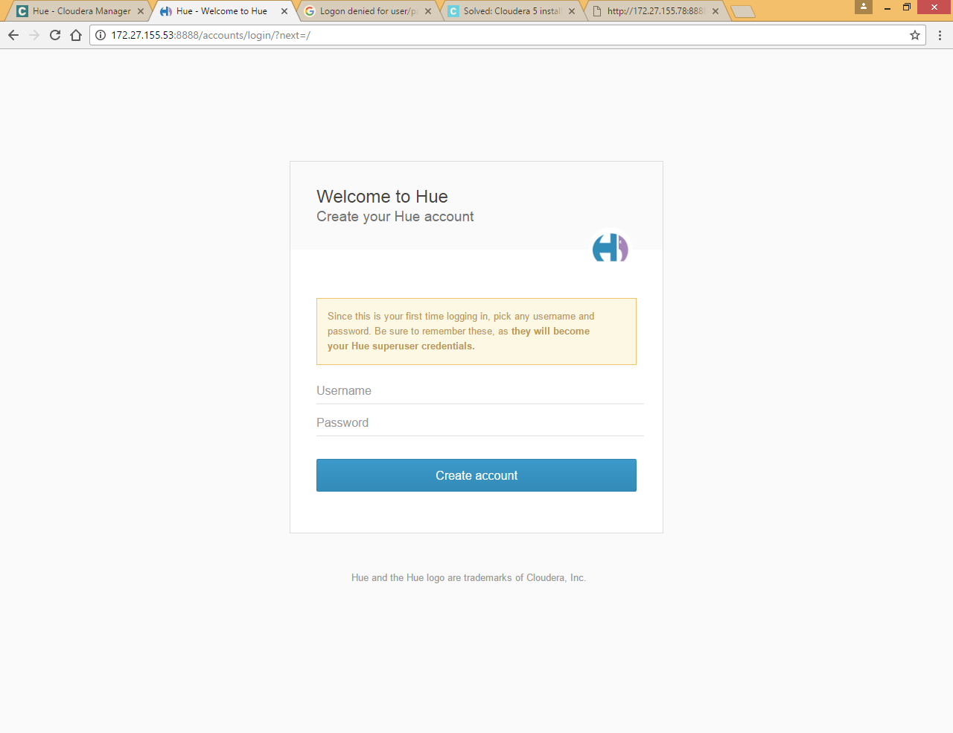

Set first time username and password admin/admin and click Create account

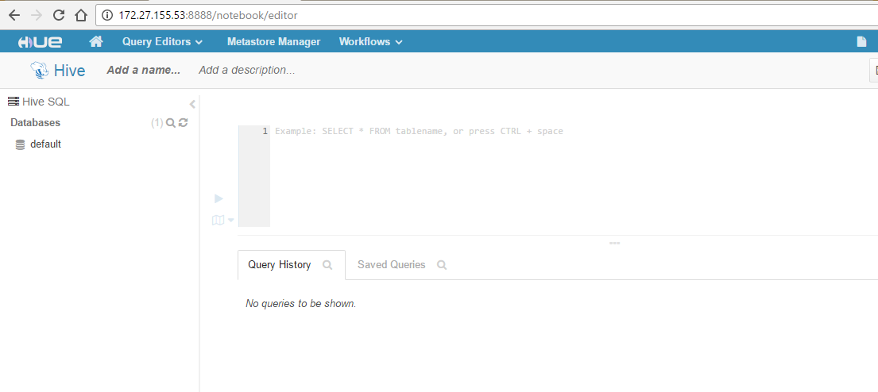

## Install Custom-database (MySQL)

In case you want custom database for hue,hive and oozie , you can install oracle and mysql and select them at the time of configuration

Refer attached doc for installation and configuration of my SQL.



## Uninstall Cloudera Manager and Managed Software

Refer attached doc for steps

